**Sai Pratyusha Gorapalli**

**Webster University**

**CSDA 6010 DATA ANALYTICS PRACTICUM**

**Student ID: 4246209**

**FALL 2025**

**PROJECT (Case-1)**

**JP WANG**

**Executive Summary:**This project builds a practical, data-driven pricing system for used smartphones. A cleaned dataset of more than 3,400 devices (brand, operating system, screen size, camera specs, memory, RAM, battery, weight, release year, days used, and both new/used normalized prices) was analyzed and split into training (70%), validation (15%), and test (15%) sets. The target for prediction is normalized_used_price; normalized_new_price serves as the market anchor.

Three regression models were developed to estimate a continuous used price: a baseline linear model, Multiple Linear Regression using numeric specs, k-Nearest Neighbors with standardized predictors, and Random Forest. Two classification models were also trained to place devices into “High” vs “Low” price bands derived from the training median: a C5.0 decision tree and logistic regression. Across models, performance on validation and test was closely matched, indicating strong generalization.

For continuous price prediction, Multiple Linear Regression delivered the best accuracy with test RMSE ≈ 0.2006 and R² ≈ 0.7821 on the normalized scale, edging out Random Forest and k-NN (both RMSE ≈ 0.21, R² ≈ 0.76). For fast tiering into price bands, Logistic Regression achieved test accuracy ≈ 0.863, slightly higher than the C5.0 tree while remaining simple and interpretable.

Key drivers of resale value are consistent with market intuition: the new price anchor is strongest, and higher camera megapixels (front and rear), larger screen, newer release year, and (to a lesser extent) device weight lift value; more days used reduce value. The results support transparent, fair pricing that aligns with customer expectations and market behavior.

Deploying Multiple Linear Regression for day-to-day price quotes and Logistic Regression for quick High/Low triage. These choices balance accuracy, stability, and explainability, and can be embedded into pricing workflows with periodic monitoring and refresh as inventory and market conditions evolve.

**TABLE OF CONTENTS**

1. INTRODUCTION ………………………………………………………………………..…7

2. BUSINESS AND ANALYTICAL………………………………………...............................7

2.1. BUSINESS PROBLEM……………………………………………………………7

2.2. BUSINESS GOAL…………………………………………………………………8

2.3. ANALYTICAL GOAL……………………………………………………………..8

2.4 ANALYTICAL APPROACH……………………………………………………….8

3. DATA EXPLORATION AND PREPROCESSING………………………………………….9

3.1. DATA SET OVERVIEW………………….……………………………………….9

3.2. ATTRIBUTE DEFINITIONS …………....………………………………………...10

3.3. TYPES OF DATA……………………………………………….………………….11

3.4 DETAILED ANALYSIS ON EACH ATTRIBUTE…………………………………12

3.5. DATA QUALITY CHECKS ……………………………………………………….25

3.6. EXPLORATORY OBSERVATIONS……………………………………………….28

4. PREDICTOR ANALYSIS AND RELEVANCY……………………………………………...29

4.1 PREDICTOR RELEVANCY FOR REGRESSION…………………………………29

4.2 PREDICTOR RELEVANCY FOR CLASSIFICATION……………………………29

5. DIMENSION REDUCTION …………………………………………………………………32

5.1 DIMENSION REDUCTION FOR REGRESSION AND CLASSIFICATION..........32

6. DATA TRANSFORMATION…………………………………………………………………34

6.1 KERNEL DENSITY ESTIMATION AND Q-Q PLOT……………………………..34

7. DATA PARTIONING…………………………………………………………………………36

8. ALGORITHM SELECTION FOR GOAL...………………………………………………….37

8.1 MODEL FITTING FOR REGRESSION ALGORITHM……………………………..38

9. IMPLEMENTATION OF EACH ALGORITHM..……………………………………………38

9.1 MULTI LINEAR REGRESSION…………………………………………………….38

9.2 K-NEAREST NEIGHBOR………………………………………………………...…41

9.3 RANDOM FOREST……………………………………………………………….43

9.4 C5.0…………………………………………………………………………………45

9.5 LOGISTIC REGRESSION…………………………………………………………50

10. COMPARISON OF MODEL PERFORMANCE EVALUATION………………………..53

10.1 COMPARING MODEL PERFORMANCE OF REGRESSION ALGORITHMS…53

10.2 COMPARING MODEL PERFORMANCE OF CLASSIFICATION ALGORITHM…………………………………………………………………………………...54

11. MODEL EVALUATION OF SELECTED MODELS……………………………………….55

11.1 MODEL EVALUATION FROM REGRESSION …………...………………………55

11.2 MODEL EVALUATION FROM CLASSIFICATION………………………………56

12. CONCLUSION………………………………………………………………………………57

**LIST OF FIGURES**

1. Types of data…………………………………………………………………………..11

2. Device brand distribution……………………………………………………………...12

3. OS Distribution………………………………………………………………………..13

4. Used Price by OS……………………………………………………………………...13

5. Battery Capacity distribution………………………………………………………….14

6. Battery Capacity boxplot………………………………………………………….......14

7. Days used distribution…………………………………………………………….......15

8. Boxplot of days used……………………………………………………………….…15

9. Distribution of front camera in megapixels……………………………………….......16

10. Boxplot of front camera in megapixels……………………………………………….16

11. Distribution of rear camera in megapixels……………………………………………17

12. Boxplot of rear camera in megapixels…………………………………………….......17

13. Distribution of Internal memory in GB………………………………………………..18

14. Boxplot of Internal memory in GB……………………………………………………18

15. Distribution of RAM in GB……………………………………………………………19

16. Boxplot of RAM in GB……………………………………………………………......19

17. Distribution of Weight in Grams………………………………………………………20

18. Boxplot of Weight in Grams…………………………………………………………..20

19. Distribution of release of each smartphone in year…………………………………...21

20. Boxplot of release years of smartphones……………………………………………...21

21. Distribution of screen size in inches…………………………………………………..22

22. Boxplot of screen size in inches………………………………………………………22

23. Distribution of normalized new price…………………………………………………23

24. Boxplot of normalized new price…………………………………………………….23

25. Distribution of normalized used price………………………………………………...24

26. Boxplot of normalized used price…………………………………………………….24

27. Pair plots for correlation Insights.……………………………………………………25

28. Missing values and zeros……………………………………………………………..26

29. Handling Missing values……………………………………………………………..27

30. Handling zeroes……………………………………………………………………….27

31. Summary of the data…………………………………………………………………..27

32. Exploratory observation between age and normalized used prices of smartphones…..28

33. screen_size, battery, front_camera_mp, rear_camera_mp, release_year, weight, internal_memory, days_used vs normalized_new_price………………………………………29

34. Correlation Matrix of Attributes……………………………………………………….32

35. Distribution of Numeric Variables………………………………………………………34

36. Q-Q plot of Numeric Variables………………………………………………………….35

37. Data Partition…………………………………………………………………………….36

38. Multi Linear Regression…………………………………………………………………38

39. Validation metrics of Multi Linear Regression…………………………………………...39

40. Evaluation metrics of test partition in MLR……………………………………………….40

41. Normalizing the predictors………………………………………………………………41

42. Tuning k values…………………………………………………………………………….42

43. Metrics of all k values……………………………………………………………………42

44. Metrics using best k value for knn…………………………………………………………42

45. Evaluation metrics for random forest……………………………………………………43

46. Evaluation metrics of model with mtry=5 for random forest algorithm…………………44

47. Decision tree for C5.0……………………………………………………………………46

48. Validation metrics, confusion matrix, statistics of C5.0…………………………………...47

49. Metrics on test data for C5.0………………………………………………………………49

50. Confusion matrix and statistics of logistic regression……………………………………50

51. Validation metrics of logistic regression…………………………………………………..51

52. Metrics on test data for logistic regression………………………………………………..52

1. **Introduction:**

The second-hand smartphone market provides lower-cost options to consumers while extending device life and reducing electronic waste. For consistent pricing, a transparent, data-driven method is needed that converts a phone’s specifications and usage history into a fair resale value. This is especially important for customers who cannot afford or choose not to purchase the latest models immediately upon release. To remain competitive, stores must set fair and consistent prices that align with prevailing market rates across different outlets.

Data on used smartphones from multiple brands can be analyzed to identify pricing patterns. Features such as screen size, camera quality, battery, RAM, storage, and days of usage directly influence resale value. By applying predictive models, fair and accurate prices can be estimated for upcoming inventory. This approach ensures that prices reflect true market value, builds trust between sellers and buyers, and supports strong business relationships.

Ultimately, the goal is to increase sales by offering reasonable and competitive prices that attract more customers while ensuring mutually beneficial transactions. In addition, data-driven insights can guide marketing strategies, improve customer satisfaction, and help reduce losses from overpricing or underpricing devices. Using machine learning methods, the resale market can shift from guesswork to structured, reliable decision-making, supporting both business growth and sustainability.

**2. Business and Analytics Goals**

* 1. **Business Problem**

Pricing for used smartphones is often inconsistent and based on guesswork, which results in customer dissatisfaction and lost revenue opportunities. Many businesses do not have a structured, data-driven approach to determine fair resale values, especially for newly released models entering the market. A reliable method that considers important technical factors such as brand, RAM, battery, and usage history is needed to ensure fair pricing, improve customer trust, and maximize revenue. This problem becomes more serious as the market for second-hand devices continues to grow, with a wide variety of brands, models, and conditions making pricing even more complex. Without a clear framework, businesses risk undervaluing premium devices or overpricing lower-quality ones, leading to inventory issues and reduced sales. The absence of consistency also damages customer trust, as buyers and sellers may feel exploited or uncertain about whether they are receiving a fair deal.

There is also a classification problem alongside pricing. Intake teams need fast, consistent decisions about a device’s **price tier or grade** (for example: Budget, Standard, Premium, or Grades A/B/C). Manual grading is subjective and differs across locations, causing uneven discounts and longer wait times. A classification approach can standardize these decisions, protect margins, and make quotes easier to explain at the counter.

* 1. **Business Goal:**

**Goal 1:** A consistent and competitive pricing framework for used smartphones is developed by selecting normalized_used_price as the target variable. This framework ensures that pricing decisions are data-driven and aligned with market patterns. At the same time, it guarantees that prices remain profitable for sellers while being fair to buyers, creating a balance that increases trust, encourages repeat sales, and strengthens long-term business relationships.

**Goal 2:** Produce a simple, customer-friendly classification output (price tier or grade) that staff can use for quick quoting and guardrails, keeping decisions uniform across stores.

**2.3 Analytics Goals:**

Building predictive models to estimate a device’s resale value based on its features (RAM, battery, brand, days used, etc.), ensuring accuracy and consistency in pricing decisions. This goal ensures competitiveness in the market by aligning resale prices with true device value, leading to better inventory management and higher customer satisfaction. For customers, the models provide confidence that the price they pay or receive reflects the real worth of the device based on measurable features.

For our first goal we will use regression algorithms to get precise estimated resale prices and for our second goal, build a classification model that assigns each device to a price tier/grade based on the same feature set. This tier becomes an operational guardrail for list prices, trade-in offers, markdown rules, and promotions. Classification accuracy, precision/recall, and confusion-matrix results will be used to confirm that tier decisions are consistent and business-safe.

Together, these models support clear pricing decisions at intake and listing time: the regression output provides an exact price estimate, and the classification output provides a transparent tier that is easy to communicate. This combination shortens negotiation, reduces pricing errors, improves inventory turnover, and strengthens customer trust.

**2.4 Analytical Approach:**

For Identifying Key Factors Affecting Resale Value:

* **Data Preparation**: Clean and preprocess the dataset by handling missing values (e.g., camera specs, battery), managing zero values where features may be absent, and encoding categorical variables such as device brand and operating system.
* **Exploratory Analysis**: Use descriptive statistics and visualizations to understand attribute distributions and correlations with the target variable (*normalized_used_price*).
* **Feature Relevance**: Apply correlation analysis and variable importance measures to identify the smartphone features (RAM, internal memory, battery, brand, days used, etc.) that most strongly influence resale price.

For Building Predictive Models:

* **Regression Modeling**: Develop regression models to estimate used smartphone prices as continuous values, capturing depreciation from *normalized_new_price*.
* **Classification Modeling**: Create classification models to segment used smartphones into pricing categories (e.g., low and high).
* **Model Evaluation**: Partition the data into training and testing sets. Evaluate regression models using RMSE and MAE, and classification models using accuracy, precision, and recall.

For Business Insights and Application:

* **Interpretation**: Translate model results into insights that highlight the key drivers of resale value.
* **Application**: Provide recommendations for stores to set competitive, fair, and profitable prices aligned with market trends.

**3. Data Exploration and Preprocessing**

In this step, the dataset's structure is examined, missing values are found, and any necessary transformations are carried out.

**3.1 Dataset Overview**

There are **3,454 observations** in the dataset (used_device_data.csv) with **15 attributes** device_brand, os, screen_size, 4g, 5g, rear_camera_mp, front_camera_mp, ram, battery, weight, release_year, days_used, normalized_used_price, normalized_new_price which are features of each used smartphone which will be used in analysis to see how these features effect the target variable.

The two price targets and explanatory features:

* The target variable is normalized_used_price.
* The baseline reference for depreciation is normalized_new_price.

**3.2 Attribute Definitions**

1. device_brand: The name of company, that belongs to the used smartphones devices.
2. os : The operating system name that the smartphone uses.
3. 4g : The network capability of the smartphone is 4G (yes/no).
4. 5g : The network capability of the smartphone is 5G (yes/no).
5. screen_size : The smartphone screen size including length and width.
6. rear_camera_mp: The megapixels that smartphone has for the back camera.
7. front_camera_mp: The megapixels that smartphone has for the front camera.
8. internal_memory: The storage capacity of the used smartphone, measured in GB.
9. ram: The random access memory of the used smartphone in GB.
10. battery: The battery capacity of the used smartphone in MAH.
11. weight: The overall weight of the used smartphone.
12. release_year: The release year of the smartphone, that is when they launched the phone.
13. days_used: The number of days the customer used the smartphone.
14. normalized_used_price: The normalized value of the used smartphone under different currencies and place.
15. normalized_new_price: The normless value of the new smartphone that is currently close to market value.

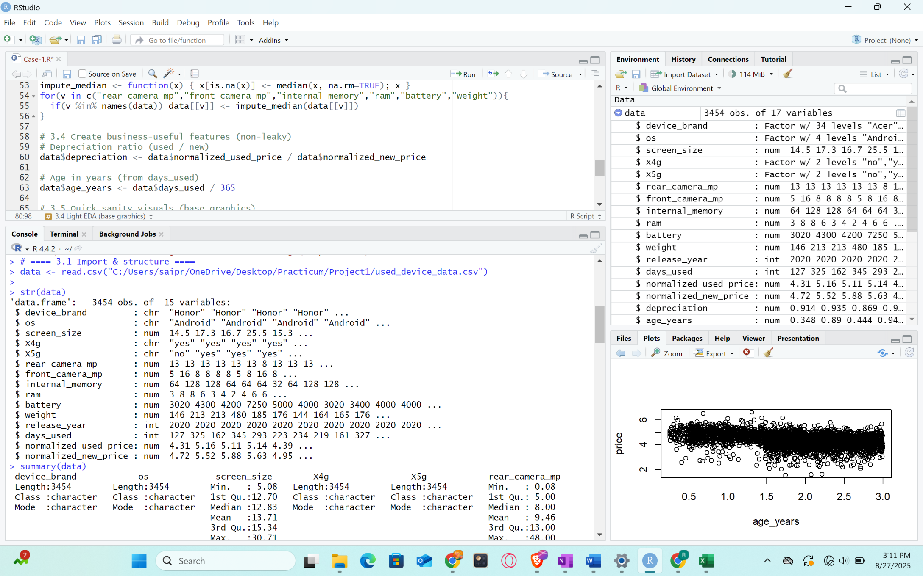

Fig 1: Types of Data

* 1. **Types of Data**

There are 3 types of data in the file.

* + 1. **Integer:**

release_year, days_used

* + 1. **Character**:

device_brand, os, 4g, 5g

* + 1. **Number**:

screen_size, rear_camera_mp, front_camera_mp, internal_memory, Ram, battery, Weight, normalized_used_price, normalized_new_price.

**Categorical Attributes:**

Ordinal:

* None in this dataset

Nominal:

* device_brand
* os

Binary:

* 4g (yes/no)
* 5g (yes/no)

Both technical details and usage history, which are important determinants of resale value, are captured by these variables.

* 1. **Detailed Analysis on each attribute:**

**Device Brand:**

* The dataset encompasses a diverse array of brands from both the premium and budget segments, including Samsung, Apple, Huawei, Oppo, Vivo, and others.
* Samsung is the most common brand, with approximately above 350 devices, followed by Huawei.
* Apple products are less common but usually have a higher resale value.
* The model is reinforced by this extensive representation, which incorporates devices of both high and low value.

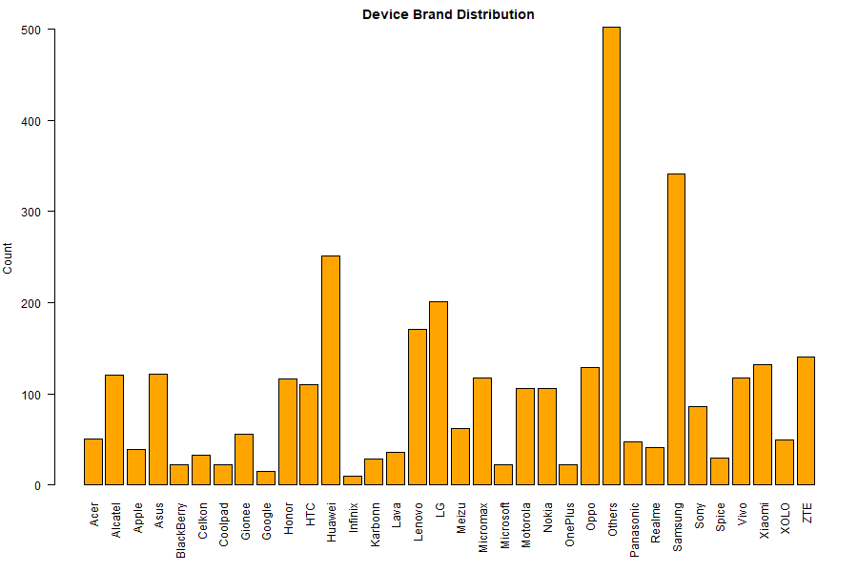

Fig2: Device brand distribution

**OS (Operating System):**

* Android dominates the dataset, making up the majority of devices.
* iOS has fewer entries but shows higher resale value.
* Windows and Others represent niche categories with the lowest resale prices.
* Boxplot confirms that iOS devices retain value best, while Android has wider spread with more low-value entries.

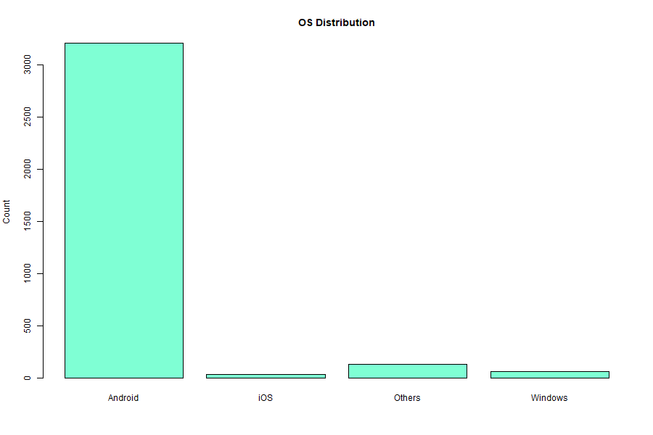

Fig3: OS Distribution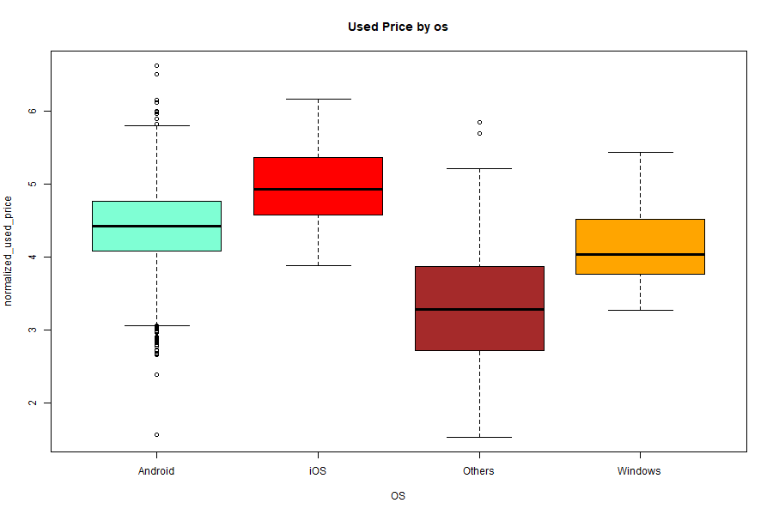

Fig4: Used Price by OS

**Battery Capacity (mAh):**

* Distribution ranges from ~1000 mAh to almost 10,000 mAh.
* Most devices cluster between 3000–4500 mAh, typical for modern phones.
* Outliers above 6000 mAh indicate gaming or endurance models.
* Histogram shows right-skewness, while the boxplot highlights extreme values.

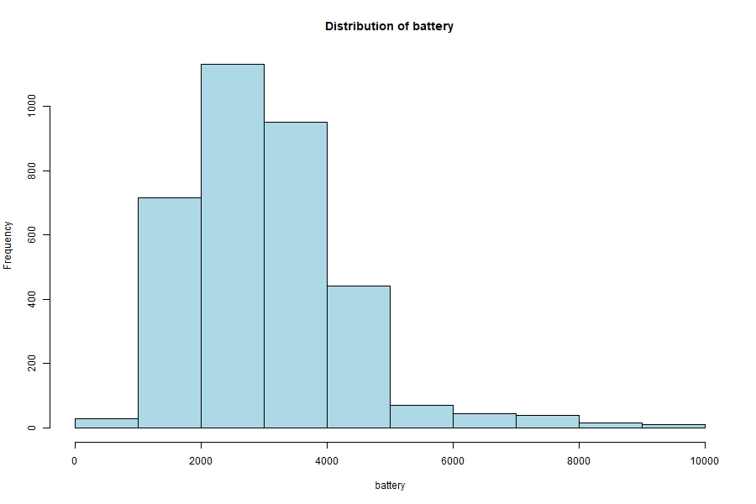

Fig5: Battery Capacity distribution

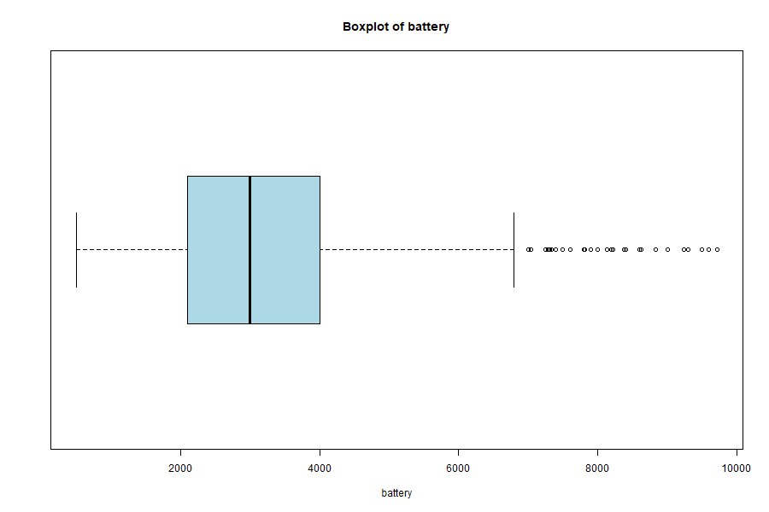

Fig6: Battery Capacity boxplot

**Days Used:**

* Usage ranges from under 100 to over 1000 days.
* Most phones are used for 500–900 days (~1.5–2.5 years).
* Histogram is balanced, while the boxplot shows minimal outliers.
* This reflects real-world upgrade cycles, where users replace devices within ~2 years.

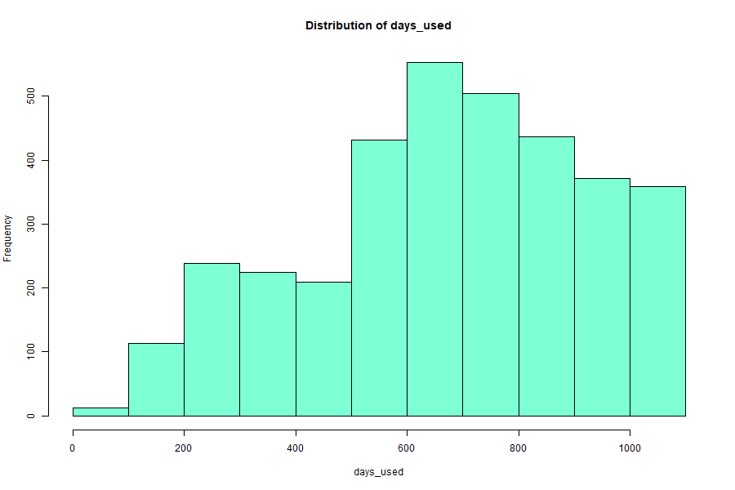

Fig7: Days used distribution

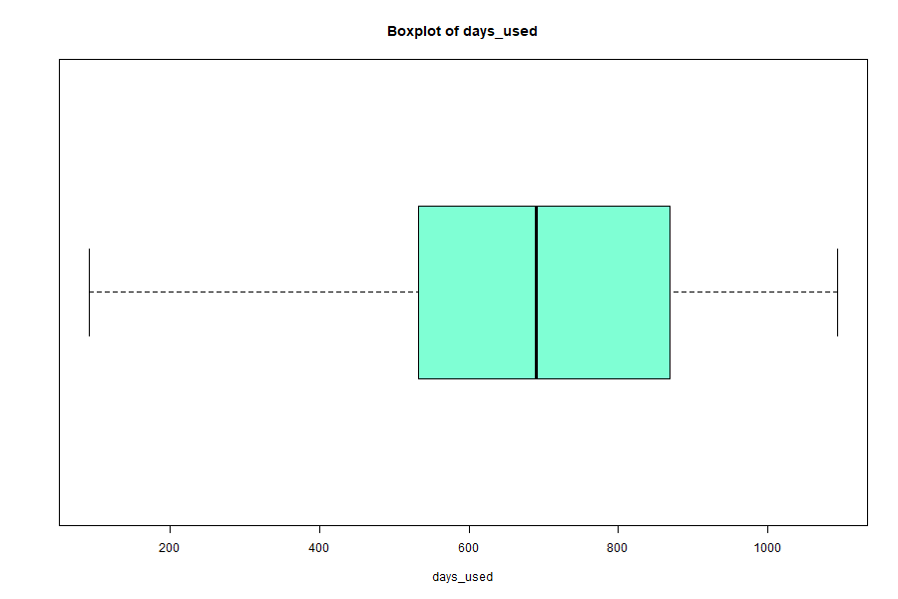

Fig8: Boxplot of days used

**Front Camera (MP):**

* Most devices fall between 5–8 MP, with distinct peaks at 5 MP, 8 MP, and 12 MP.
* Outliers above 20 MP show premium selfie-focused models.
* Histogram indicates a heavily skewed distribution, with most phones below 12 MP.
* Flagship devices with 30 MP front cameras appear as rare outliers.

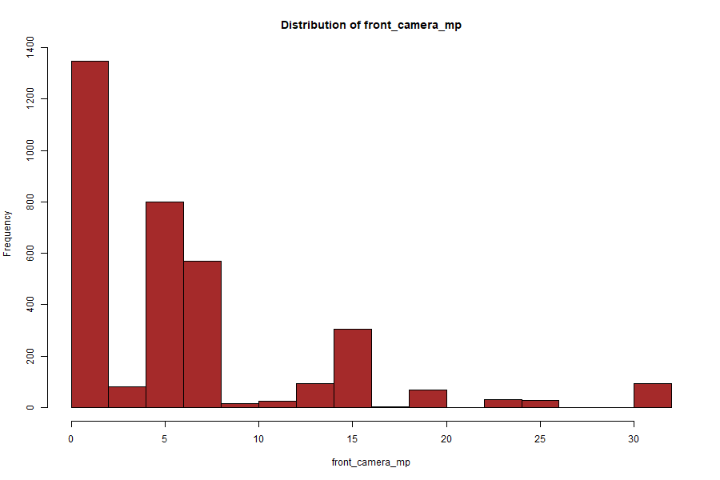

Fig9: Distribution of front camera in mega pixels.

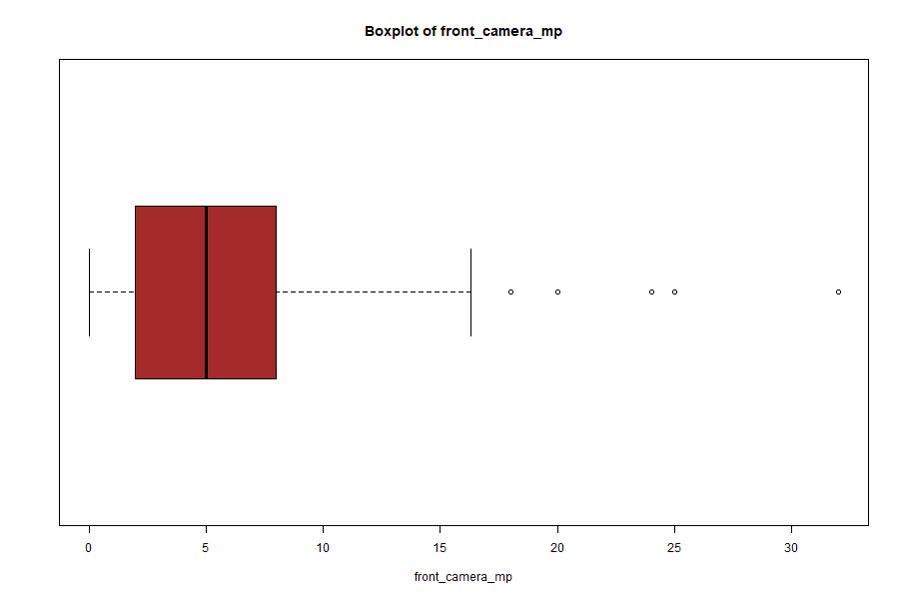

Fig10: Boxplot of front camera in megapixels.

**Rear Camera (MP):**

* The majority of devices lie between 8–16 MP.
* Outliers above 40 MP represent flagship phones with advanced camera systems.
* Histogram reveals clustering at 8 MP and 12 MP, followed by jumps at 48 MP.
* Confirms rapid technological evolution in rear cameras.

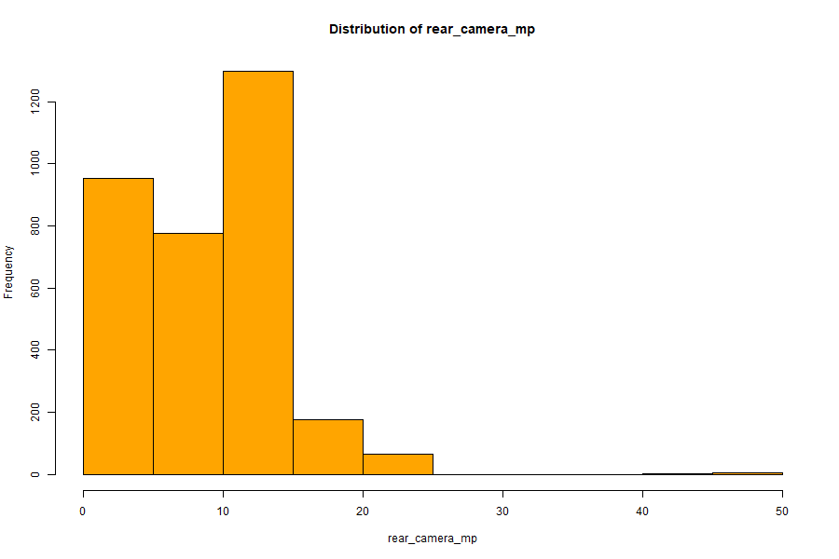

Fig11: Distribution of rear camera in megapixels.

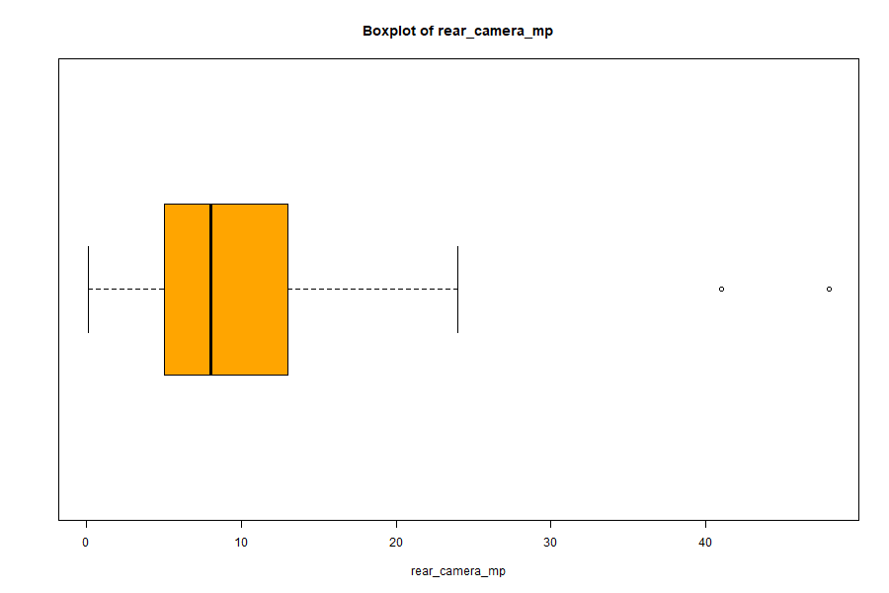

Fig12: Boxplot of rear camera in megapixels

**Internal Memory (GB):**

* Most devices fall between 16–128 GB.
* Outliers include high-storage phones (256 GB, 512 GB, and even 1 TB).
* Histogram is strongly right skewed, with peaks at 32 GB, 64 GB, and 128 GB.
* Storage is a strong predictor of resale value, as higher memory phones retain more value.

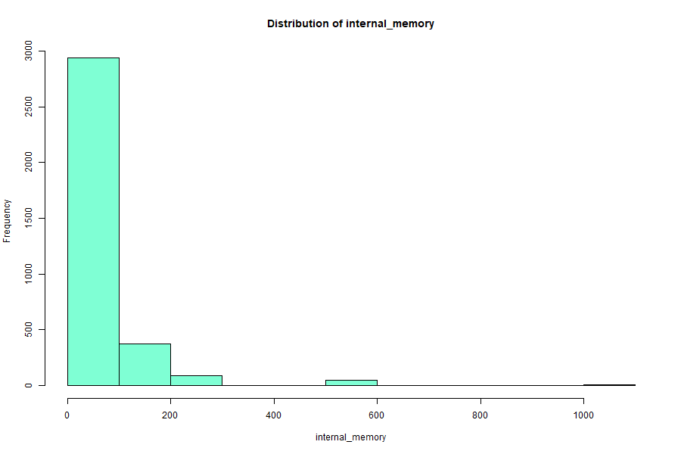

Fig13: Distribution of Internal memory in GB

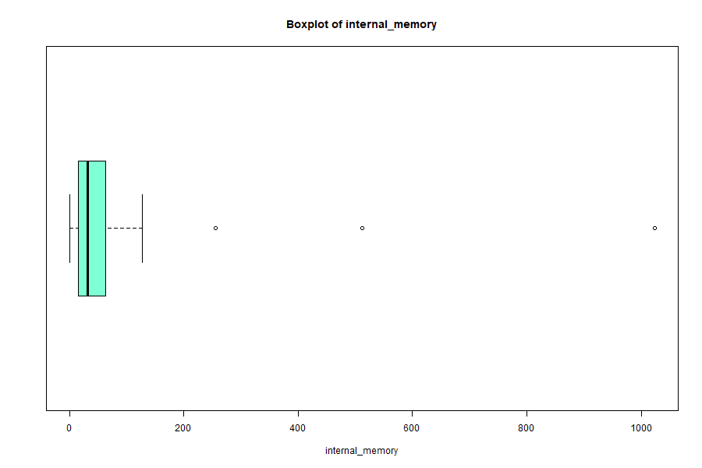

Fig14: Boxplot of Internal memory in GB

**RAM (GB):**

* RAM ranges from less than 1 GB (old phones) up to 12 GB (flagships).
* Most devices cluster at 4 GB, the most common standard.
* Outliers on both extremes show the transition in industry standards.
* Both histogram and boxplot indicate skewness, reflecting technological growth.

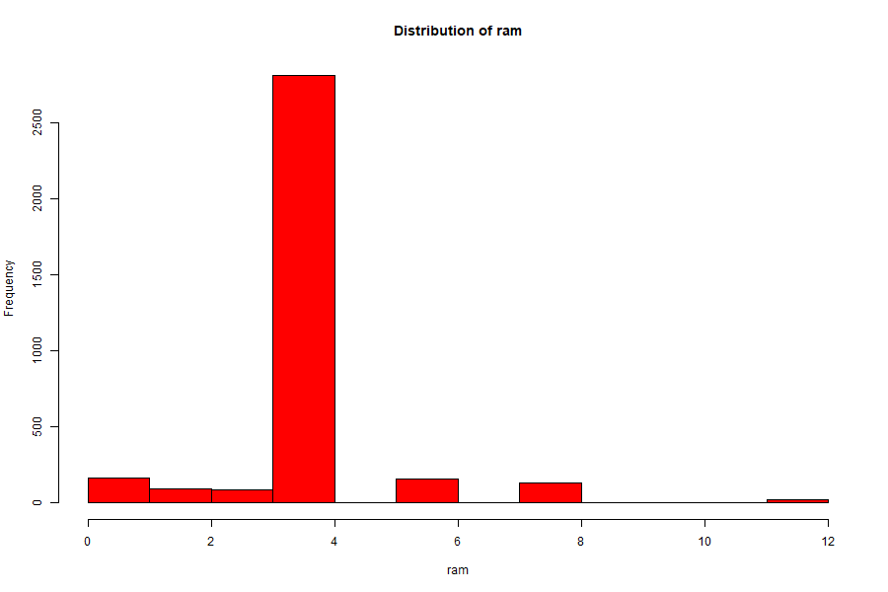

Fig15: Distribution of RAM in GB

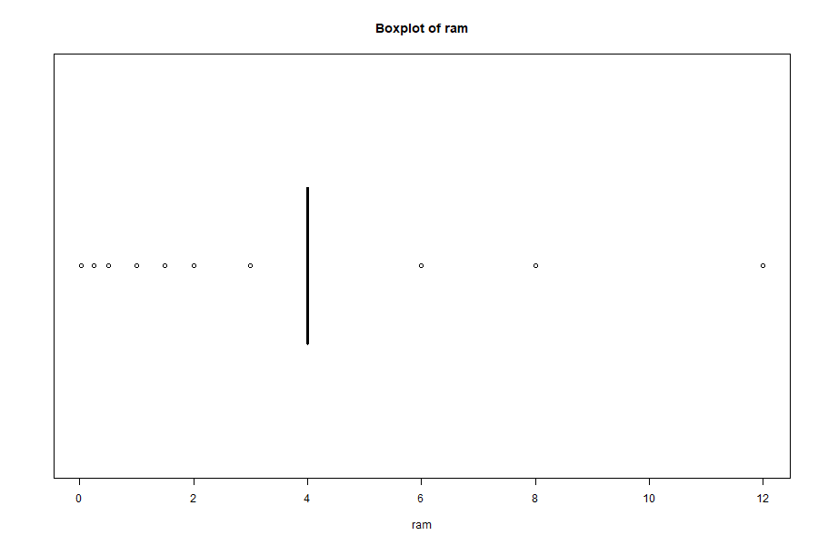

Fig16: Boxplot of RAM in GB

**Weight (grams):**

* Most devices weigh 120–250 g, which is the modern smartphone range.
* Histogram shows right skewness with several heavier outliers (above 400 g), possibly tablets.
* Boxplot highlights that while most phones fall within a narrow band, extreme values exist.

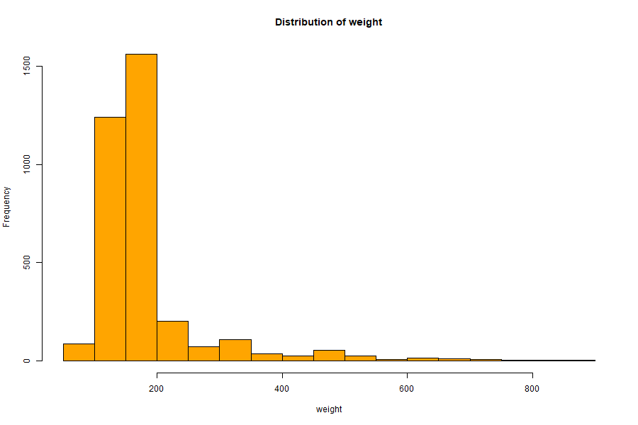

Fig17: Distribution of Weight in Grams

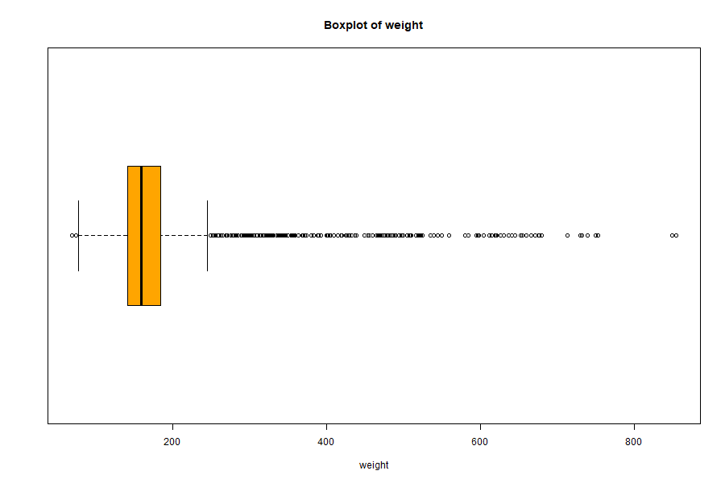

Fig18: Boxplot of Weight in Grams

**Release Year:**

* Devices are mainly released between 2013 and 2020.
* Peak releases occurred in 2014 and 2015, with consistent representation throughout 2019.
* Ensures dataset reflects both older and recent generations.

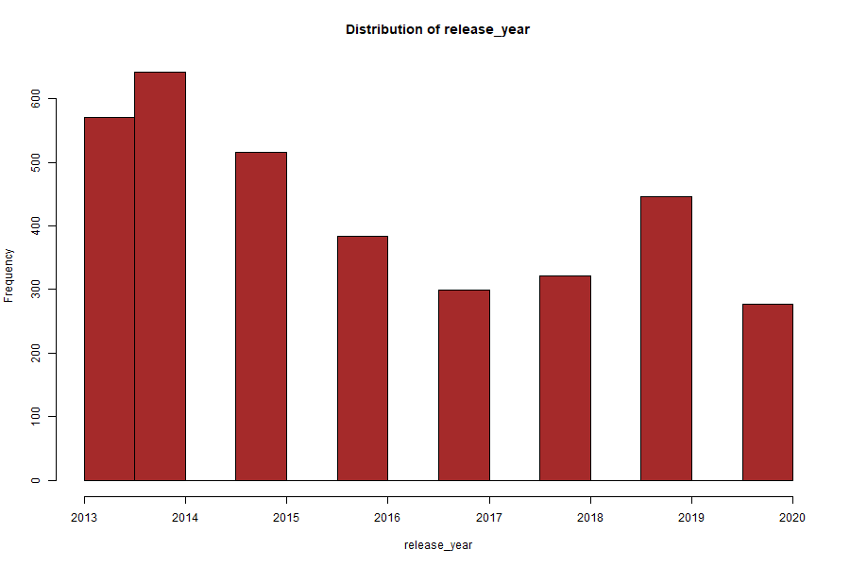

Fig19: Distribution of release of each smartphone in year.

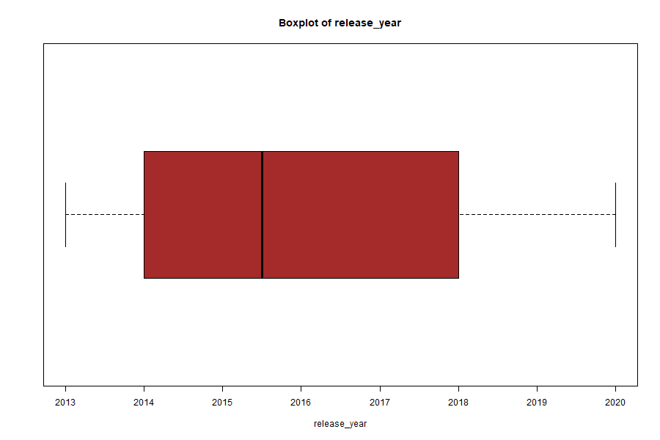

Fig20: Boxplot of release years of smartphones

**Screen Size (inches):**

* Most devices fall between 12–16 cm (~5–6.5 inches).
* Outliers include very small (<10 cm) and very large (>20 cm) screens.
* Histogram shows clustering at 13–15 cm, which is the modern standard size.
* Boxplot highlights a few extreme devices with exceptionally large screens.

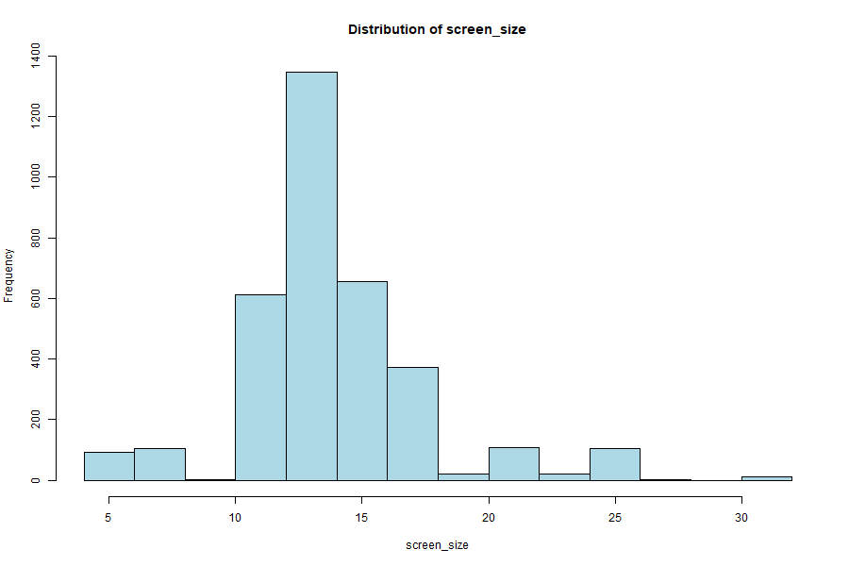

Fig21: Distribution of screen size in inches.

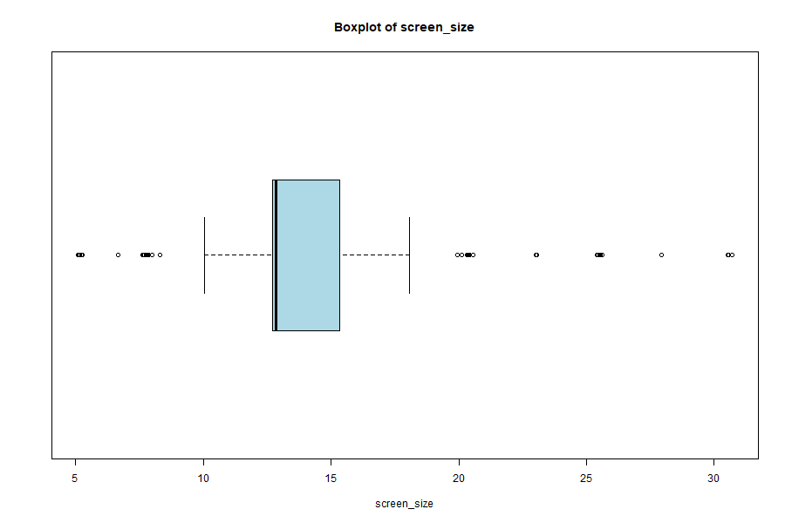

Fig22: Boxplot of screen size in inches.

**Normalized New Price:**

* Histogram follows a bell-shaped curve centered at ~5 (scaled).
* Outliers above 7 reflect premium flagship phones.
* Budget phones fall below 4.
* Boxplot confirms symmetrical spread with both high- and low-price outliers.

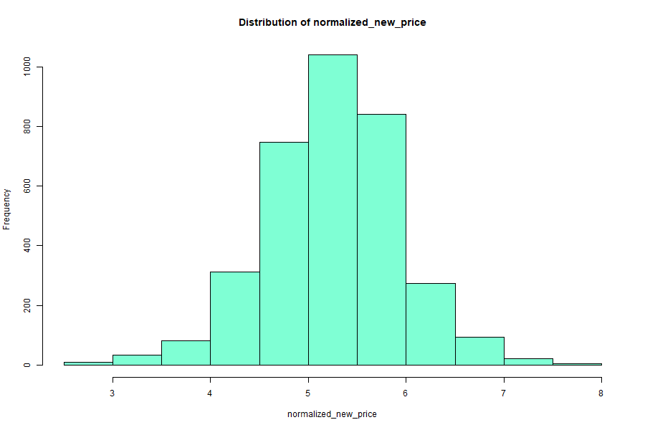

Fig23: Distribution of normalized new price of smartphones

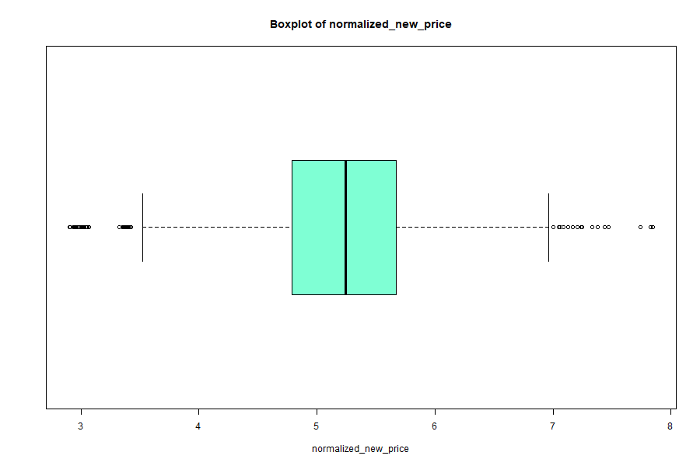

Fig24: Boxplot of normalized new price of smartphones

**Normalized Used Price:**

* Median resale price ~4–4.5 (scaled).
* Outliers below 2 reflect low-value older devices.
* Outliers above 6 correspond to premium flagships that retain better resale.
* Histogram shows slight right skewness but a compact central cluster.

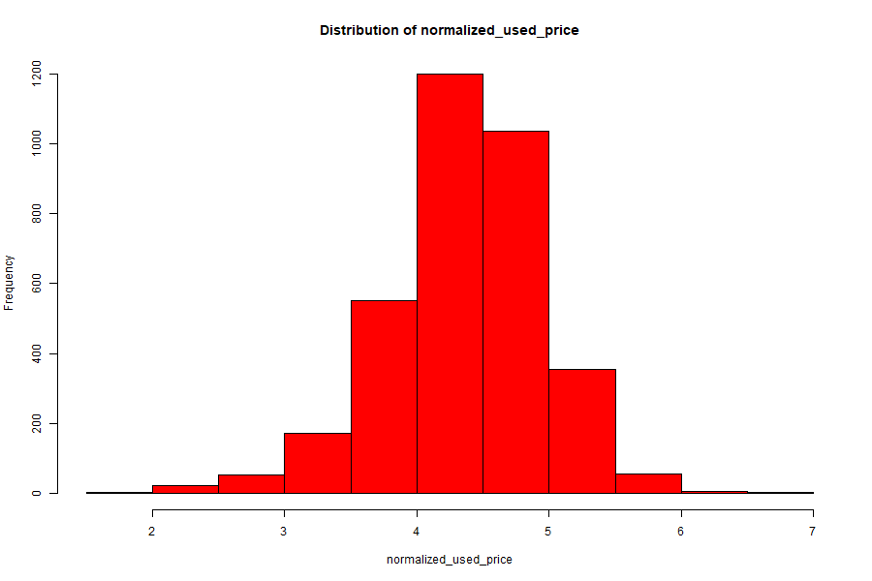

Fig25: Distribution of normalized used price of smart phones

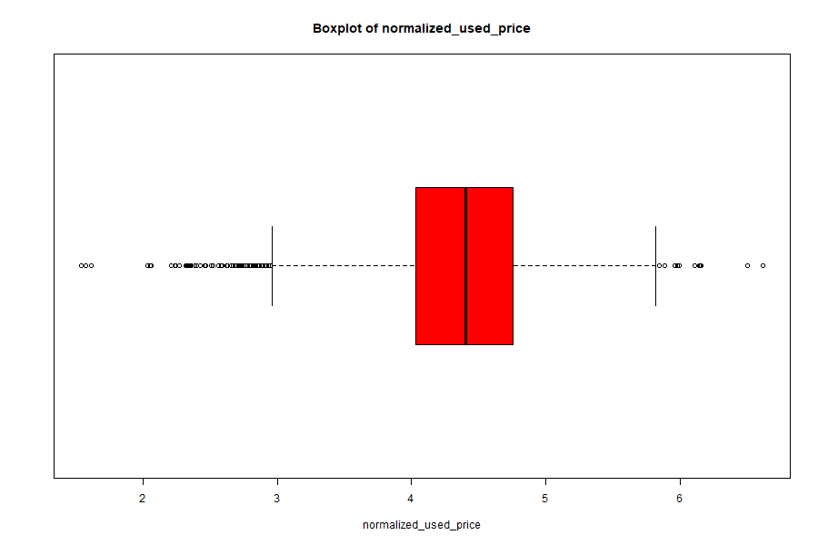

Fig26: Boxplot of normalized used price of smartphones

**3.4 Correlation Insights:**

The pairs plot indicates strong positive correlations:

* Internal memory and RAM with normalized prices.
* Battery capacity and weight show moderate correlation.

Confirms that specifications strongly drive resale pricing.

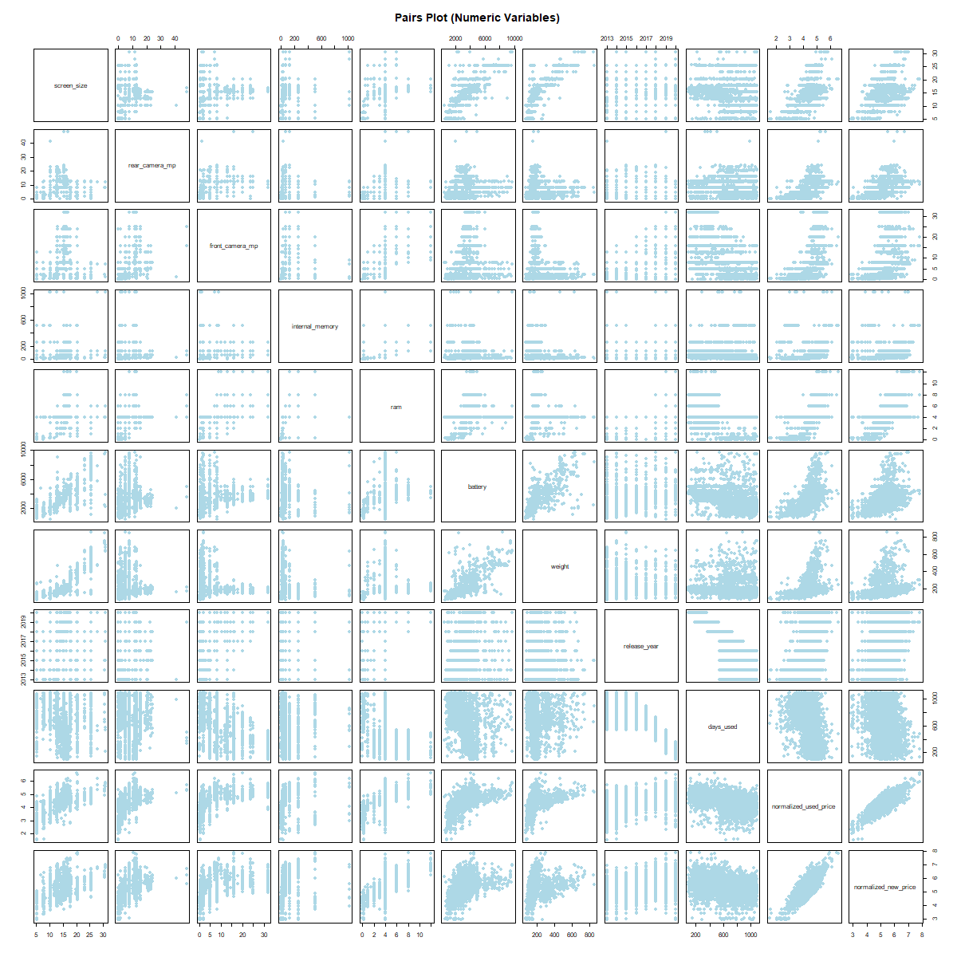

Fig27: Pair Plots for correlation Insights

The pairs plot gives a clear picture of how the smartphone features move with price. Normalized new price and normalized used price form the tightest upward line, confirming the new price as the strongest anchor for resale value. Memory and RAM also trend upward against both price measures, with step-like bands reflecting common storage tiers (16/32/64/128 GB) and RAM tiers; devices on higher tiers consistently sit at higher used-price levels. Camera megapixels and screen size show positive slopes as well, indicating that better cameras and larger displays tend to command higher resale prices. Release year rises with price, while days used tilts downward, matching real-world depreciation. Battery and weight move together and show moderate positive association with price; heavier phones likely carry larger batteries or more premium builds, which map to higher value. The scatter clouds widen slightly at the top end, hinting at greater variability among premium devices, and a few distant points suggest potential outliers worth checking.

These visual patterns guide both modeling and business use. Strong, mostly linear trends support regression for point price estimates, while visible feature interactions and tiering justify models that can capture nonlinearity (e.g., random forests) as a cross-check. Noticeable co-movement among normalized new price, internal memory, and RAM points to multicollinearity; a linear model can still perform well, but coefficient interpretation should favor anchors and avoid double-counting closely related specs. The spread differences and tiered bands also explain why standardization is essential for distance-based k-NN, and why simple, interpretable logistic regression can cleanly separate “High” vs “Low” price bands for quick triage. For pricing policy, the picture aligns with market logic: newer models with larger storage, better cameras, and bigger screens deserve higher quotes, while heavy prior usage should pull prices down.

* 1. **Data Quality Checks and handling.**
* **Checking Missing values:**

A few fields include missing values, such as rear_camera_mp = 179 NAs, front_camera_mp = 2 NAs, and battery = 6 NAs. Imputation or exclusion will be necessary for these.

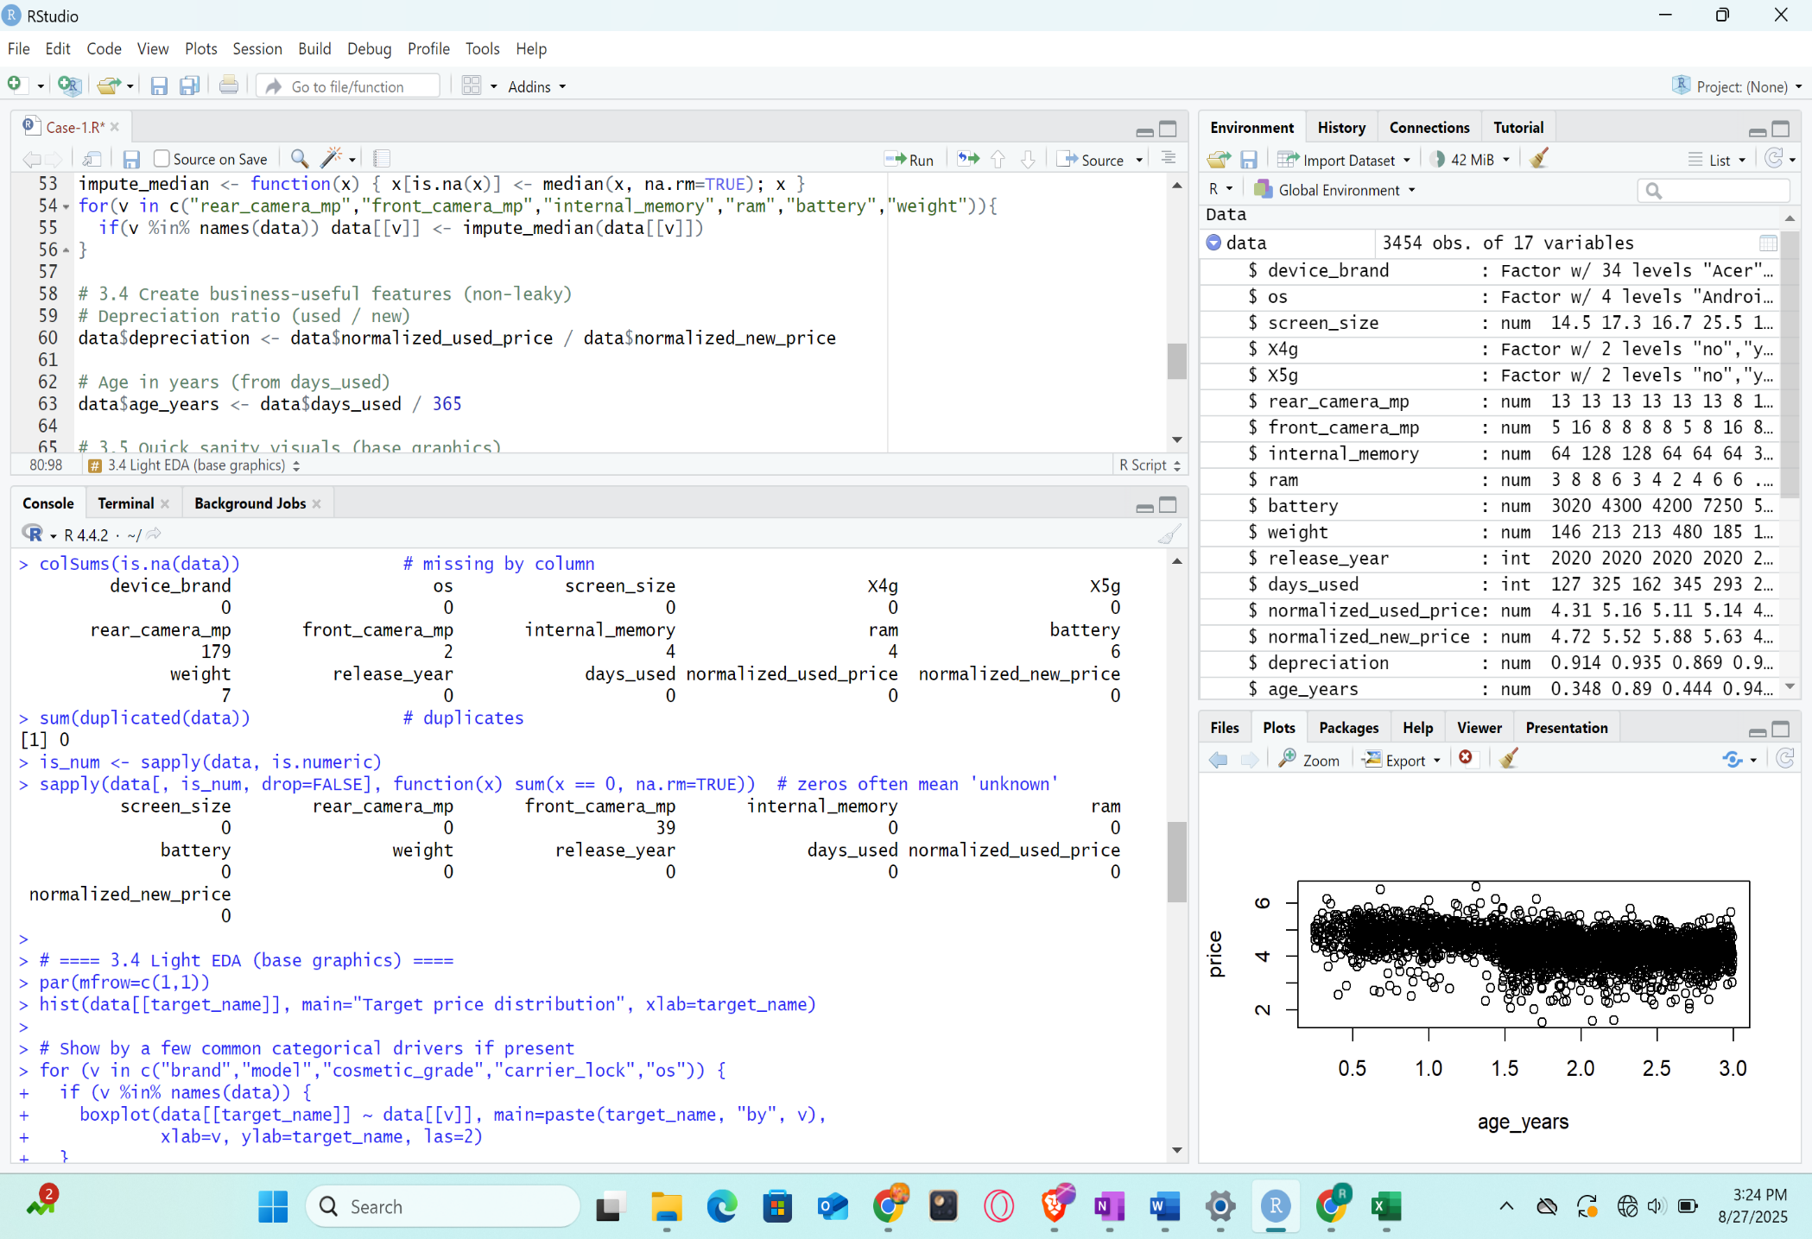

Fig28: Missing values and zeroes

* **Handling Missing values:**

The above missing values are handles as follows,

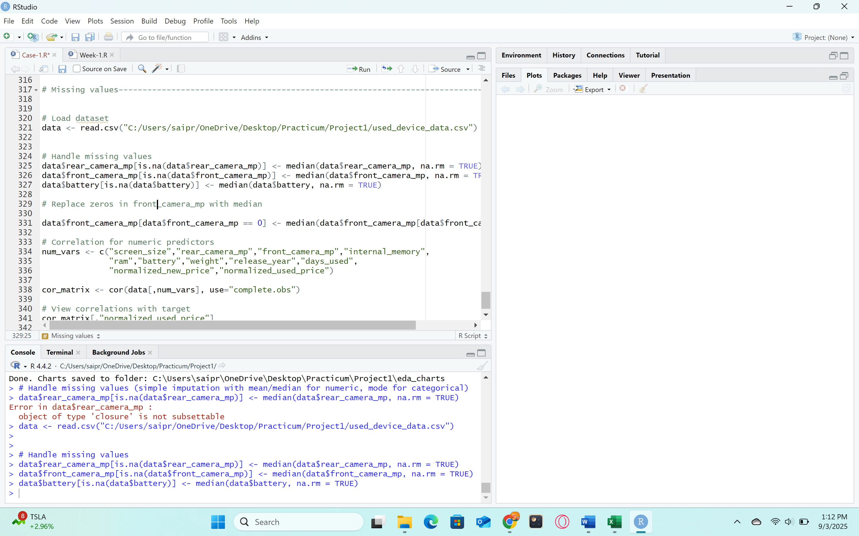

Fig29: Handling Missing values

* **Checking Zeros:**

39 instances of 0 were found in front_camera_mp as seen in fig28; these could be non-camera or missing models. Since zeros might signify either missing data or the absence of a feature, they should be handled carefully.

* **Handling Zeros:**

As we found zeros in attribute front_camera_mp, we replace those zeros with the median value in that attribute to maintain the data with same resultant value.

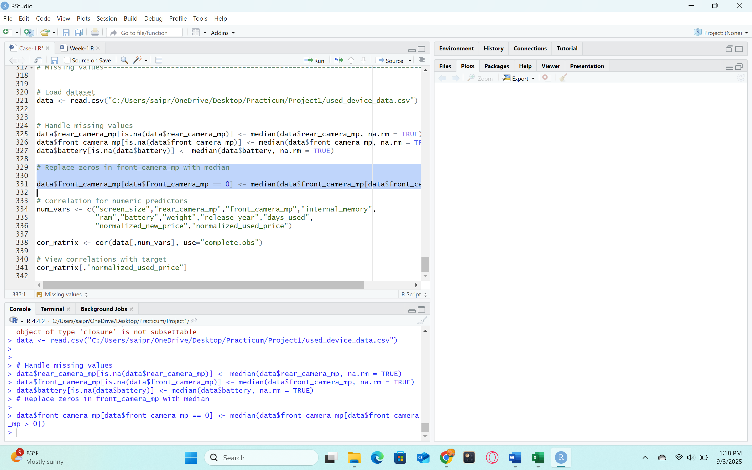

Fig30: Handling zeroes.

* **Checking for Duplicate Values:**

No duplicates were found.

* **Checking if Data types are accurate:**

Numerical and categorical data types were shown to be accurate.

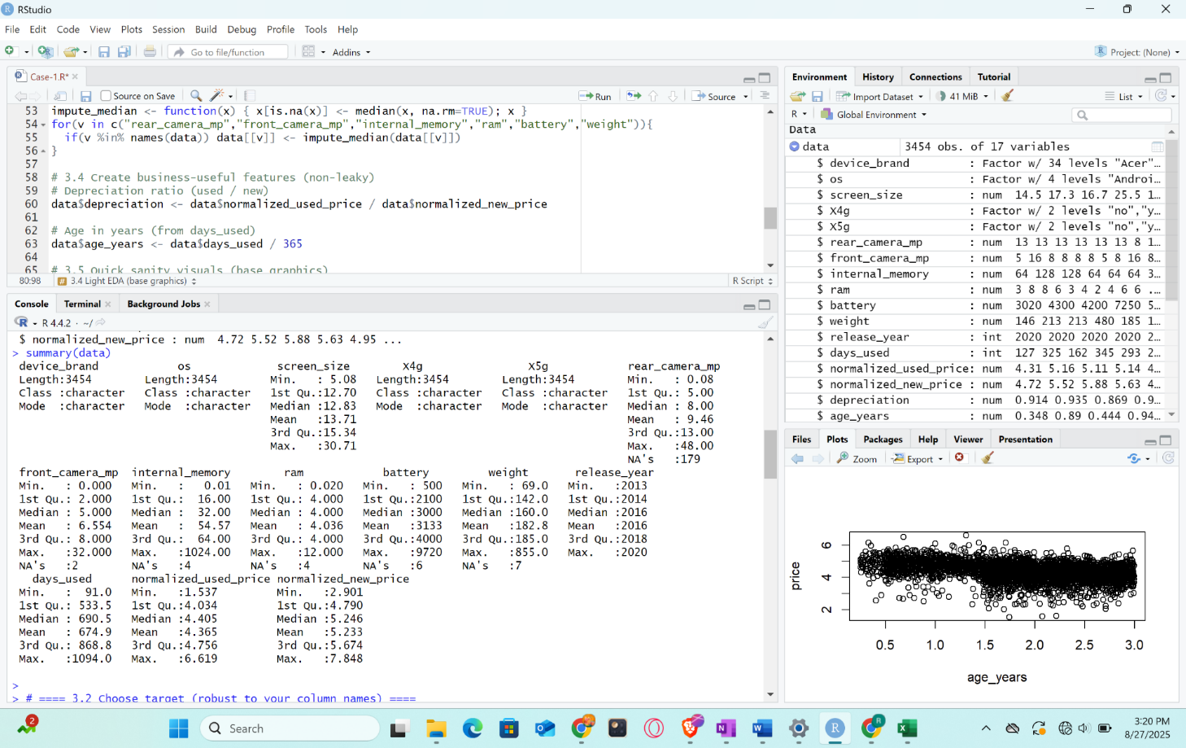

Fig31: Summary of the Data

**3.5 Exploratory Observations**

• The target variable (normalized_used_price) has a distribution that is skewed but roughly normal, ranging from about 1.5 to 6.6. shows the fluctuation of resale markets.

• The connection between age and days_used: The depreciation trend is confirmed by the obvious negative correlation—older equipment have lower normalized used pricing that is when used smartphones when are really old are having low prices.

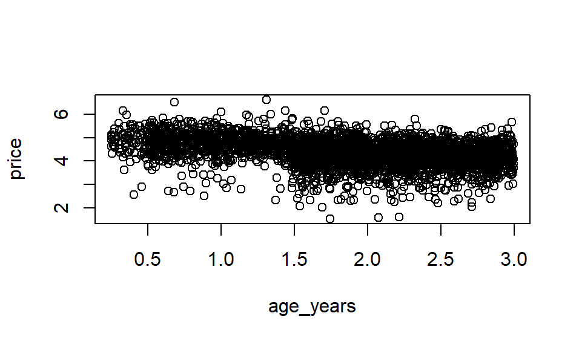

Fig32: Exploratory observation between age and normalized used prices of smartphones

* **Other predictors:**
* Higher internal memory and RAM are associated with higher resale value.
* Greater value retention is demonstrated by larger batteries and high-end brands (such as Apple and Samsung).
* When compared to devices that solely use 4G, the presence of 5G raises the normalized used price.
  + 1. **Predictor Analysis and Relevancy**

With the help of predictor analysis, one can determine which variables are most pertinent for predicting the target variable, normalized_used_price. The most important variables can be chosen to create efficient and interpretable models by assessing the connection between predictors and the target.

**4.1 Predictor Relevancy for Regression Model**

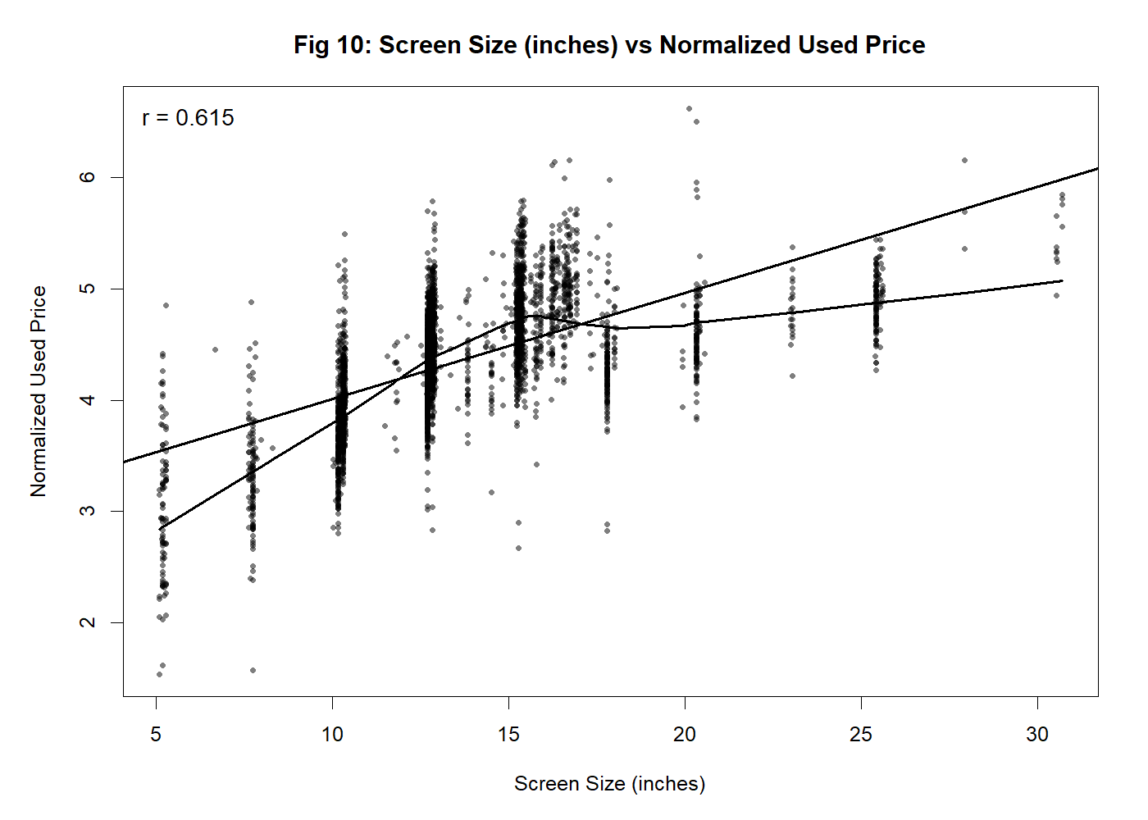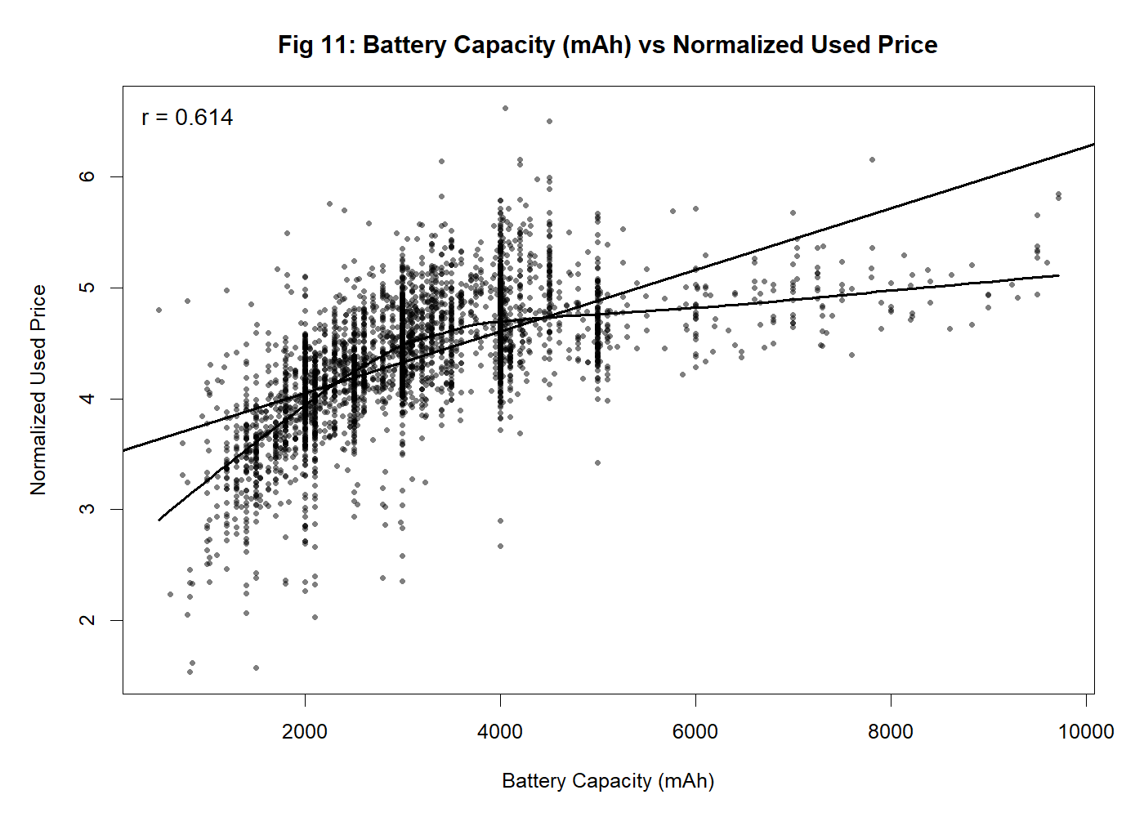

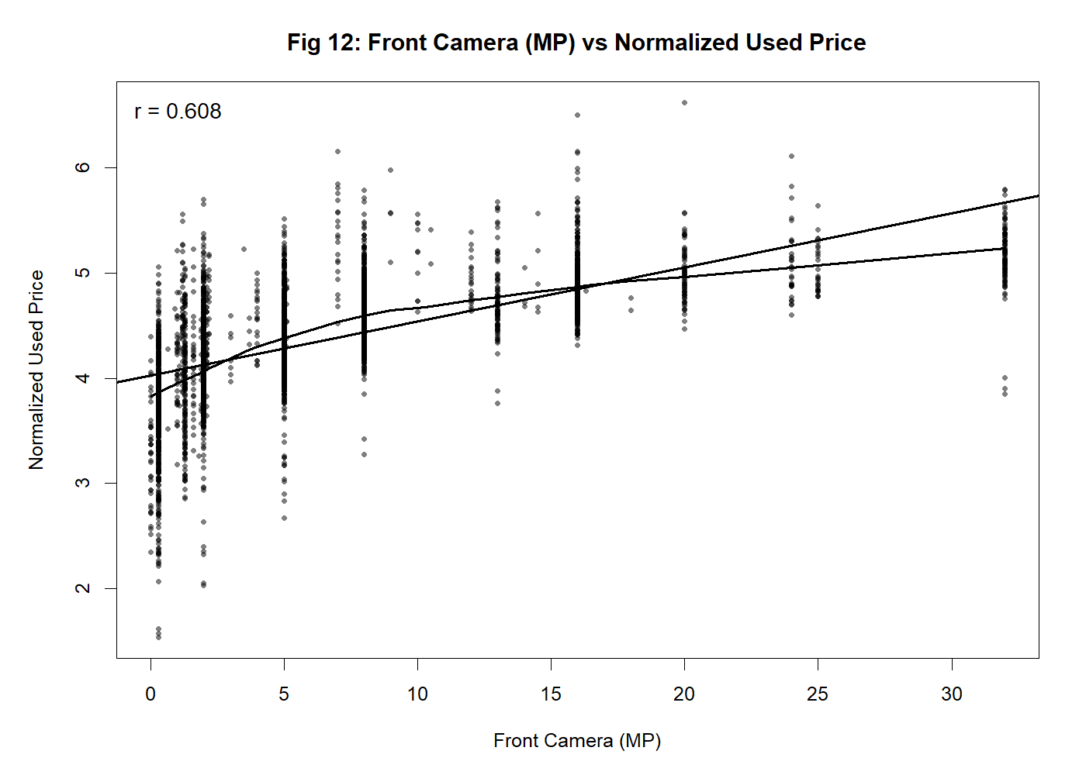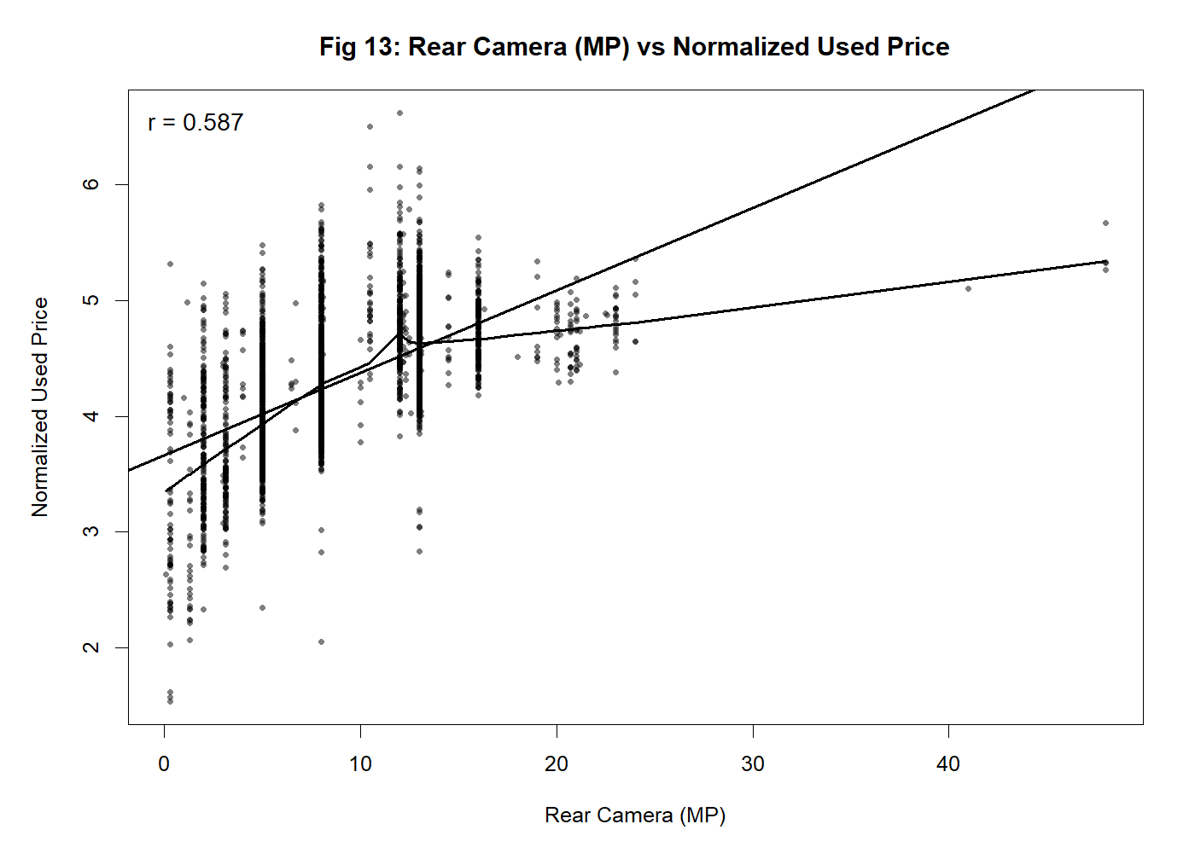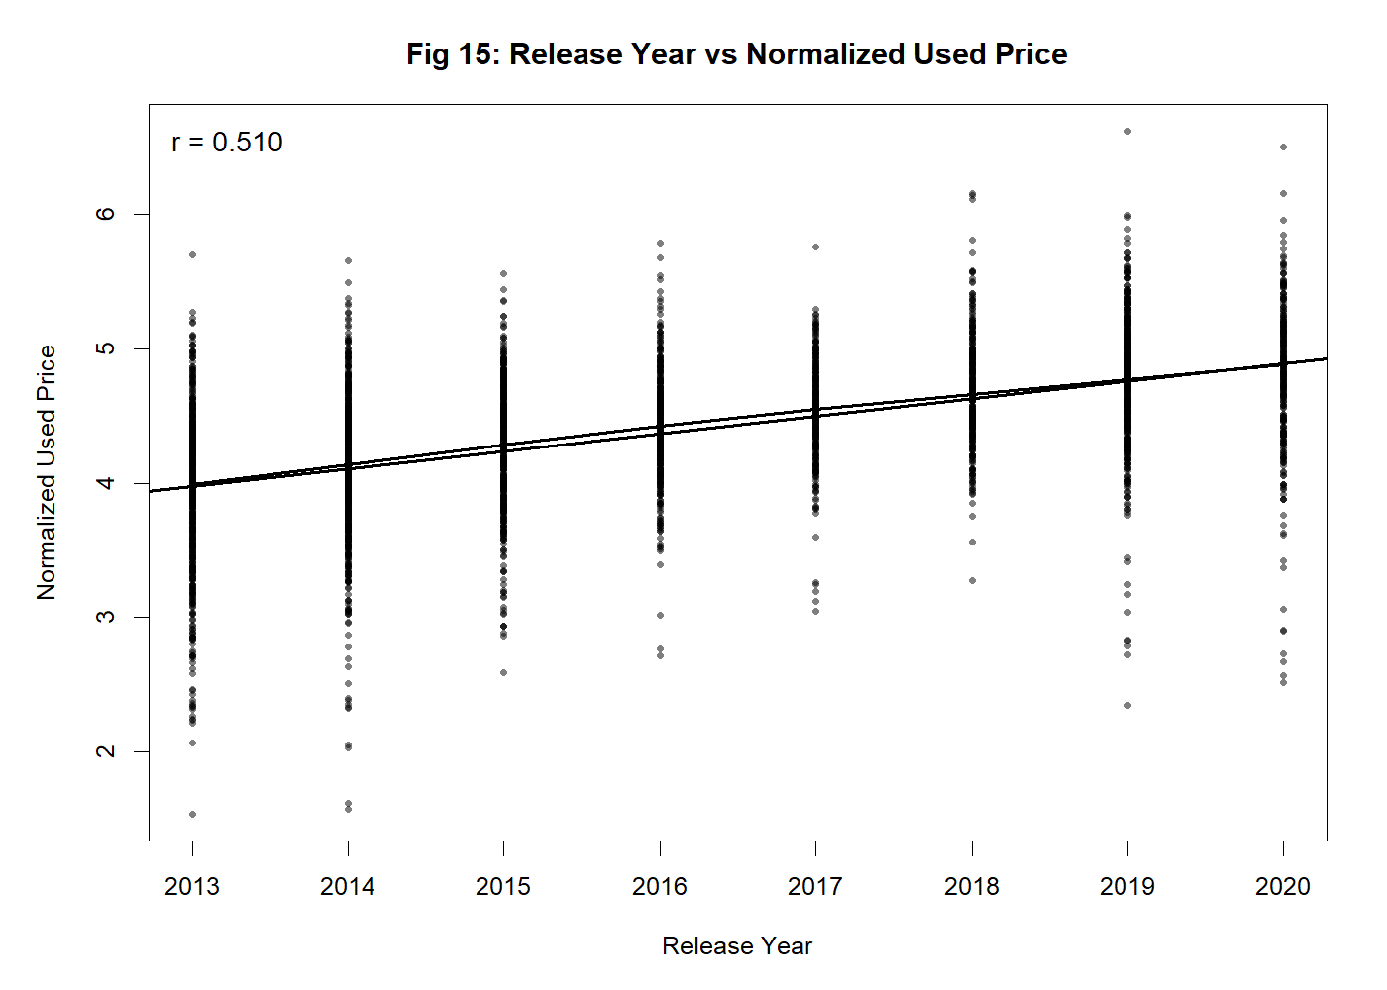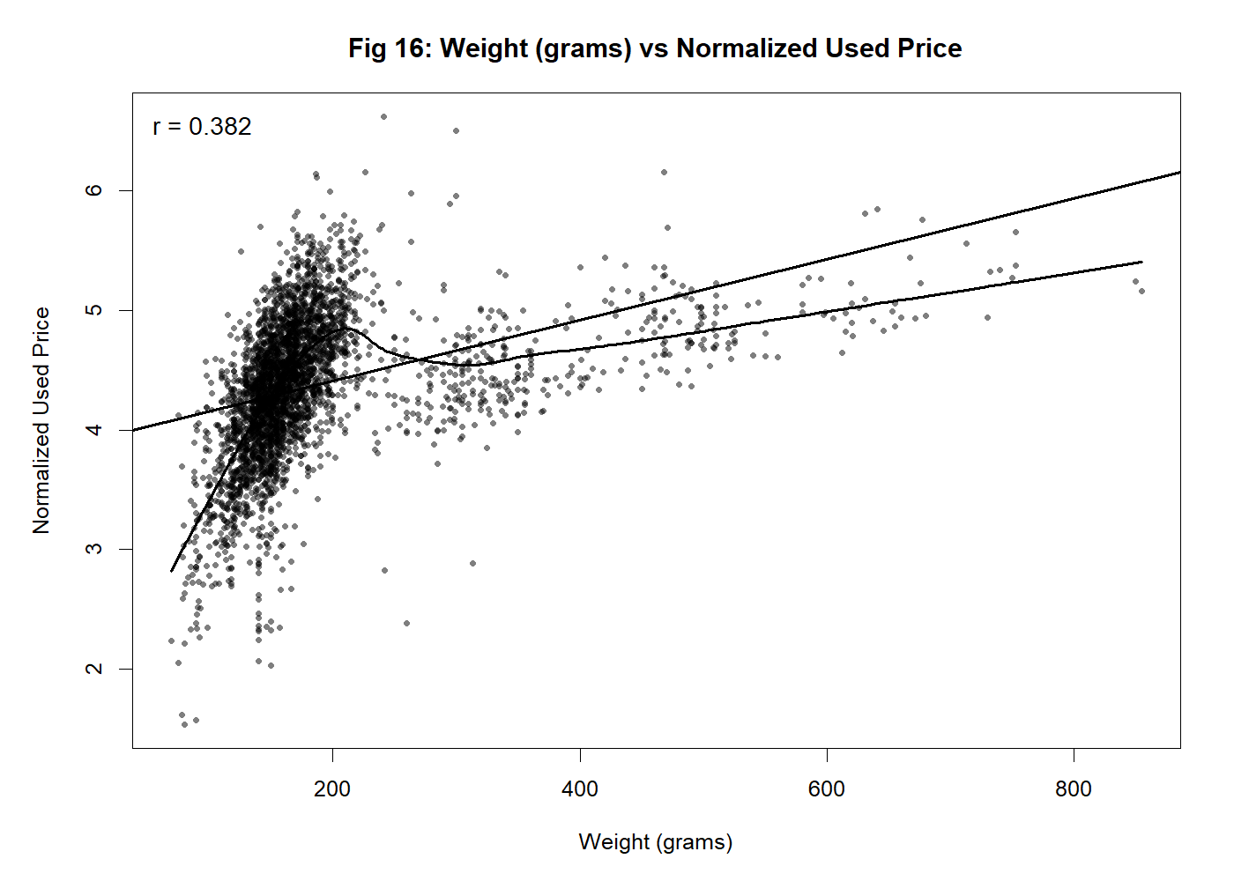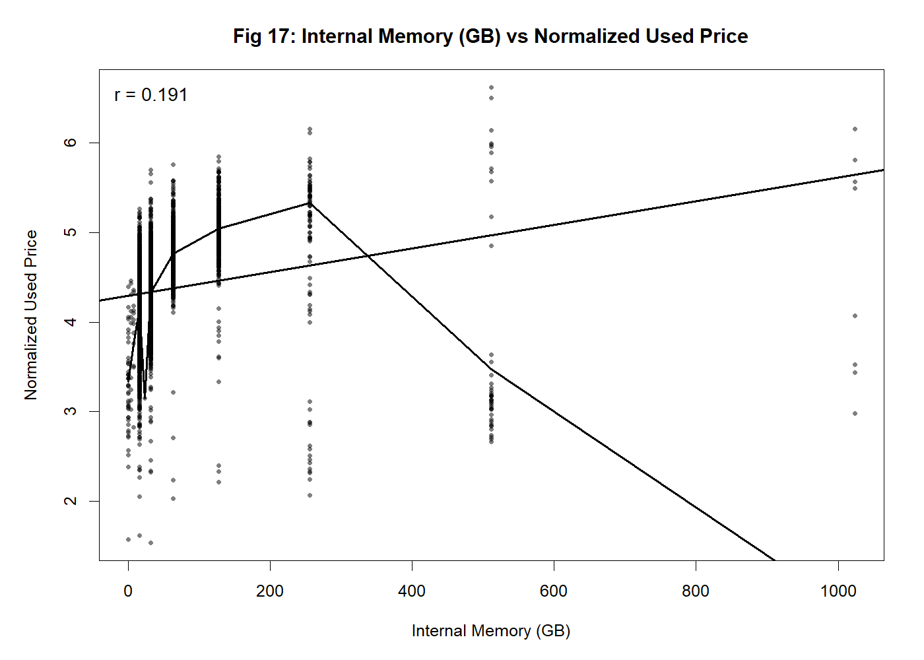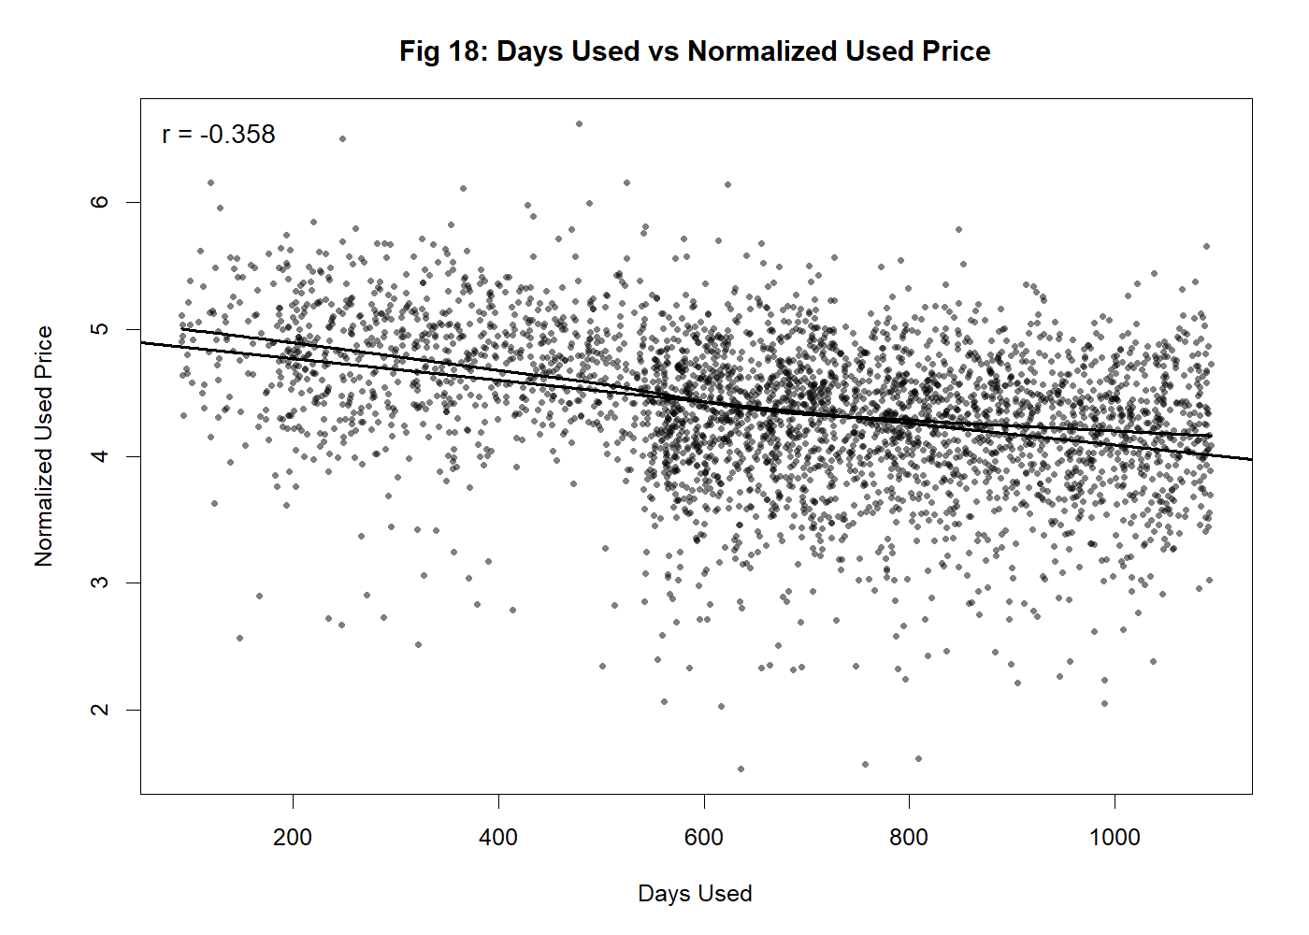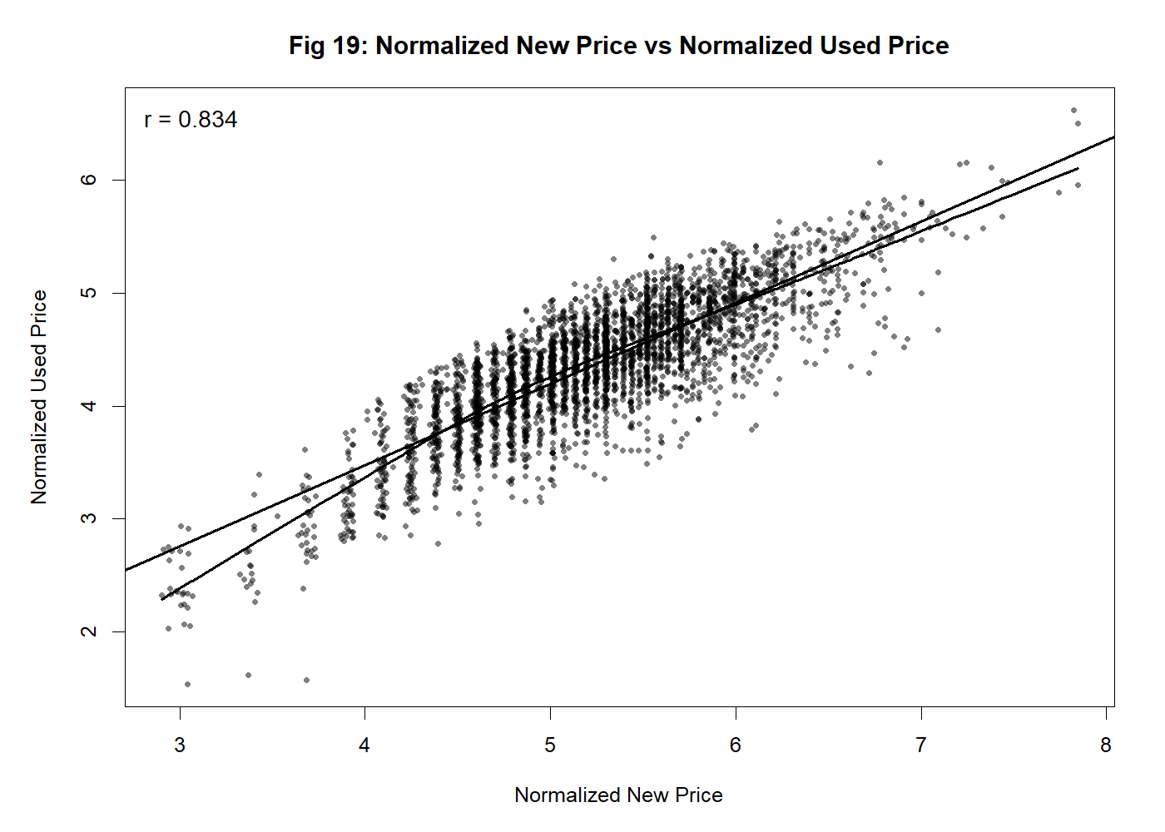

Fig33: screen_size, battery, front_camera_mp, rear_camera_mp, release_year, weight, internal_memory, days_used vs normalized_new_price

Screen Size vs. Normalized Used Price

A positive correlation (r = 0.615) is observed. As screen size increases, resale value rises. The trend line shows a steady upward pattern, confirming that larger displays, typical of modern premium phones, hold greater resale value.

Battery Capacity vs. Normalized Used Price

Battery capacity correlates strongly with resale value (r = 0.614). The scatter plot shows that devices with higher battery capacities retain higher prices, with the curve flattening at very high capacities (>6000 mAh). This suggests diminishing returns beyond typical modern batteries.

Front Camera MP vs. Normalized Used Price

Front camera quality shows a strong positive correlation (r = 0.608). The relationship indicates that selfie-focused devices are priced higher in resale markets. Although variation exists, the overall upward trend highlights the importance of front-facing camera technology.

Rear Camera MP vs. Normalized Used Price

Rear camera resolution also contributes positively (r = 0.587). Higher megapixel counts, especially in flagship devices, correlate with increased resale value. The spread of points confirms technological advancements in smartphone cameras significantly affect pricing.

RAM vs. Normalized Used Price

RAM exhibits a strong relationship (r = 0.520). Devices with higher RAM consistently sell for more, reflecting consumer preference for performance and multitasking capability.

Release Year vs. Normalized Used Price

The correlation (r = 0.510) shows that newer models generally retain higher resale prices. The trend is clear across devices released between 2013 and 2020, aligning with typical depreciation cycles in technology.

Weight vs. Normalized Used Price

A moderate correlation (r = 0.382) exists between device weight and resale value. Heavier devices often contain larger batteries or premium materials, slightly boosting their resale appeal. However, the relationship is weaker compared to technical specifications.

Internal Memory vs. Normalized Used Price

Internal memory has the weakest positive correlation (r = 0.191). While devices with larger storage options (128 GB or above) do show higher resale, the scatter plot suggests inconsistency. This indicates that internal memory alone is not a strong driver of resale prices.

Days Used vs. Normalized Used Price

A negative correlation (r = -0.358) confirms depreciation over time. The scatter plot shows a downward trend, with resale value decreasing steadily as usage days increase. This reflects the natural aging process of smartphones in the secondhand market.

Normalized New Price vs. Normalized Used Price

The strongest correlation (r = 0.834) is with the original retail price. The scatter plot displays a near-linear relationship, confirming that new price is the single most important predictor of resale value. It serves as the baseline reference for depreciation calculations.

* + 1. **Dimension Reduction**

Reducing the dimensionality of data is an important aspect of data preprocessing, especially when there are correlations among several predictors. It aids in the elimination of redundant and less relevant variables, enhancing model efficiency while preserving vital information. The primary objective is to reduce the number of features while maintaining predictive power.

**5.1 Dimension reduction for regression:**

**Correlation Analysis:**

To investigate the connections between smartphone attributes and the target variable, normalized_used_price, a correlation analysis was performed. Figure 34: Correlation Matrix of Smartphone Attributes shows the results.

A correlation threshold of |r| > 0.20 was used. This made certain that only variables with significant predictive relationships were considered for regression modeling.

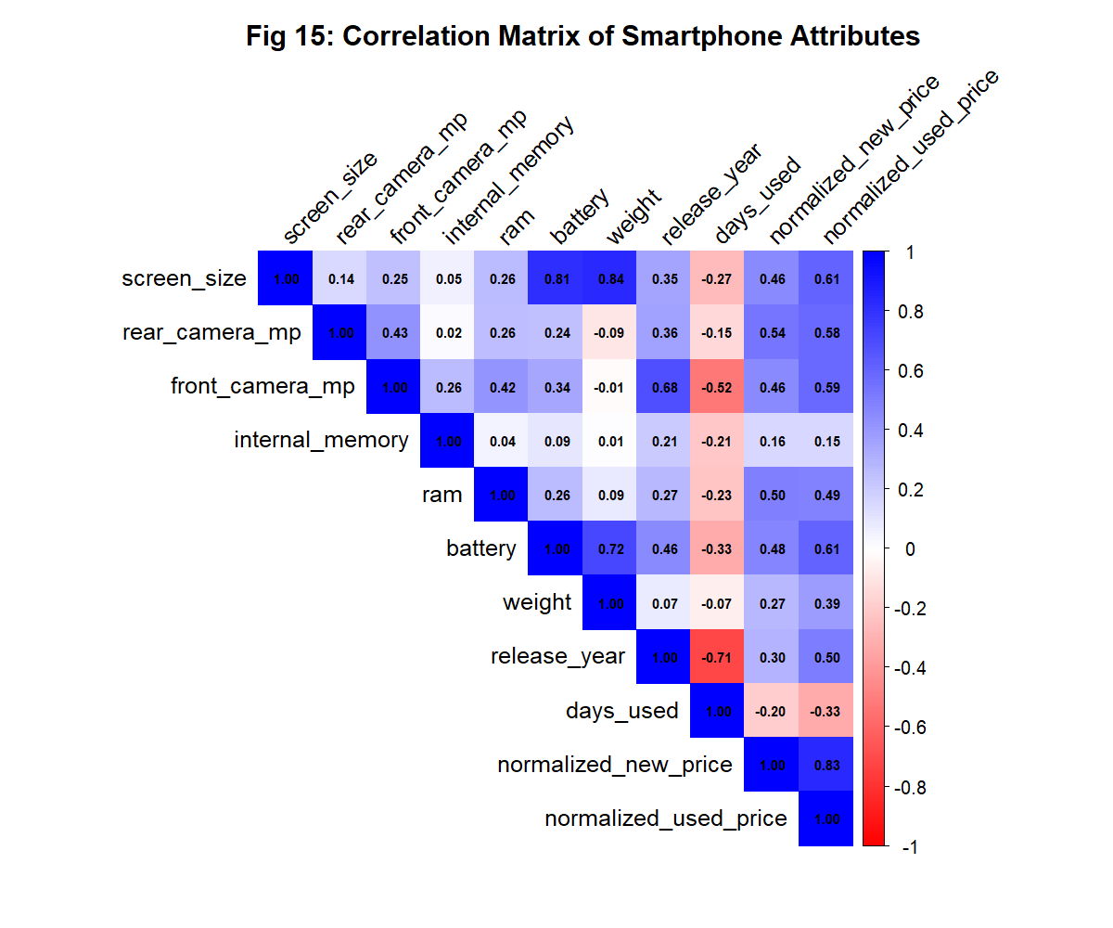

Fig 34: Correlation Matrix of Smartphone Attributes

**Selected Variables (|r| > 0.20):**

The following variables met the threshold criteria and were retained for further analysis based on their significant correlation with normalized used price:

* Normalized New Price (r = 0.83): The most robust predictor, directly associated with resale value.
* Screen Size (r = 0.61): Exhibits a strong correlation with resale, mirroring trends of premium devices.
* Battery Capacity (r = 0.61): There is a positive correlation, since larger batteries enhance value retention.
* Front Camera MP (r = 0.59): A strong predictor that corresponds with consumer demand for selfie performance.
* Rear Camera MP (r = 0.58): The quality of the camera plays a major role in boosting resale value.
* RAM (r = 0.52): Enhanced RAM boosts usability and resale value.
* Release Year (r = 0.50): Naturally, newer phones are worth more.
* Weight (r = 0.39): There is a moderate correlation, indicating that heavier devices are associated with premium build quality.
* Days Used (r = -0.33): This shows a negative correlation, which affirms that as time passes, depreciation occurs.

**Removed Variables (|r| ≤ 0.20):**

The following variables had weak correlations and were excluded from the analysis: Internal Memory (r = 0.15): This reflects a weak correlation, indicating that storage alone is not a significant factor affecting resale. The regression model becomes more efficient and interpretable by excluding less significant predictors like internal memory and concentrating on the most pertinent variables. By removing variables with weak correlations, the model focuses on attributes that have a substantial impact on normalized used price.

**Removing Empty Rows and Columns:**

No empty rows and columns were found to remove.

* + 1. **Data Transformation**

Data transformation is used to make the data easier to work with and to improve the accuracy of the models. Data transformation is needed to make the data more suitable for analysis and modeling. Raw data often comes in different formats, scales, or distributions that can cause problems for machine learning models. Transforming the data, such as normalizing values or converting categories into numbers, ensures that all features are on a similar scale and can be compared fairly. It also helps in improving model accuracy, reducing bias, and handling skewed or non-normal distributions. This step prepares the data so that the patterns and relationships between variables can be captured more effectively.

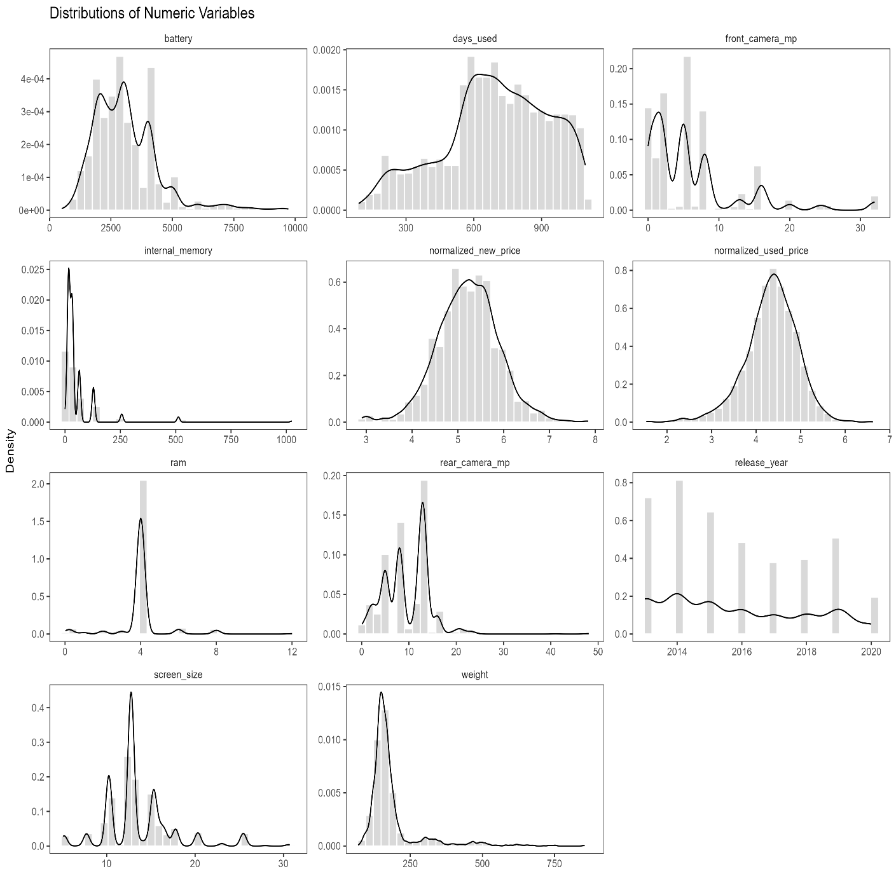

Fig 35: Distributions of Numeric Variables

* 1. **Kernel density estimation (KDE) by Kdeplot of the numeric columns**

Kernel density estimation (KDE) was included to visualize the continuous shape of each numeric variable without assuming normality. KDE helps reveal skew (e.g., long right tails in battery or memory), multi-modality (clusters of devices around common spec tiers), and outliers. These distribution cues inform several downstream decisions: whether transformations or robust statistics are needed, whether median imputation is safer than mean for skewed fields, whether linear models are likely to see non-normal residuals, and whether distance-based methods require standardization. The evaluator specifically asked to state the purpose of KDE or remove it; the plots remain here because they justify scaling choices and model expectations.

The Q-Q plot displays data distribution in comparison to the predicted normal distribution. The observations should roughly fall on a straight line for data that is normally distributed. The points in a curve that deviates significantly from a straight line are indicative of non-normal data. Points at the extremities of the line, far from many of the observations, could be outliers.

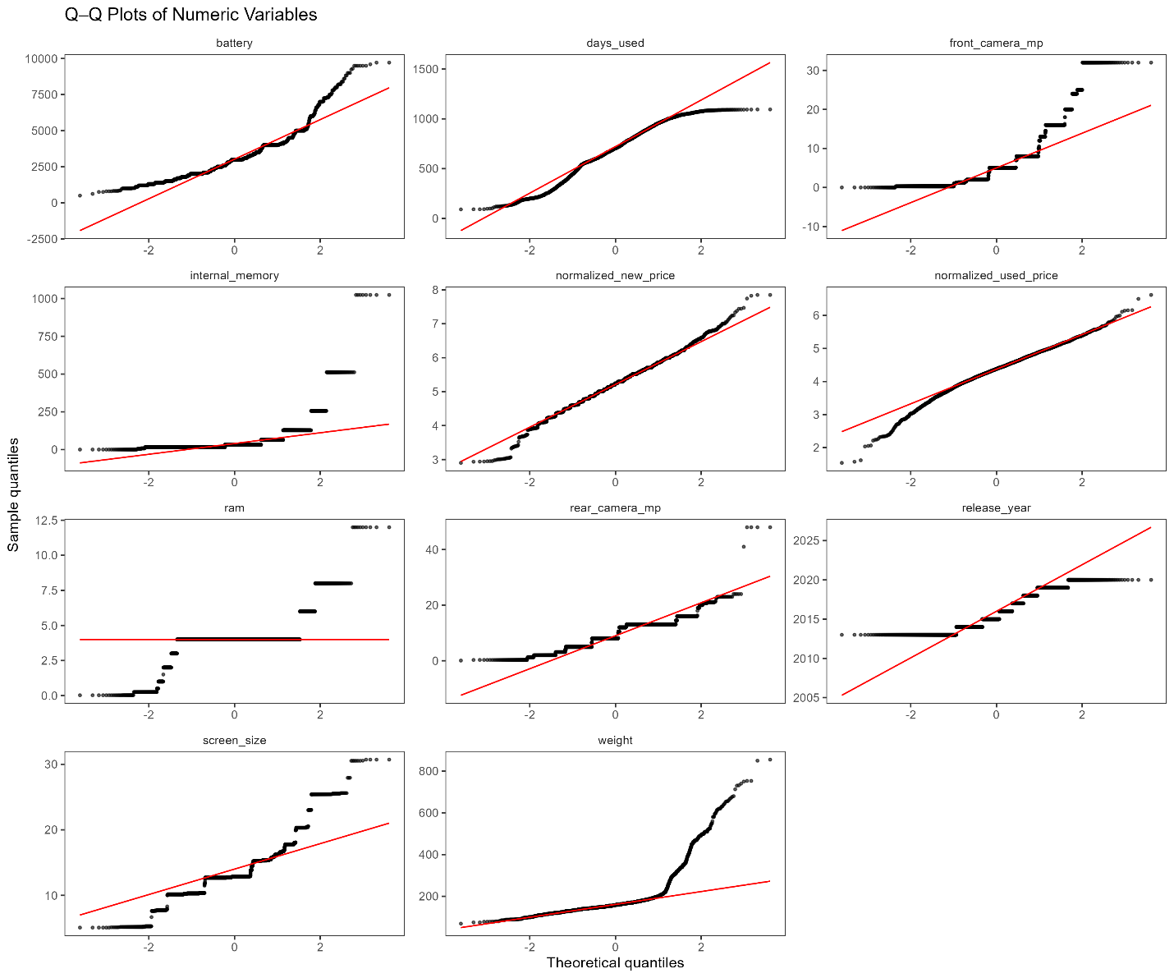

Fig36: Q-Q Plots of Numeric Variables

Except for the "normalized_used_price" and "normalized_new_price" columns, the numeric columns include non-normal distributions. It is time to normalize them.

s

* + 1. **Data Partitioning**

Training partition data is the portion of the dataset used to teach the model. The model looks at the input variables (like brand, RAM, battery, release year, etc.) and the output (normalized used price) and learns patterns between them. This is the data on which the model builds its understanding.

Validation partition data is used during the model building process to tune and improve the model. It helps in choosing the best parameters, avoiding overfitting, and comparing different models. For example, if several models are built (linear regression, decision tree, random forest), validation data helps decide which one performs better before testing on unseen data.

Test partition data is kept aside and used only at the end to evaluate how well the chosen model generalizes completely new data. It simulates how the model will perform in the real world when predicting prices for new incoming smartphones.

This splitting of the dataset into training and testing subsets helps to build robust model. This allows us to train the model on a portion of the data and evaluate its performance on unseen data.

The data set is divided into 3 sets:

* **Training Set (70%)** – used to fit the model.
* **Validation Set (15%)** – used to tune/compare models and avoid overfitting.
* **Testing Set (15%)** – kept aside until the end for an unbiased final evaluation.

This 70–15–15 split gives enough data to learn, enough to tune, and a clean hold-out to judge final performance. The validation set helps improve model performance before testing. We predict log_used_price. To keep the split balanced, we create simple bins of the target and sample within bins.

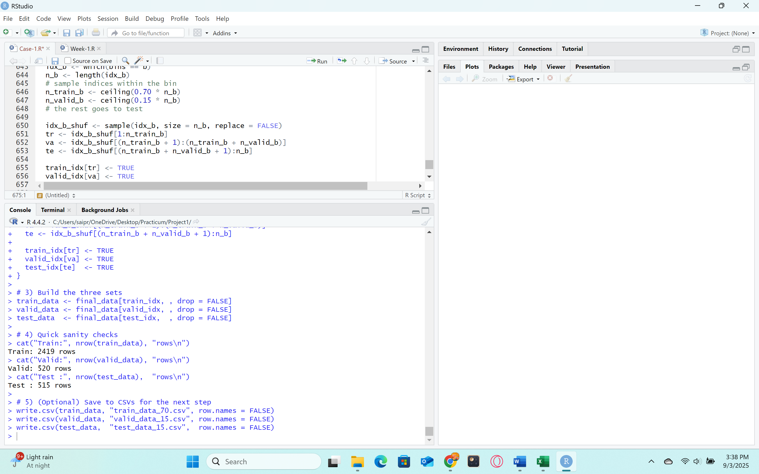

Fig37: Data Partition

**Normalization:**

To prevent information from leaking from validation or testing into training, standardization is carried out after partitioning. Standardized copies are prepared for models like KNN, where scaling is crucial. Since linear regression itself doesn't require standardized predictors, the model above uses unscaled data for interpretability.

**8. Algorithm Selection for the Goal**

Multiple algorithms were tested because different model families capture different types of structure and trade off bias, variance, and interpretability in distinct ways. A baseline linear model using normalized_new_price sets a transparent market anchor; a full Multiple Linear Regression adds additive effects from technical features to improve accuracy while preserving explainability. k-Nearest Neighbors offers a flexible, non-parametric alternative that can fit local patterns when similar devices behave alike, but it depends on proper scaling. Random Forest introduces nonlinearities and interactions automatically and is robust to noise and mixed data types, often improving fit when linear assumptions are violated. For the classification view (High vs. Low price band), logistic regression provides a simple probabilistic decision rule with clear coefficients, while a C5.0 decision tree yields readable rules and can reveal nonlinear thresholds. Testing a small, well-justified set enables fair comparison on the same validation split and supports a defensible recommendation.

Regression and classification serve the pricing goal in two complementary ways. Regression predicts the exact resale amount on a continuous scale, turning device features (RAM, battery, cameras, year, usage days, and new price) into a numeric estimate that can be used for quotes, budgeting, or revenue forecasts. Classification groups the same devices into clear price bands (for example, “High” vs. “Low”) so that intake teams, catalog managers, or sales channels can act quickly without needing a precise dollar value every time. The two outputs work together: the regression number provides the detailed estimate, while the classification label provides a fast decision aid for routing, tiering, or flagging exceptions. This approach also supports different operational needs—exact pricing for checkout and reporting, and risk-aware bands for screening and promotions. Using both views improves clarity for stakeholders and makes the pricing workflow faster, more consistent, and easier to audit.

**8.1 Model Fitting for Regression Algorithms:**

Model fitting is the process of training a chosen model using the available data. The model starts as a structure with empty parameters. By fitting, the model learns patterns and relationships between the input variables (such as screen size, RAM, battery, and camera quality) and the target variable (used smartphone price). The purpose of fitting is to find the best parameters or rules that minimize the error between predicted values and actual values. After fitting, the model becomes ready to make predictions on new smartphone data. The model fitting turns a general algorithm into a trained model that can estimate prices based on past smartphone information.

Model fitting is done on data and training setup using the cleaned dataset into 70% training, 15% validation, and 15% test. In place of a classification accuracy %, we use R² as an accuracy-like measure of fit and RMSE/MAE as error measures.

**9. Implementation of Each Algorithm:**

**9.1 Multiple Linear Regression:**

Multiple linear regression is selected to predict the normalized used price of a device from its technical specifications and age. This model quantifies how several predictors jointly relate to price and, because it is transparent, it lets us see which features matter most for valuation. This aligns directly with the goal to produce reliable, explainable price guidance for used smartphones. Among the most straightforward and uncomplicated predictive models is MLR. It assumes that the cost of a used phone can be accounted for by a weighted combination of factors including screen size, RAM, camera quality, battery life, and usage duration. Performs well as a baseline model to compare with more intricate methods.

For multi linear regression, two models are used one is baseline model with only one predictor, that is normalized_new_price only. Other models full numeric multi linear Regression model where all numerical columns, screen_size, cameras, internal memory, ram, battery, weight, release_year, days_used, normalized_new_price are projected as predictors. The reason for doing this is to view the difference between these two models, either linear or multiple regression to check out the performance as the predictor chosen for baseline model has highest correlation with the target variable. The ram column was automatically dropped by R due to perfect/near-perfect collinearity, this is expected as it does not affect fit.

Normalization is not adopted here because linear regression does not require feature scaling coefficients rescale accordingly. Reserving the normalization for distance-based models like KNN where scale truly matters. Keeping the raw numeric scale here makes the model easier to interpret.

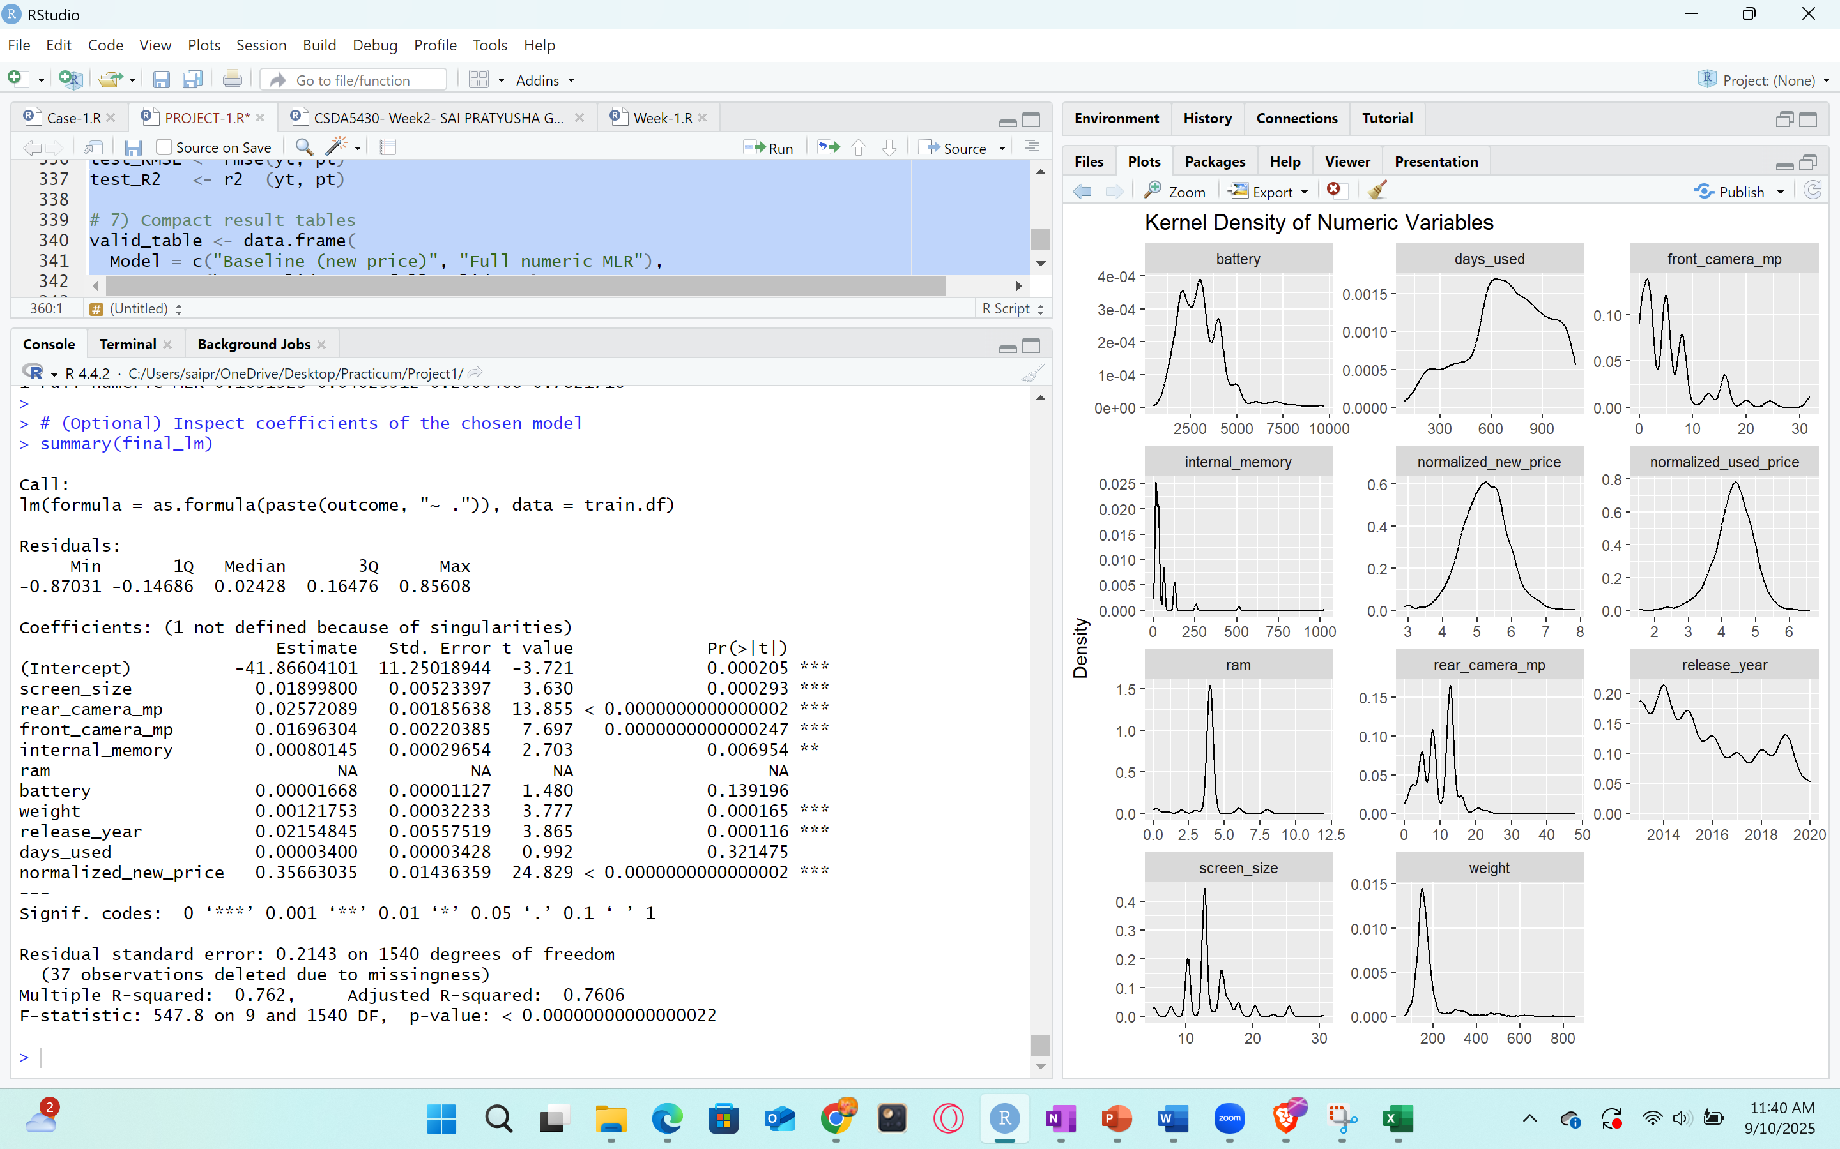

Fig38: Multiple Linear Regression Coefficients

**Evaluation metrics**

According tostandard regression metrics, lower the MAE/MSE/RMSE is better; higher R² indicates greater explanatory power.

**Validation (15%) Accuracy:**

Validation data is used during the model building process to tune and improve the model. It helps in choosing the best parameters, avoiding overfitting, and comparing different models. validation data helps decide which one performs better before testing on unseen data. In place of a classification accuracy %, we use R² as an accuracy-like measure of fit and RMSE/MAE as error measures.

* Baseline (new price only):  
  MAE = 0.2201, MSE = 0.0770, RMSE = 0.2775, R² = 0.6007
* Full numeric MLR:  
  MAE = 0.1633, MSE = 0.0406, RMSE = 0.2015, R² = 0.7862

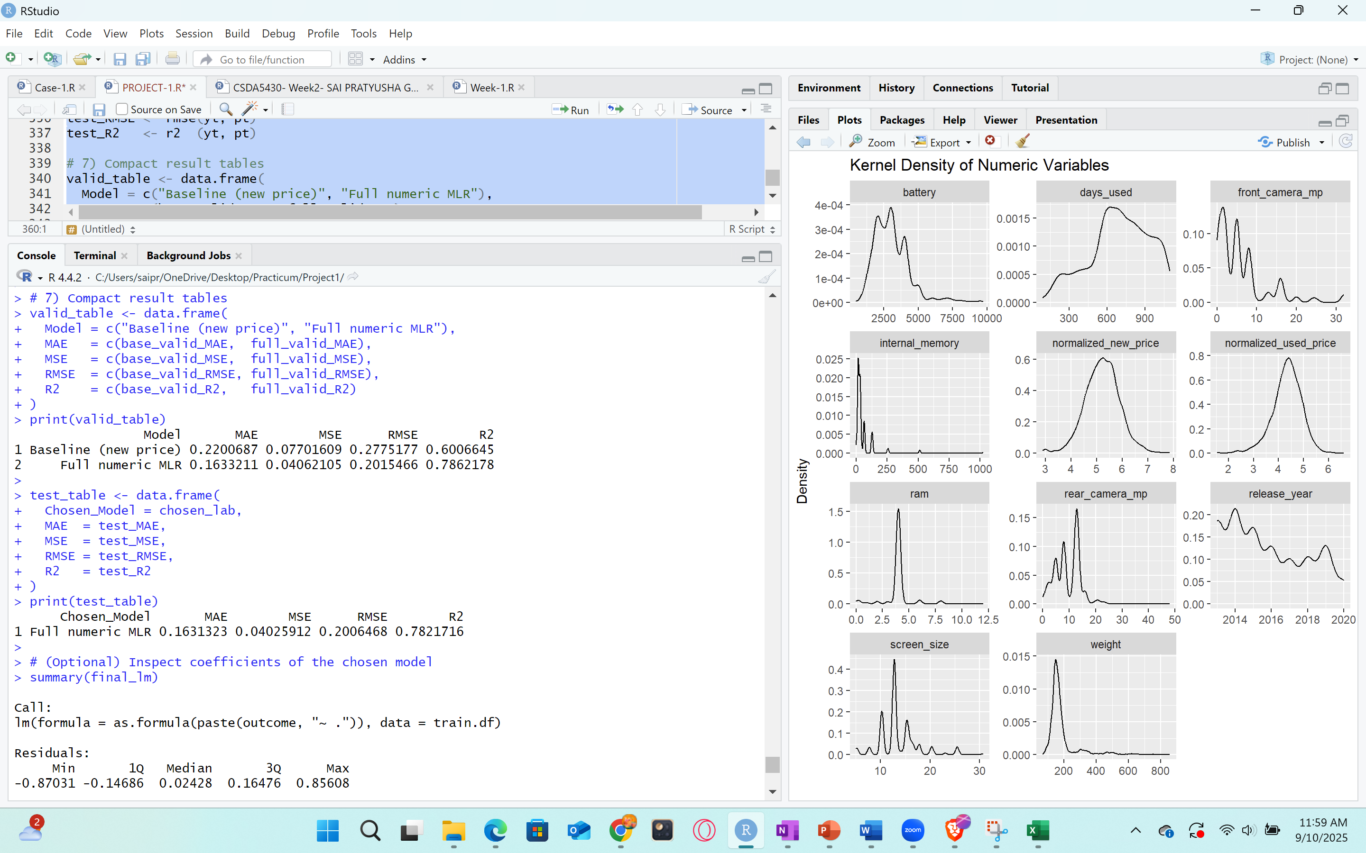

Fig39: Validation metrics of Multi-Linear-Regression.

After training on the 70% training split and evaluated them on the 15% validation split that result had, MAE = 0.2201, MSE = 0.0770, RMSE = 0.2775, R² = 0.6007. The full numeric multi linear regression of all numeric specifications treated as predictors, MAE = 0.1633, MSE = 0.0406, RMSE = 0.2015, R² = 0.7862. By using only, the new price explains about 60% of the validation in normalized used price. Adding device specs and age lifts explanatory power to ~79% and cuts error substantially validation RMSE drops by ~27%, from 0.2775 → 0.2015; MAE drops by ~26%. That is exactly to turn specification information into better pricing accuracy beyond the MSRP anchor.

**Interpretability:**

From the full model summary, the strongest positive, statistically significant drivers were normalized_new_price, rear_camera_mp, front_camera_mp, screen_size, weight, and release_year (newer phones and higher specs command higher used prices. Battery and days_used were weaker in this sample days_used not significant.

This pattern is economically sensible and supports pricing decisions that reward newer models and stronger specifications. The significant coefficients point to features that add resale value (cameras, screen size, newer release year), which the business can use in pricing rules.

**Test (15%)**

The selected model by the lower validation RMSE, full numeric MLR and reported its performance once on the 15% untouched test split:

* Chosen model: Full numeric MLR  
  MAE = 0.1631, MSE = 0.0403, RMSE = 0.2006, R² = 0.7821



Fig40: Evaluation metrics of test partition in Multi Linear Regression

**Generalization:**

The validation RMSE 0.2015 vs. test RMSE 0.2006 and validation R² 0.786 vs. test R² 0.782 are nearly identical. That tight match indicates little to no overfitting and stable out-of-sample performance exactly what we want before using the model for pricing guidance.

The Baseline confirms what is expected from the new price is a strong anchor (R² ≈ 0.60). The Full numeric MLR proves that specifications and age meaningfully refine price estimates (R² ≈ 0.78–0.79), which supports practical pricing for used/refurbished devices. In the fitted model, positive and statistically significant coefficients for normalized_new_price, release_year (newer = pricier), screen_size, rear_camera_mp, front_camera_mp, and weight suggest these features increase used price on the normalized scale. Battery and days_used are weaker in this run that days_used is small and not significant, which is useful for feature prioritization. ram was aliased which means it is not defined because of singularities, this is normal in linear models when a predictor is almost a linear combination of others as if RAM co-moving with internal memory or specific device segments thus RAM is automatically removed by R, as it does not affect fit.

**Conclusion:**

The model of multi linear regression is a good model as it meets the goal of accurate used-price prediction and generalizes well. Adding specifications to the new-price anchor improves validation. Validation vs. test are nearly identical, indicating little/no overfitting. The significant coefficients point to features that add resale value, front_camera_mp, rear_camera_mp, screen size, newer release year can be used in pricing rules.

**9.2 K-NN Regression:**

k-Nearest Neighbor is a non-parametric, instance-based method to predict the target for one record, it finds the k most similar records in the training set neighbors using a distance metric, Euclidean. and averages their target values. Here no other equation is assumed the model strengthened locally from similar devices. Used-device pricing is highly comparative, two phones with very similar specs and age tend to sell for similar used prices. k-NN operationalizes that idea directly price like your closest peers. It is also flexible as non-linear relationships are captured locally.

**Normalization:**

Before the Model Fittingnormalization is required for k-NN on all partitions because distance is sensitive to scale. Variables like battery thousands would otherwise dominate screen_size (~5–7). To make distances fair, center & scale the predictors using the training set statistics, then apply the same transformation to validation and test. We use normalization on already split data to make sure no data is leaked.

k-NN uses Euclidean distance. Distances over numeric coordinates are well defined and meaningful; factors need careful dummy coding and can distort distance if high-dimensional.

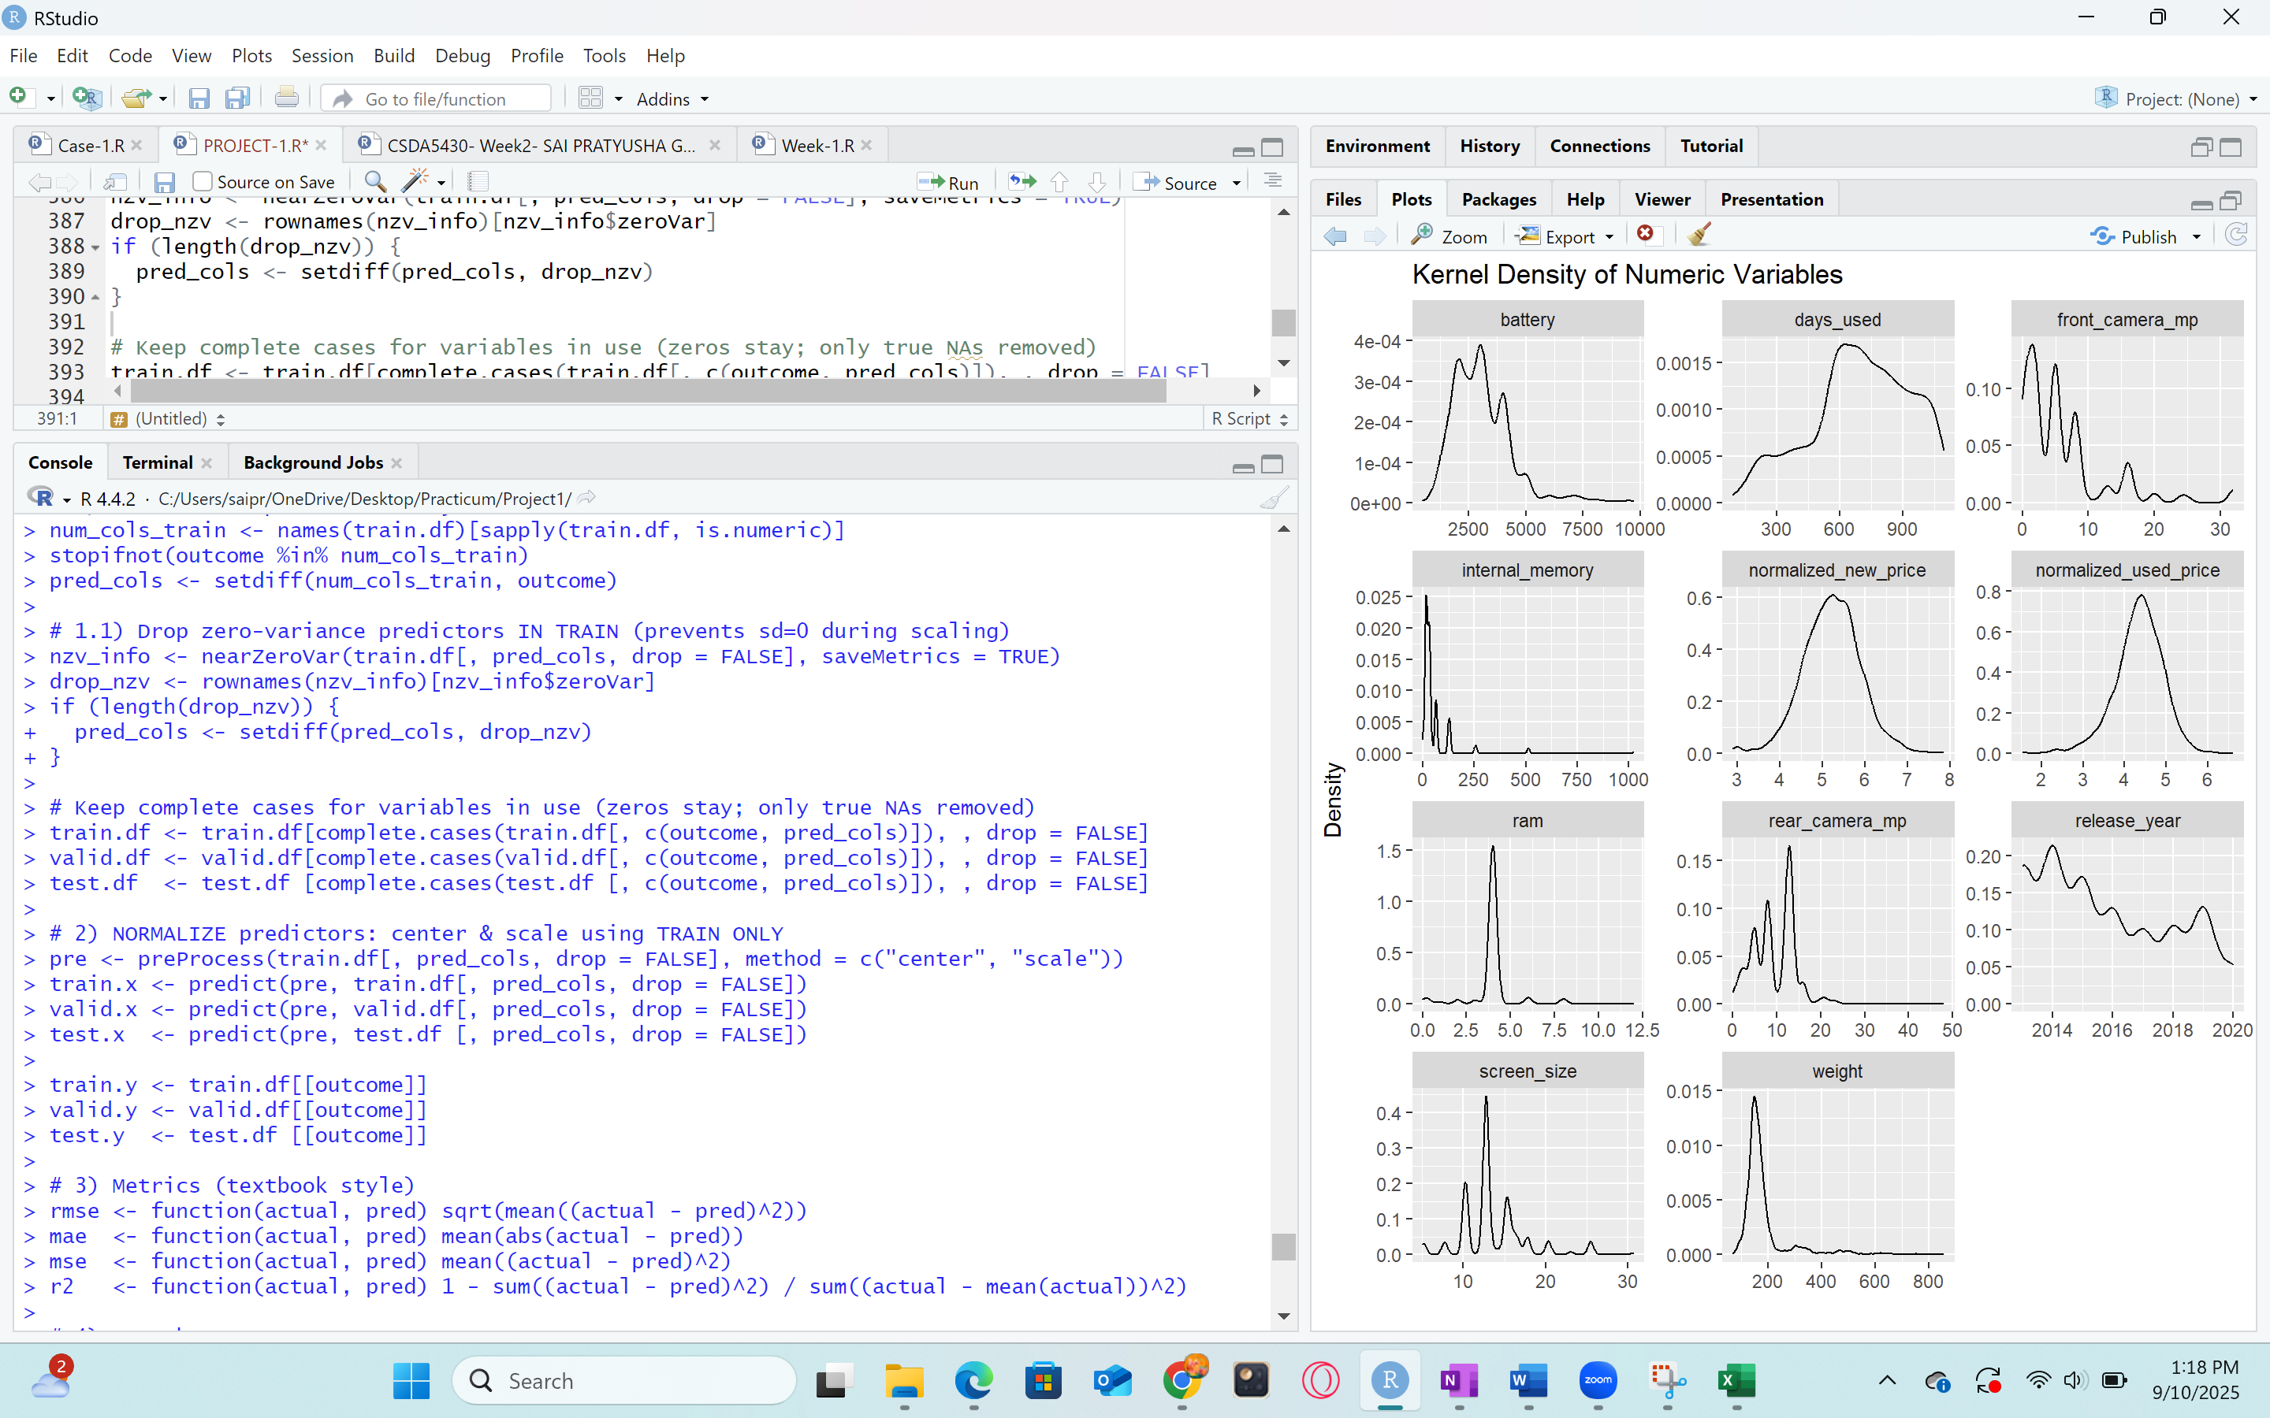

Fig41: Normalizing the predictors using training set

**Standardization:**

Predictors with no variation in the training set have standard deviation 0. Standardization would divide by 0, giving NA. Removing zero-variance columns with nearZeroVar is standard practice and prevents numerical issues without losing information a constant adds no discrimination.

Only true NAs are removed for the variables in use; zeros are kept for no front camera. This ensures the distance computation runs on valid rows and avoids NA predictions.

In KNN, metrics MAE/MSE/RMSE, lower is better and R² higher is better serves as the accuracy figure for regression.

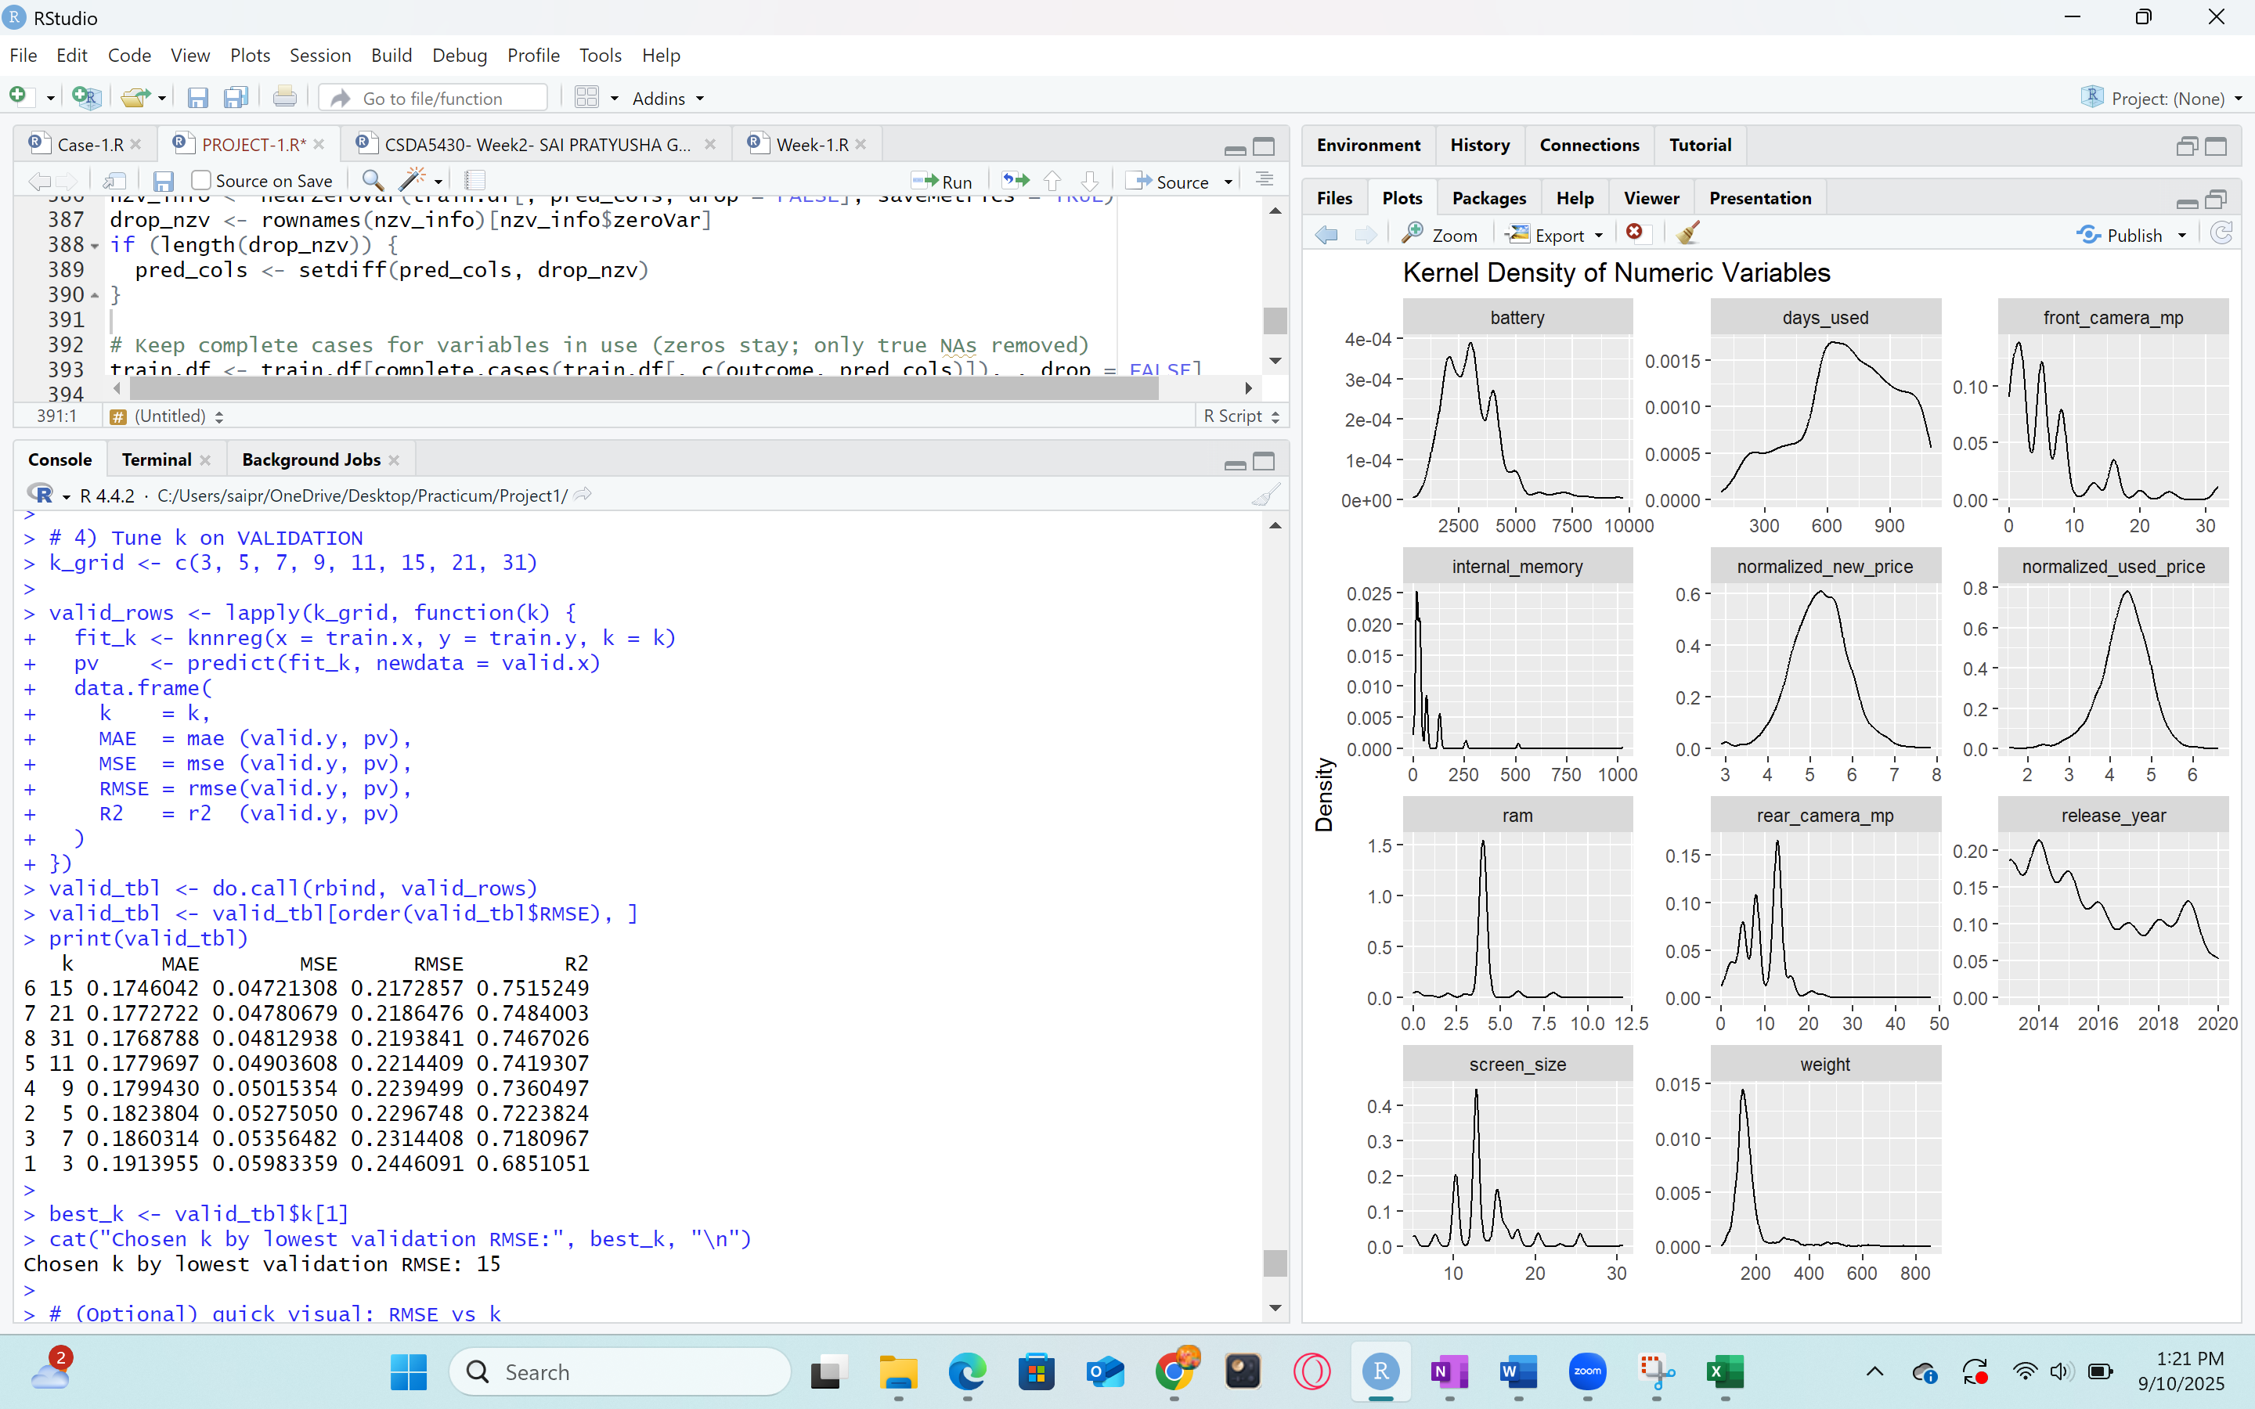

Fig42: Tuning K values on validation partition

**Hyperparameter tuning:**

A small grid of k values is evaluated on the validation set. The lowest validation RMSE defines the chosen k. A plot of RMSE vs k helps explain the bias-variance tradeoff. Small k means more flexible, can overfit low bias, high variance. Large k means smoother, can underfit high bias, low variance. The chosen k reflects the neighborhood size that best captures local price structure for this dataset. After selecting k on validation, performance is reported once on the test split to estimate true out-of-sample error and check generalization.

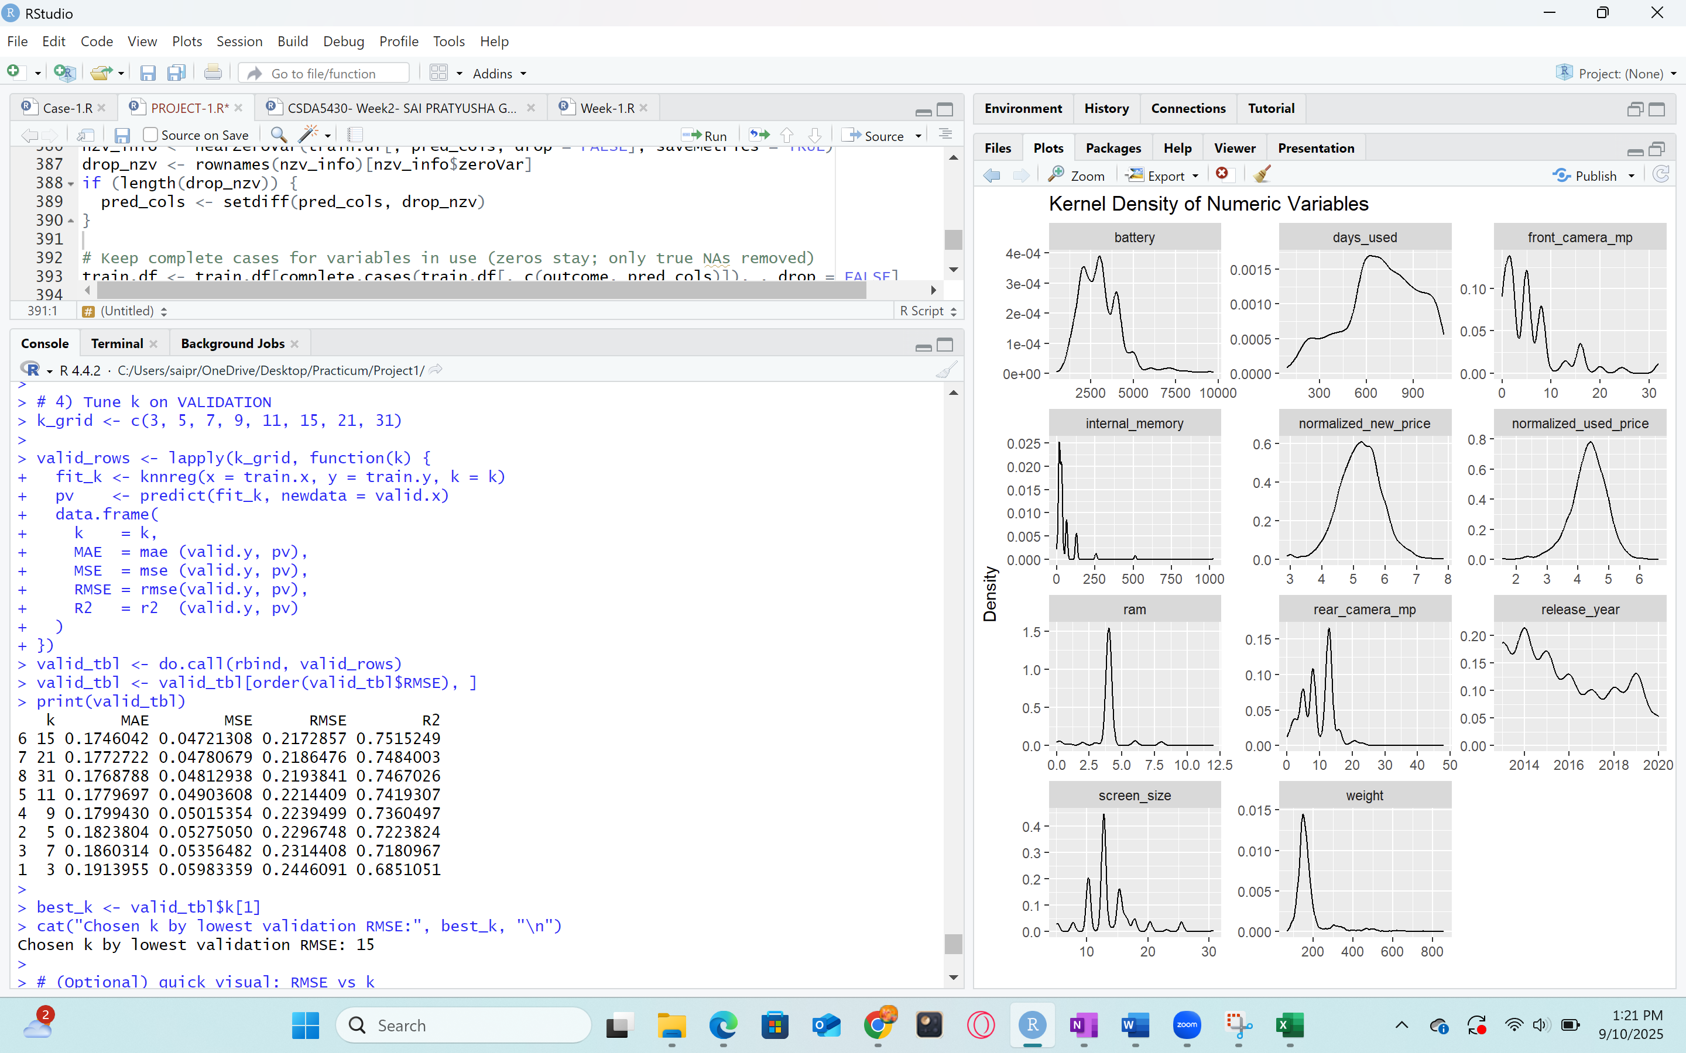

Fig43: Metrics with all k values

**Validation accuracy:**  
A grid of neighbor counts was tested on the validation split. The best value was **k = 15** with MAE = 0.1746, MSE = 0.0472, RMSE = 0.2173, R² = 0.7515.

As, k increased from 3 → 15, RMSE dropped and R² rose, showing that very small k values were too noisy (overfitting). After k = 15, performance flattened or dipped, indicating the start of underfitting for larger neighborhoods. Validation accuracy refers to R² on the validation set, reported together with error measures (MAE/MSE/RMSE).

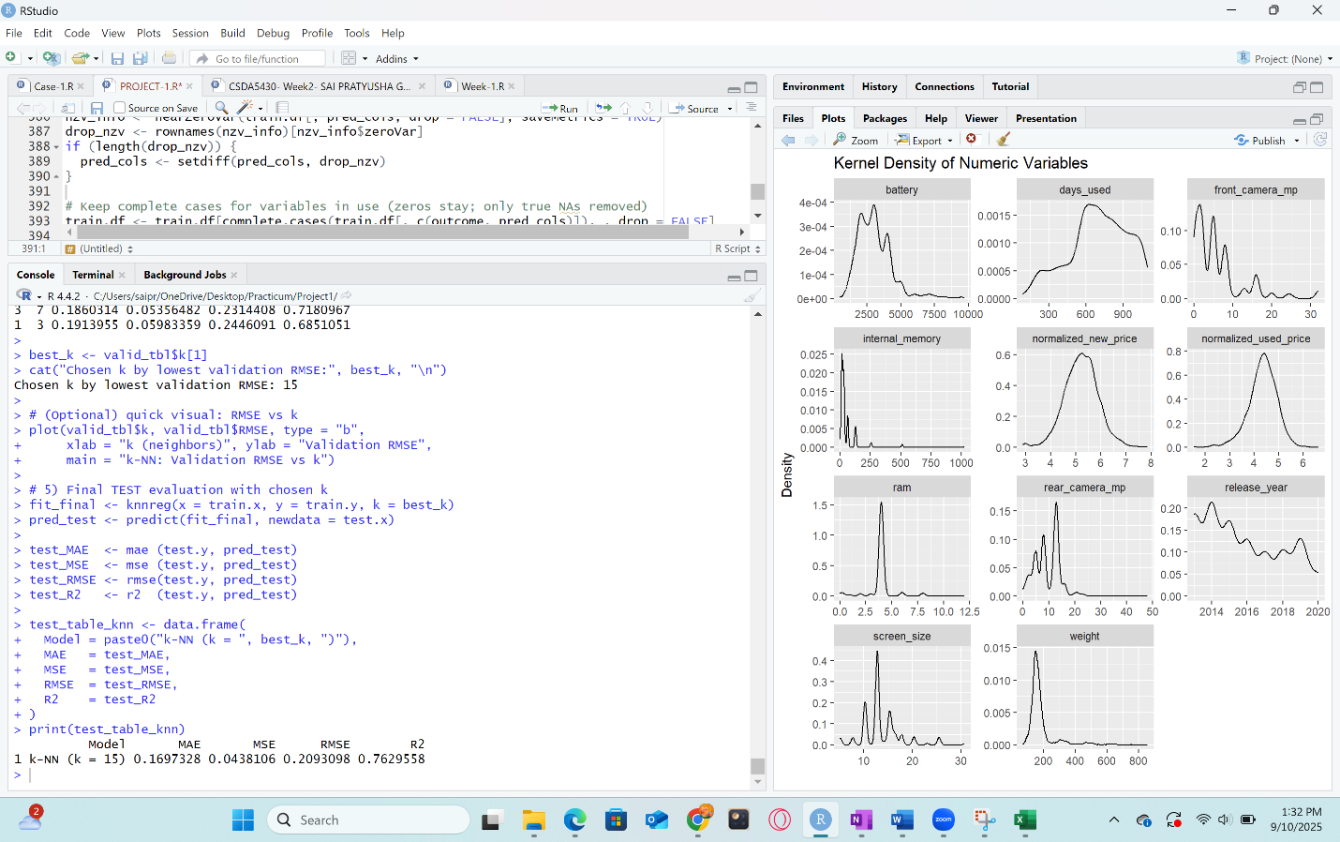

Fig44: Metrics using best k value for knn

**Test accuracy:**

Using k = 15, the test performance was MAE = 0.1697, MSE = 0.0438, RMSE = 0.2093, R² = 0.7630. Validation and test metrics are close (RMSE 0.2173 vs 0.2093, R² 0.7515 vs 0.7630). This indicates stable generalization and little overfitting.

k-NN predicts a device’s used price as the average of its 15 most similar devices in the standardized feature space. The validation and test R² ≈ 0.75–0.76 show that the model explains a large share of variation in normalized used price. RMSE ≈ 0.21 (normalized scale) is consistent across validation and test, which is desirable for deployment.

**Conclusion:**

K-NN is a good model as it generalizes well validation and test nearly match. The R² ≈ 0.76 and RMSE ≈ 0.21 indicate useful predictive power on the normalized scale. k-NN with k = 15 provides reliable, market-intuitive pricing by averaging close comparable and achieves stable performance.

**9.3 Random Forest**

Random Forest is an ensemble method that builds many decision trees on bootstrapped samples of the training data and averages their predictions. Each split in a tree considers only a random subset of predictors controlled by mtry. This randomness reduces correlation among trees and lowers variance, which helps the model generalize. Trees natively model nonlinear effects and interactions for example, how release year and camera specs combine to influence used price without requiring feature scaling.

For used-smartphone pricing, Random Forest aligns directly with the goal: predict the continuous target normalized_used_price from device specs, age, and the normalized new price anchor. The model was tuned on the validation set by trying a small grid of mtry values around standard regression defaults and selecting the setting with the lowest validation RMSE. The chosen forest was then evaluated once on the test split to estimate out-of-sample performance.

Random Forest does not need normalization or standardization. Tree splits compare values within a single variable as in is rear_camera_mp > threshold or not, so the scale of different variables does not affect how splits are chosen. Random Forest is therefore scale-invariant. Standardizing features won’t change which splits the trees pick or the final predictions.

So, no normalization was applied to Random Forest. The only preprocessing done for Random Forest was making sure factor levels were aligned across train/validation/test and then tuning mtry.

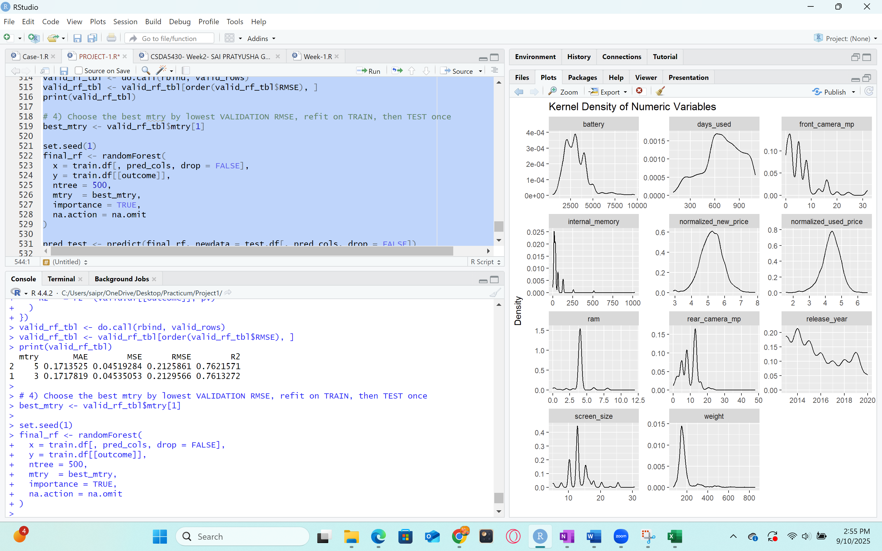

Fig45: Evaluation Metrics of Random Forest

**Evaluation metrics**

MAE: measures the average size of the errors. Here MAE = 0.1691 means predictions differ from actual values by about 0.169 normalized-price units on average. Lower MAE means more precise estimates across typical cases.

MSE: squares errors before averaging, so it penalizes larger misses more strongly. MSE = 0.0439 indicates that large errors are reasonably controlled.

RMSE: The square root of MSE is in the same units as the target. RMSE = 0.2096 says the typical prediction error is about 0.21 normalized-price units, which is easy to interpret against the target’s scale.

R²: The fraction of variance explained. R² = 0.7623 means the model explains about 76% of the variation in normalized used price, a strong level for pricing with heterogeneous devices.

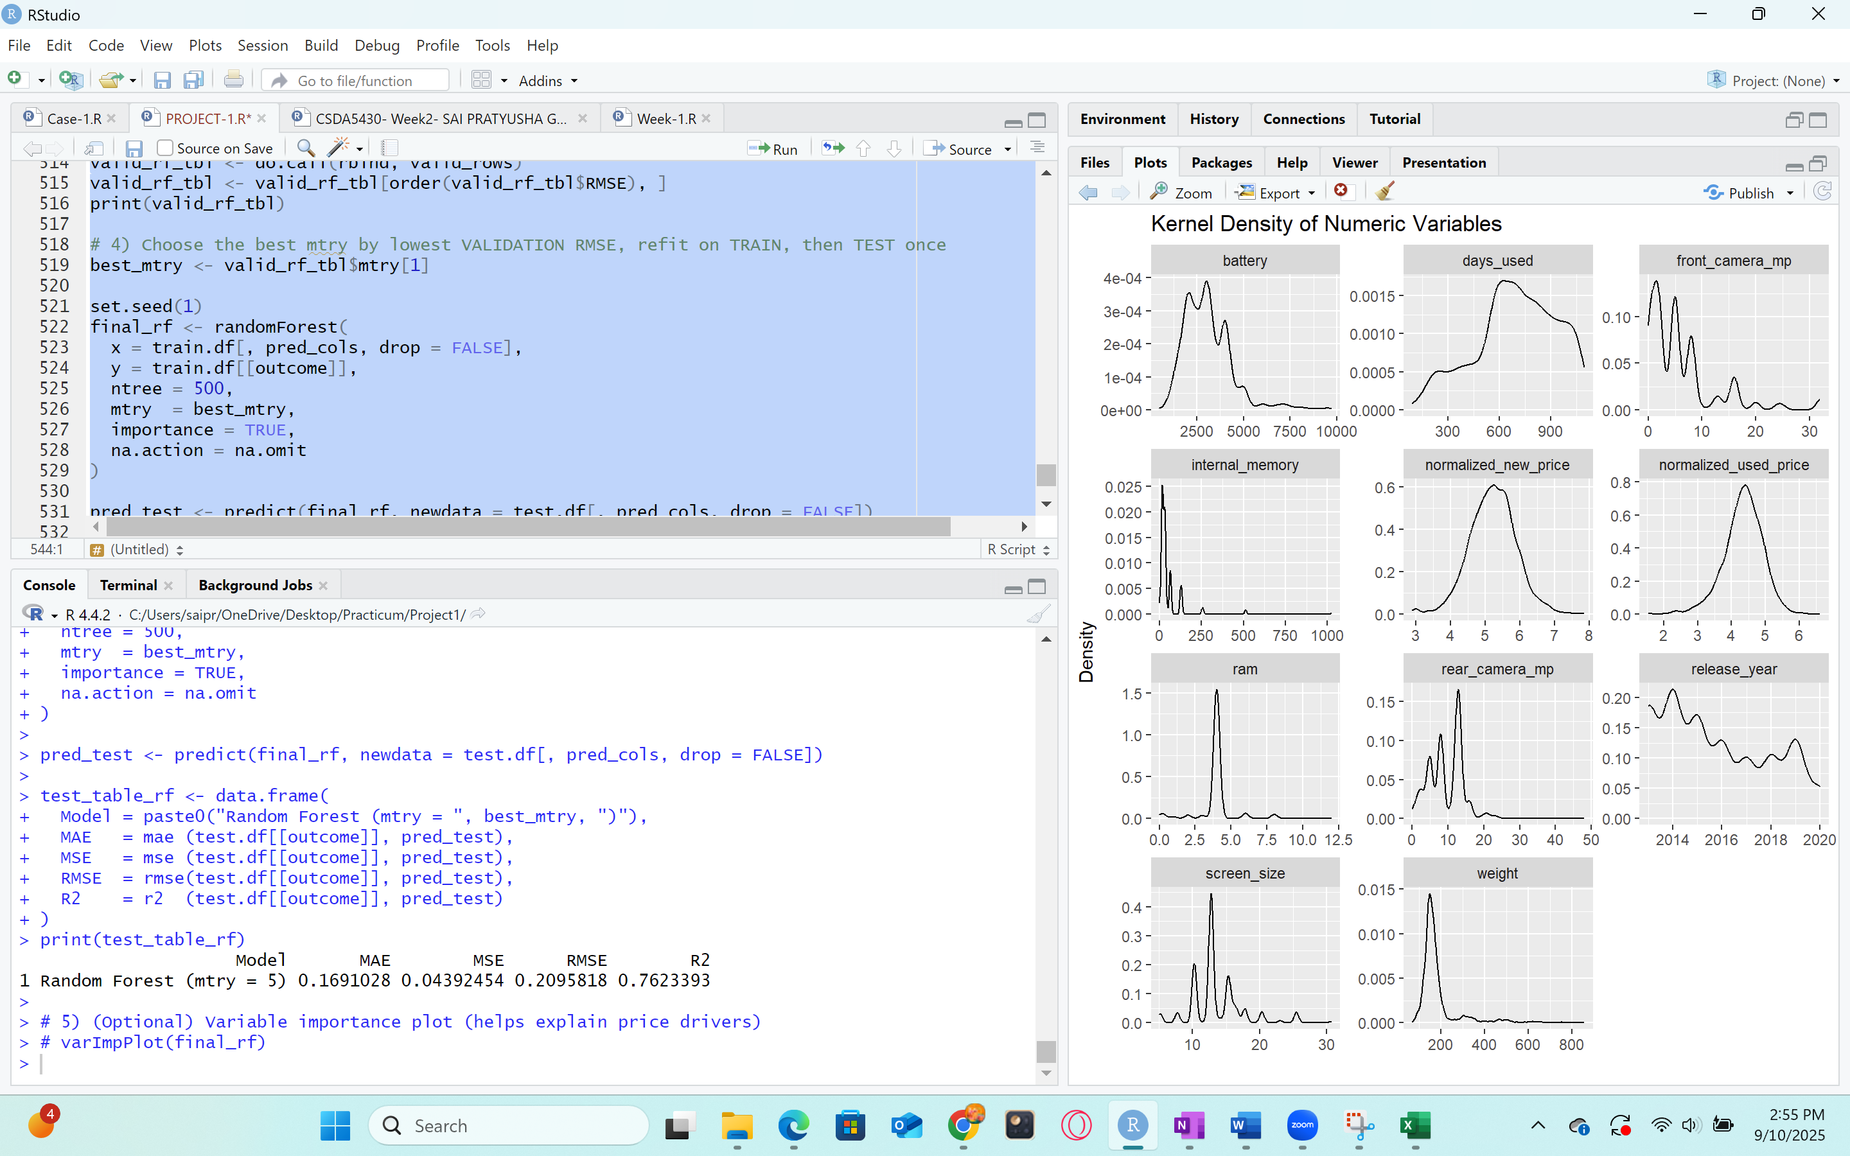

Fig46: Evaluation metrics of model with mtry=5 for Random Forest Algorithm

**Validation Accuracy:**

On the validation split, the best setting was mtry = 5, giving MAE = 0.1714, MSE = 0.0452, RMSE = 0.2126, and R² = 0.7622. These results indicate a strong fit with balanced bias–variance: the model captures most of the structure in the data while avoiding overfitting.

**Accuracy (test):**

Using mtry = 5 on the test split produced MAE = 0.1691, MSE = 0.0439, RMSE = 0.2096, and R² = 0.7623. Validation and test are closely matched (RMSE 0.2126 vs 0.2096; R² 0.7622 vs 0.7623), which shows stable generalization and reliable performance for pricing unseen devices.

**Conclusion**

The Random Forest model is a good fit for this dataset. It delivers strong accuracy (R² ≈ 0.76) with low error (RMSE ≈ 0.21) and, importantly, shows nearly identical validation and test results, indicating robust generalization. Its ability to capture nonlinearities and interactions among specs makes it well-suited for pricing used smartphones from their technical features and age, complementing the linear benchmark with a flexible, high-performing alternative.

**Model Fitting for Classification Algorithms**

Model fitting in classification starts by defining a categorical target and a set of predictors, then letting an algorithm learn decision rules that map predictors to classes. The learning process optimizes a purity criterion such as entropy or Gini so that each split of the data makes the resulting groups more homogeneous with respect to the class label. To estimate how well those learned rules generalize, the data are partitioned into training to fit, validation to tune choices and check for overfitting, and test to report final, unbiased performance. Any preprocessing must be done carefully to avoid leakage: thresholds or scalers are computed from the training set only and then applied to validation and test. Performance is summarized with a confusion matrix and derived measures such as accuracy, sensitivity, specificity, and kappa.

**9.4 C5.0 Algorithm**

C5.0 is a decision-tree classifier that learns a set of “if–then” rules by repeatedly splitting the data on the predictor that most cleanly separates the classes. Splits are chosen by an information-gain criterion, branches are pruned to prevent overfitting, and the final tree can be read as human-interpretable rules. Because trees split a single variable at a time, no normalization or standardization is required. In this project, the continuous target was converted into a label—High vs. Low normalized used price using the training median. That creates balanced classes and keeps the price signal aligned with the original goal.

This approach supports the pricing goal in two ways. First, it translates device specifications and market anchors into transparent rules, e.g., combinations of rear camera megapixels, internal memory, normalized new price, and screen size that indicate a higher or lower used-price band. Second, it complements regression by offering an operational categorization: which devices fall into a higher resale tier versus a lower one. In the fitted tree, the first and strongest splits involve rear_camera_mp and internal_memory, with normalized_new_price, front_camera_mp, screen_size, release_year, and weight contributing to later decisions patterns that are intuitive for used-price behavior.

For the C5.0 decision tree above, model fitting began by converting the continuous pricing target into a balanced two-class label, “High” vs. “Low,” using the training median of normalized_used_price as the cutoff. That keeps the classification task aligned with the same business outcome—price level—while preventing information from the validation or test sets from influencing the threshold. Predictors were all columns except the numeric target, with factor levels aligned across splits so that the model sees a consistent representation at training and prediction time. No normalization was necessary because tree algorithms split on single-variable thresholds, which are invariant to linear rescaling.

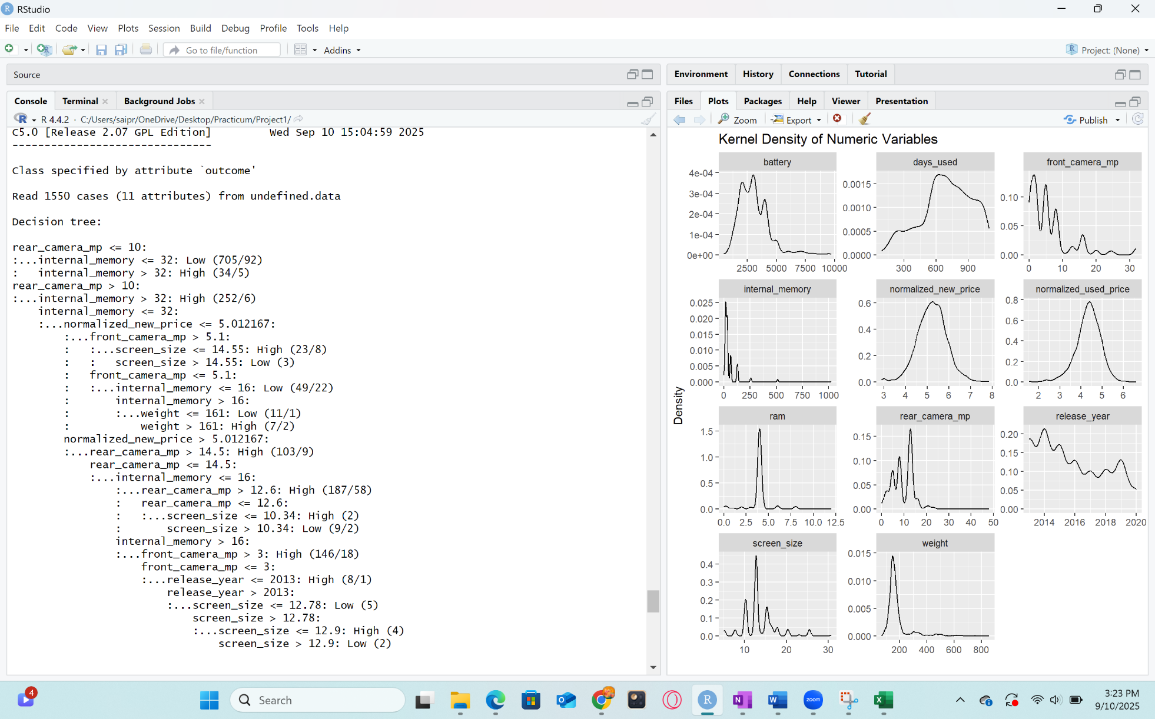

Fig47: Decision Tree of C5.0 Algorithm

The tree itself fitted with C5.0(PriceBand ~ .) on the training partition. During fitting, C5.0 evaluates potential splits on every predictor using an information-gain criterion adjusted by gain ratio, chooses the split that most reduces class impurity, and then continues recursively until no further improvement is possible. It then prunes the tree to remove branches that do not improve estimated out-of-sample accuracy, controlling variance and reducing overfitting. The resulting model is compact and interpretable. In this case, the learned structure emphasized rear_camera_mp and internal_memory at the top of the tree, with additional refinement from normalized_new_price, front_camera_mp, screen_size, release_year, and weight. Those cut points form a set of if–then rules that cleanly separate higher and lower price bands in terms that are meaningful for device valuation.

After fitting, the model was applied to the validation split to compute the confusion matrix and key metrics. Validation accuracy, sensitivity for the “High” class, and specificity for the “Low” class were used to judge whether the tree captured stable structure rather than noise. Because the validation results were strong and well balanced, the same fitted model was then evaluated once on the test split to obtain the final generalization estimate. The close agreement between validation and test performance indicates that pruning struck a good bias–variance balance and that the learned rules transfer well to unseen devices. C5.0 produced an interpretable, accurate classifier that complements the regression models by offering a transparent, rule-based categorization of used-phone price tiers.

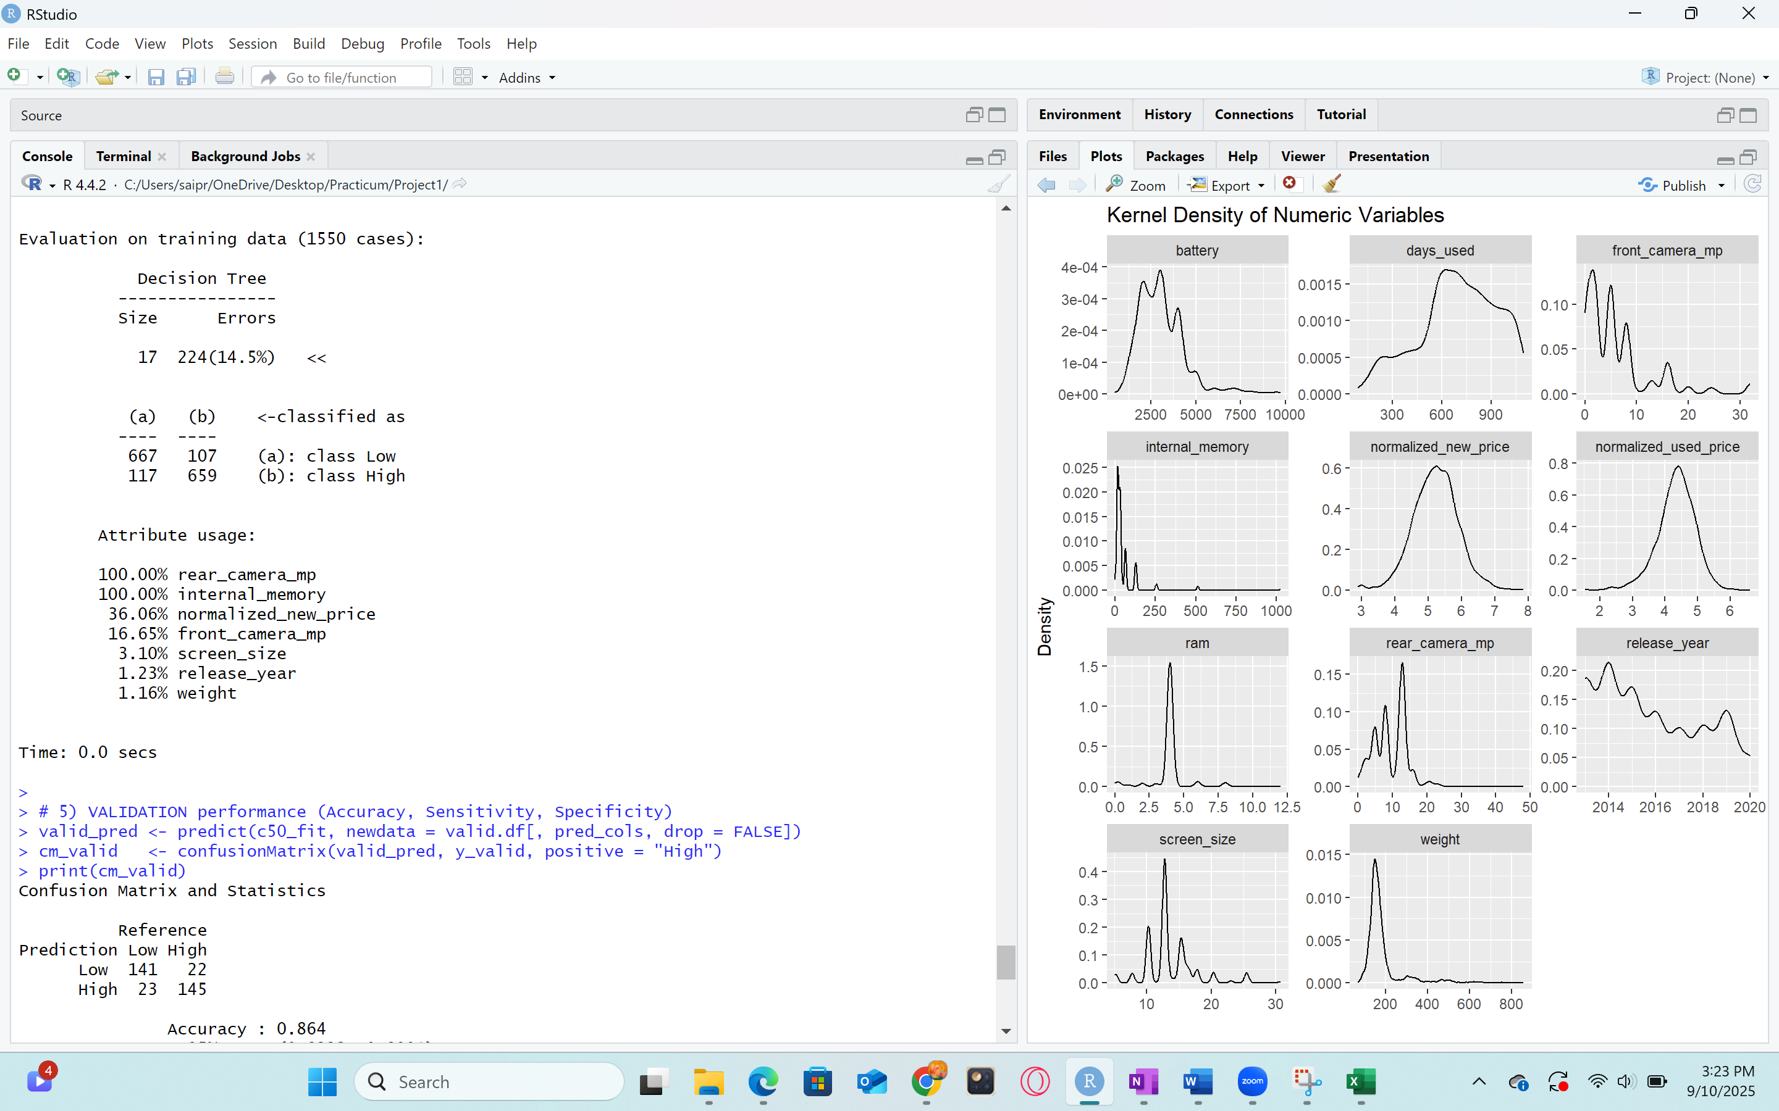

Fig47: Evaluation on training data of C5.0 Algorithm

**Evaluation metrics:**

**Accuracy:** Reports the overall share of correct High/Low assignments; here it shows strong performance on both validation (0.864) and test (0.844).

**Sensitivity:** Recall for High measures how many truly High devices are captured as High; values around 0.84–0.87 indicate strong detection of the higher price band.

**Specificity:** Measures how many truly Low devices are labeled Low; values around 0.86–0.85 show balanced control of false Highs.

**Positive Predictive Value:** Precision for High indicates, among predictions of High, how many are truly High; values near 0.86 suggest reliable High flags.

**Negative Predictive Value:** Indicates, among predictions of Low, how many are truly Low; values around 0.84–0.87 show similarly reliable Low flags.

**Kappa**: Adjusts accuracy for chance agreement; values of 0.73 (validation) and 0.69 (test) indicate substantial agreement and a model that is learning meaningful structure beyond class balance.

**Validation accuracy:**

Validation results show Accuracy = 0.864 with a 95% CI of 0.822–0.899. Sensitivity is 0.868 for the High class, meaning most truly High-priced phones are correctly identified, while Specificity is 0.860, indicating Low-priced phones are also recognized reliably. Positive Predictive Value is 0.863, so a device predicted as High is High most of the time, and Negative Predictive Value is 0.865, so a device predicted as Low is Low most of the time. The Kappa of 0.728 reflects substantial agreement beyond chance. Overall, the tree generalizes well during model selection and balances the two classes effectively.

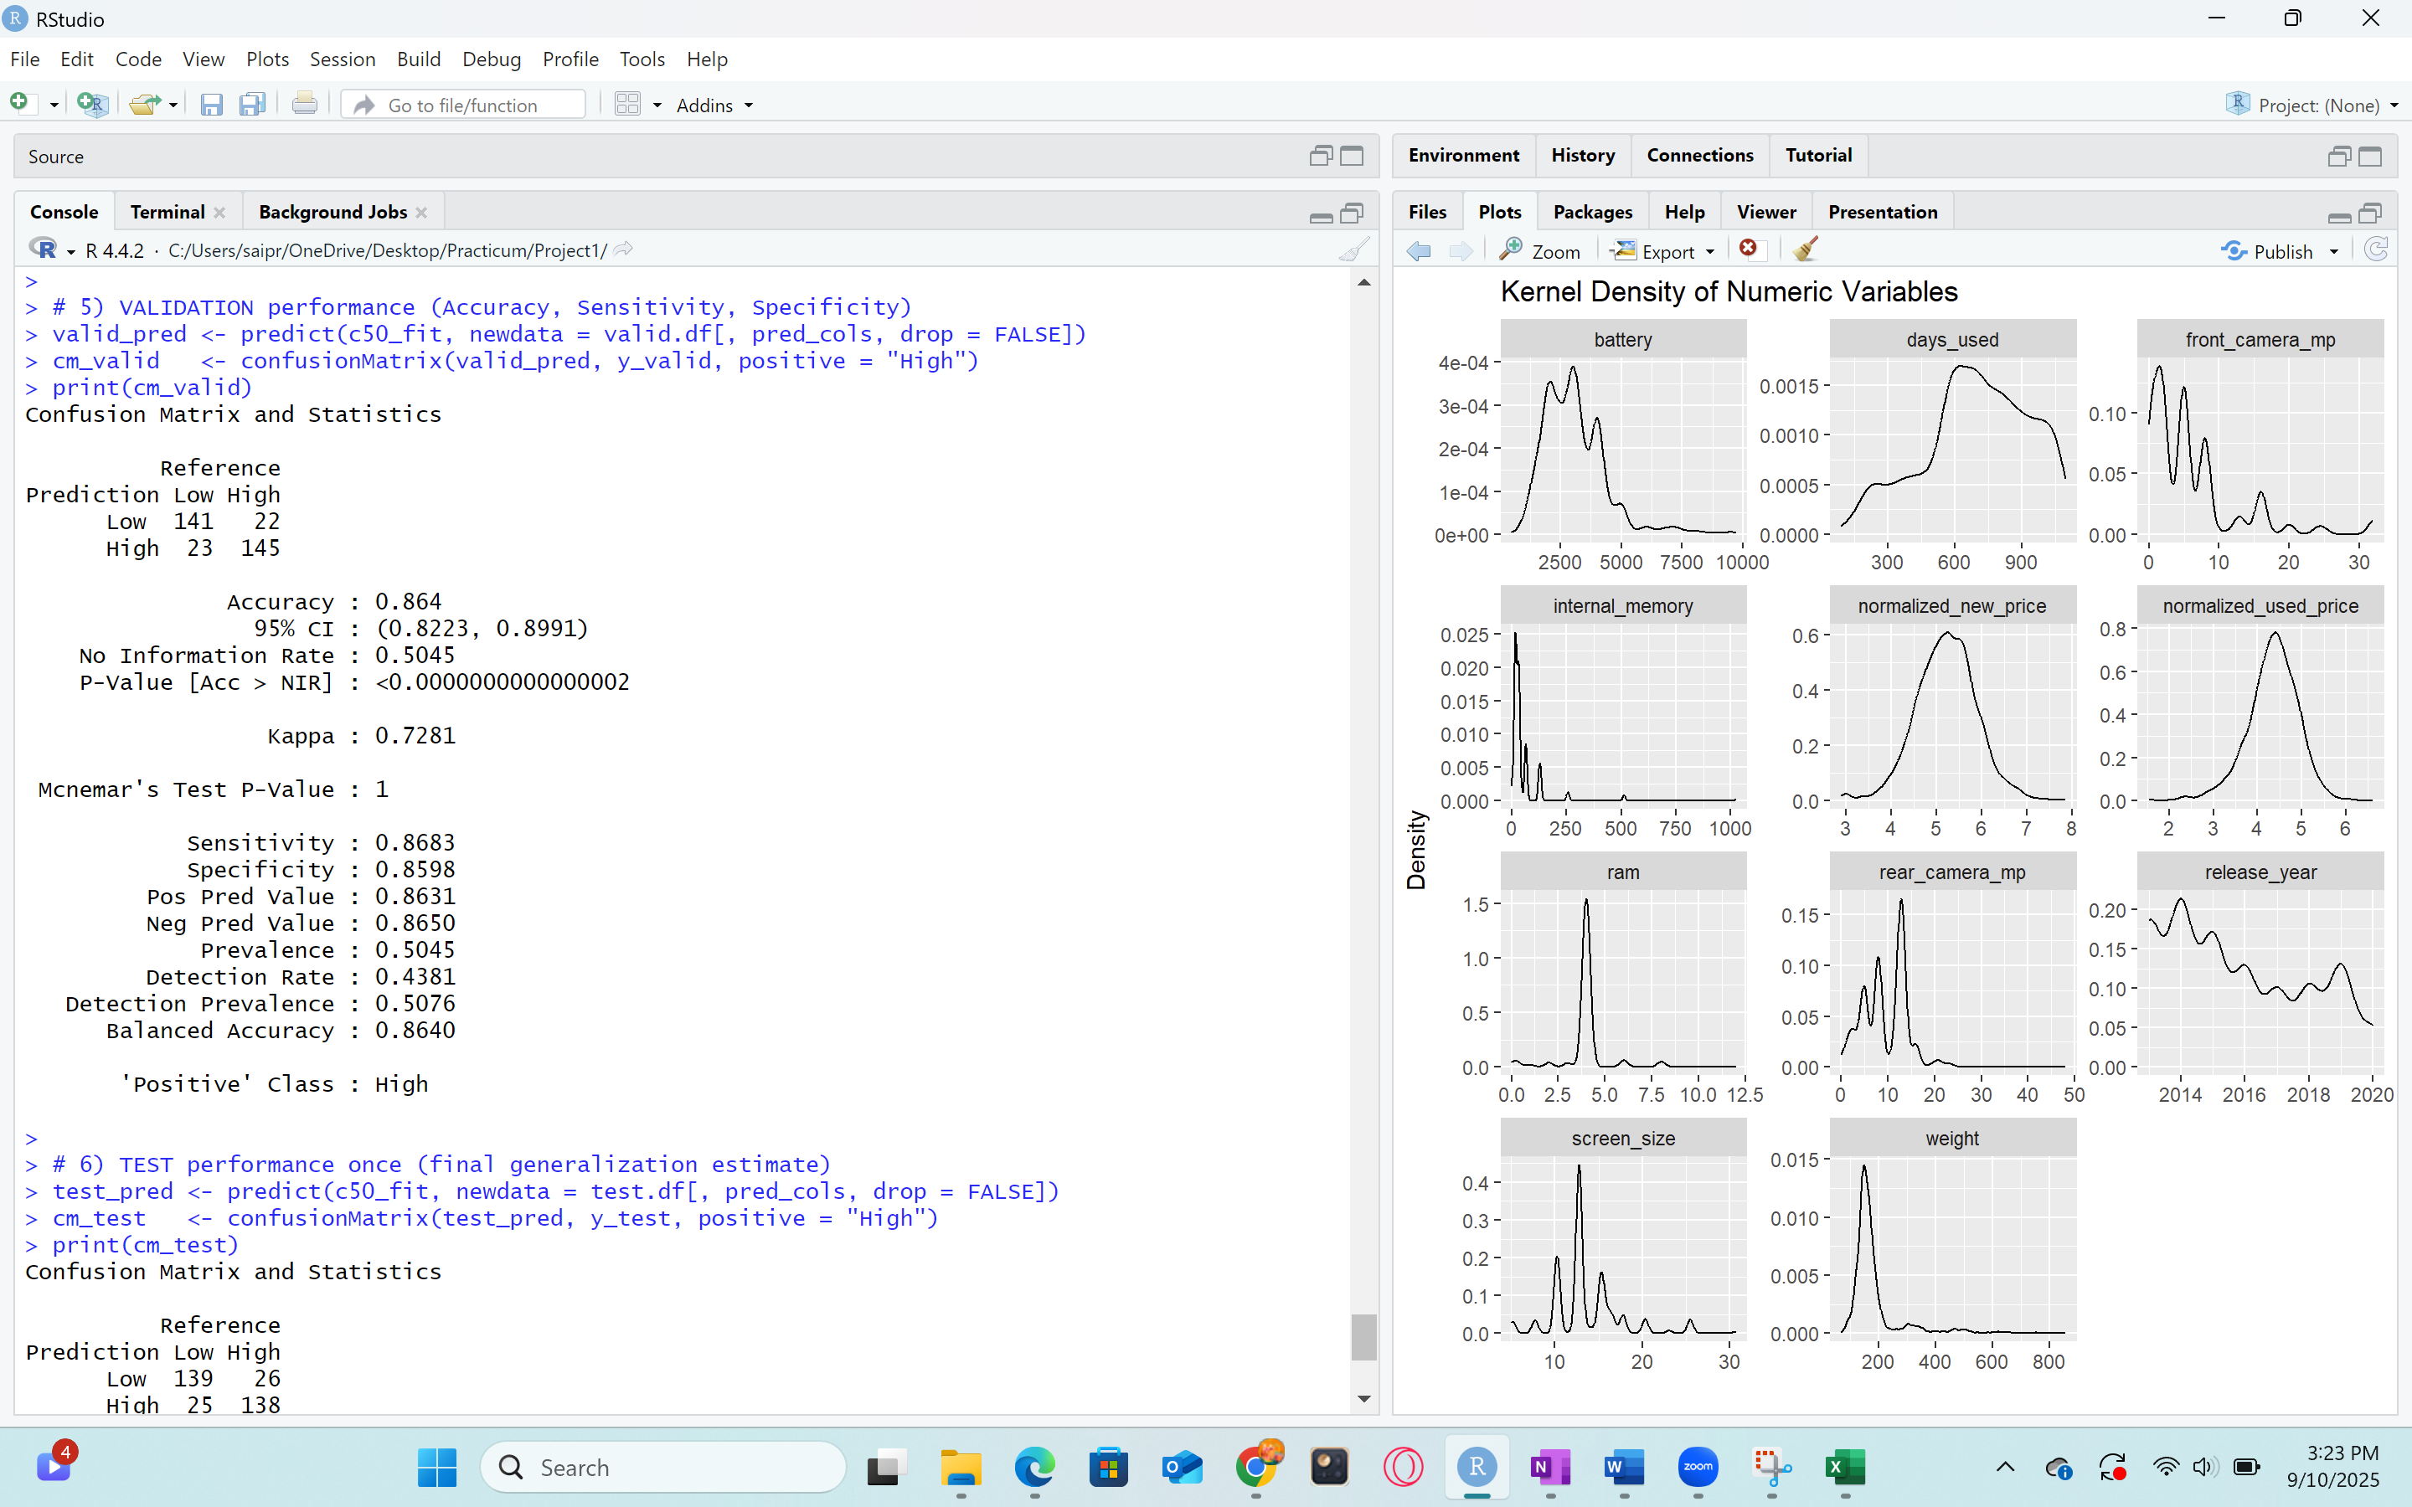

Fig48: Validation metrics, Confusion Matrix and Statistics of C5.0 Algorithm

**Accuracy (test):**

Held-out test performance is consistent with validation: Accuracy = 0.844 (95% CI 0.801–0.882), Sensitivity 0.842, and Specificity 0.848. Positive Predictive Value is 0.847 and Negative Predictive Value is 0.842. Balanced Accuracy equals 0.844, matching overall accuracy because the classes are roughly even. The Kappa of 0.689 remains in the substantial-agreement range. The close match between validation and test indicates stable out-of-sample behavior without signs of overfitting.

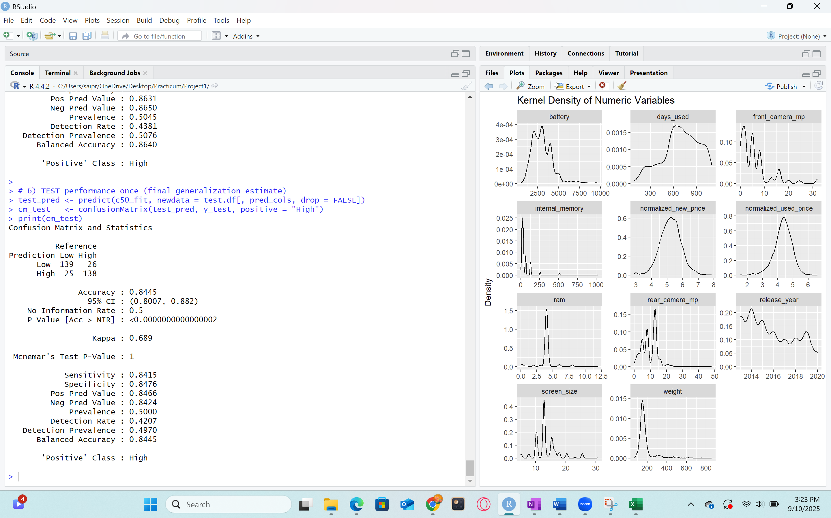

Fig49: Metrics on test data for C5.0 Algorithm

**Conclusion**

The C5.0 decision tree is a good fit for the classification view of this problem. It delivers high and balanced accuracy on both validation and test, uses intuitive splits tied to device capability and new-price anchors, and provides clear, explainable rules for assigning used phones to higher or lower price bands. These properties make it a practical companion to the regression models: regression supplies precise price estimates, while C5.0 supplies transparent tiering that can guide quick triage, policy rules, or pricing thresholds.

**9.5 Logistic Regression**

Logistic regression is a statistical method used to predict the probability of an outcome that can only take two possible values, such as high versus low, or yes versus no. Instead of directly predicting a continuous number like linear regression, logistic regression estimates the likelihood that an observation falls into a particular category. This is achieved by using the logistic function, which transforms predictions into probabilities between 0 and 1. In the smartphone pricing project, logistic regression can classify devices into price ranges, such as “above average value” or “below average value,” based on their features like brand, camera quality, memory, and age.

This model falls under classification rather than regression because the focus is on predicting categories rather than continuous numeric prices. By mapping how device specifications affect the probability of belonging to a higher or lower price class, logistic regression provides a clear understanding of how each feature influences resale value. This makes it useful for setting transparent and fair pricing strategies in the used smartphone market, aligning directly with the project goal of helping businesses and customers make informed decisions about device value.

Logistic Regression models the probability that a device belongs to the High price band as a function of specs, age, and the new-price anchor. It is widely used, easy to interpret via coefficients and signs, and provides a strong baseline for classification. Using the training median to define High/Low keeps classes balanced and aligned with the original pricing target.

Predictors include both numeric specs (cameras, screen size, RAM, battery, weight), device age markers (release year, days used), and the normalized new price. The method handles mixed predictors cleanly and does not require feature scaling to produce valid probabilities. By fitting a baseline model with only normalized_new_price and a full model using all available predictors, it becomes clear how much incremental classification power the device specifications add.

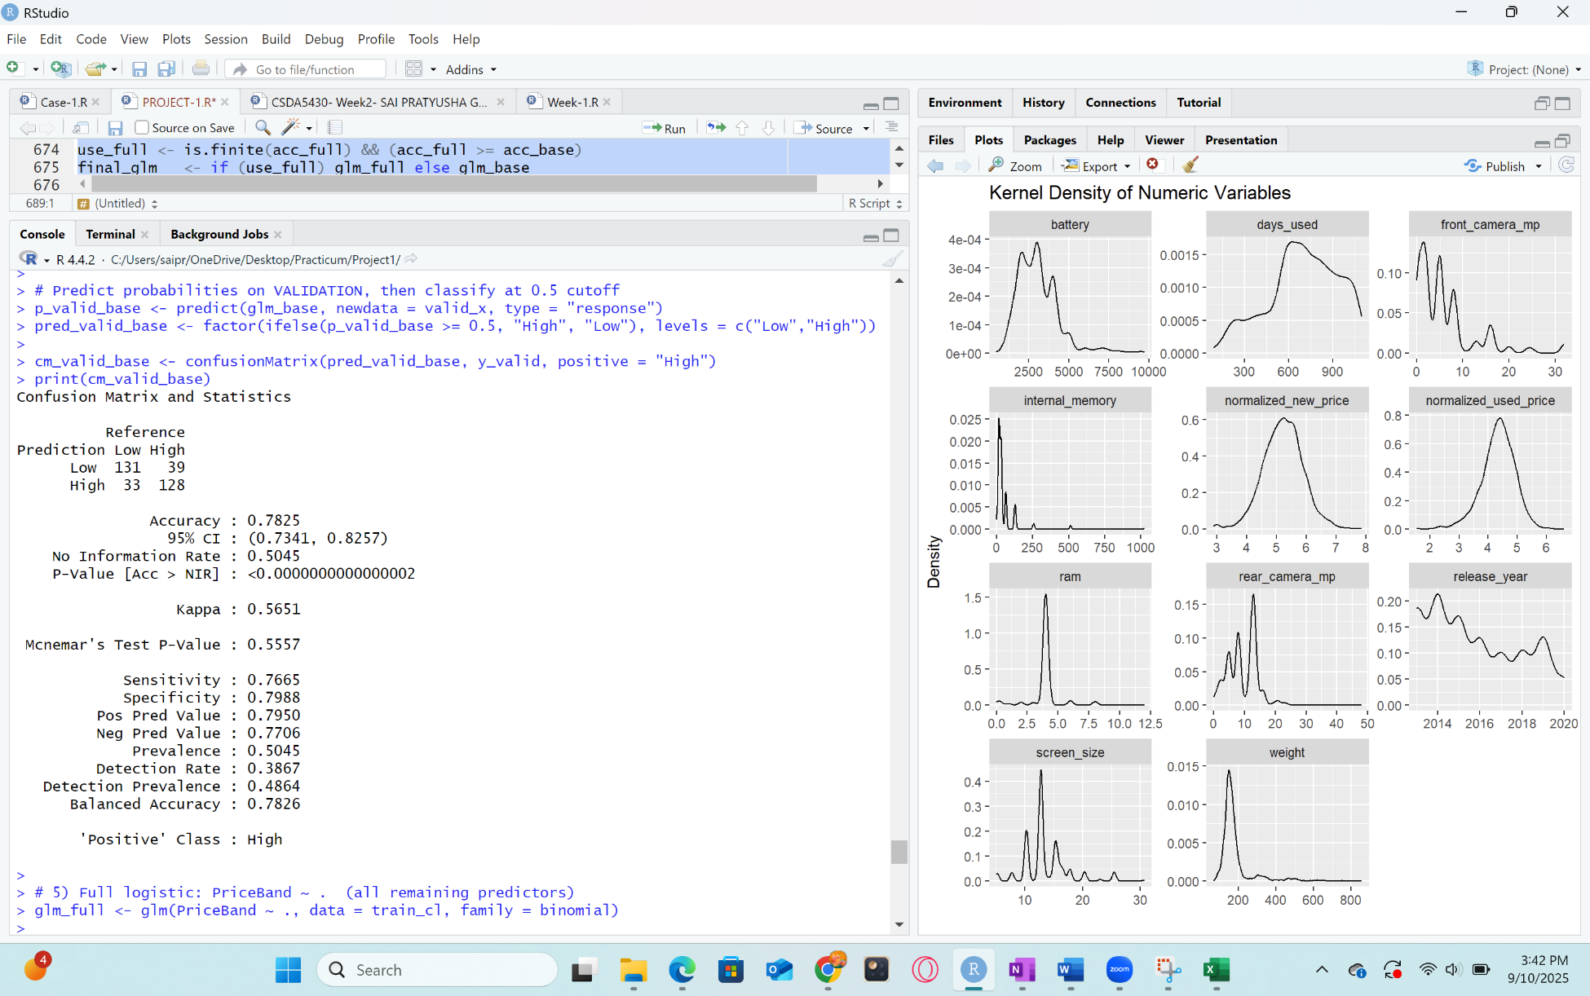

Fig50: Confusion Matrix and Statistics of Logistic Regression

**Evaluation of metrics:**

Accuracy is the share of correct classifications overall. On validation the full logistic model achieved 0.8731, which means about 87.3% of phones were assigned to the correct High/Low price band; on test it was 0.8628, or about 86.3% correct, with tight 95% confidence intervals, showing stable performance. Sensitivity (also called recall for the High class) is the proportion of truly High-price phones that are predicted as High; the model’s sensitivity was 0.8683 on validation and 0.8720 on test, indicating that higher-valued devices are captured. Specificity is the proportion of truly Low-price phones predicted as Low; values of 0.8780 (validation) and 0.8537 (test) show solid control of false High predictions. Positive Predictive Value (precision for High) tells, among those predicted High, how many truly are High; it was 0.8788 on validation and 0.8563 on test, so High labels are usually correct. Negative Predictive Value tells, among those predicted Low, how many truly are Low; it was 0.8675 on validation and 0.8696 on test, indicating reliable Low labels as well.

**Validation accuracy:**

On the validation split, the baseline logistic regression (new price only) achieved Accuracy = 0.7825 with Sensitivity 0.7665 for the High class and Specificity 0.7988 for the Low class. The full logistic model improved substantially to Accuracy = 0.8731 (95% CI 0.832–0.907), with Sensitivity = 0.8683 and Specificity = 0.8780. Positive Predictive Value reached 0.8788 and Negative Predictive Value 0.8675, indicating that High and Low predictions are reliable in both directions. The Kappa statistics of 0.7462 shows substantial agreement beyond chance. These results indicate that including device specifications meaningfully strengthens the ability to separate higher-valued from lower-valued phones.

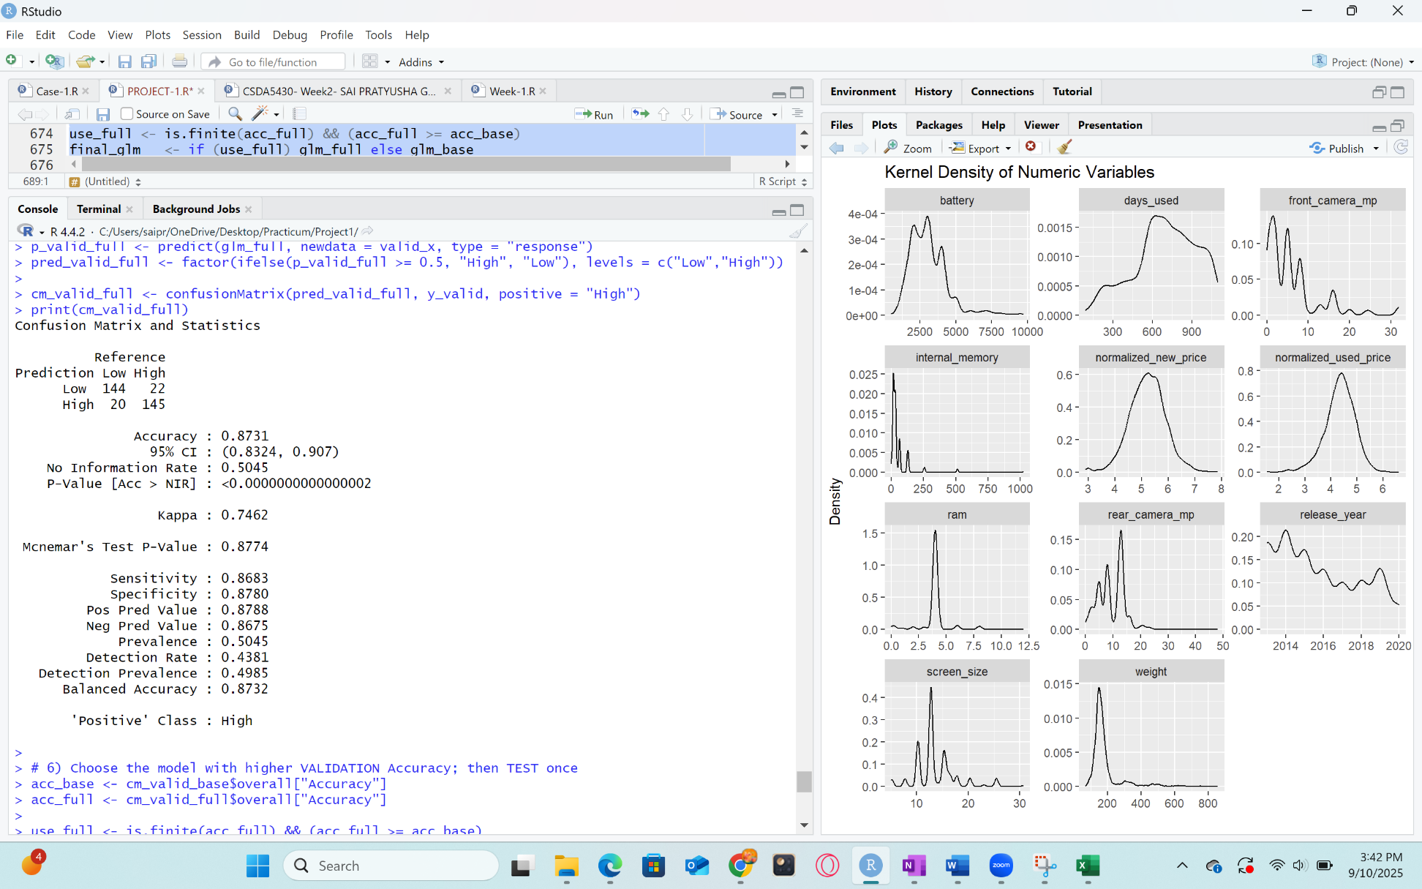

Fig51: Validation metrics of Logistic Regression Algorithm

**Accuracy (test):**

Using validation accuracy to choose the model, the full logistic regression was evaluated once on the untouched test split and reached Accuracy = 0.8628 (95% CI 0.821–0.898). Sensitivity was 0.8720 and Specificity 0.8537, with Positive Predictive Value 0.8563 and Negative Predictive Value 0.8696. The Kappa of 0.7256 again reflects substantial agreement beyond chance. The close correspondence between validation (0.873) and test (0.863) accuracy indicates stable generalization without overfitting.

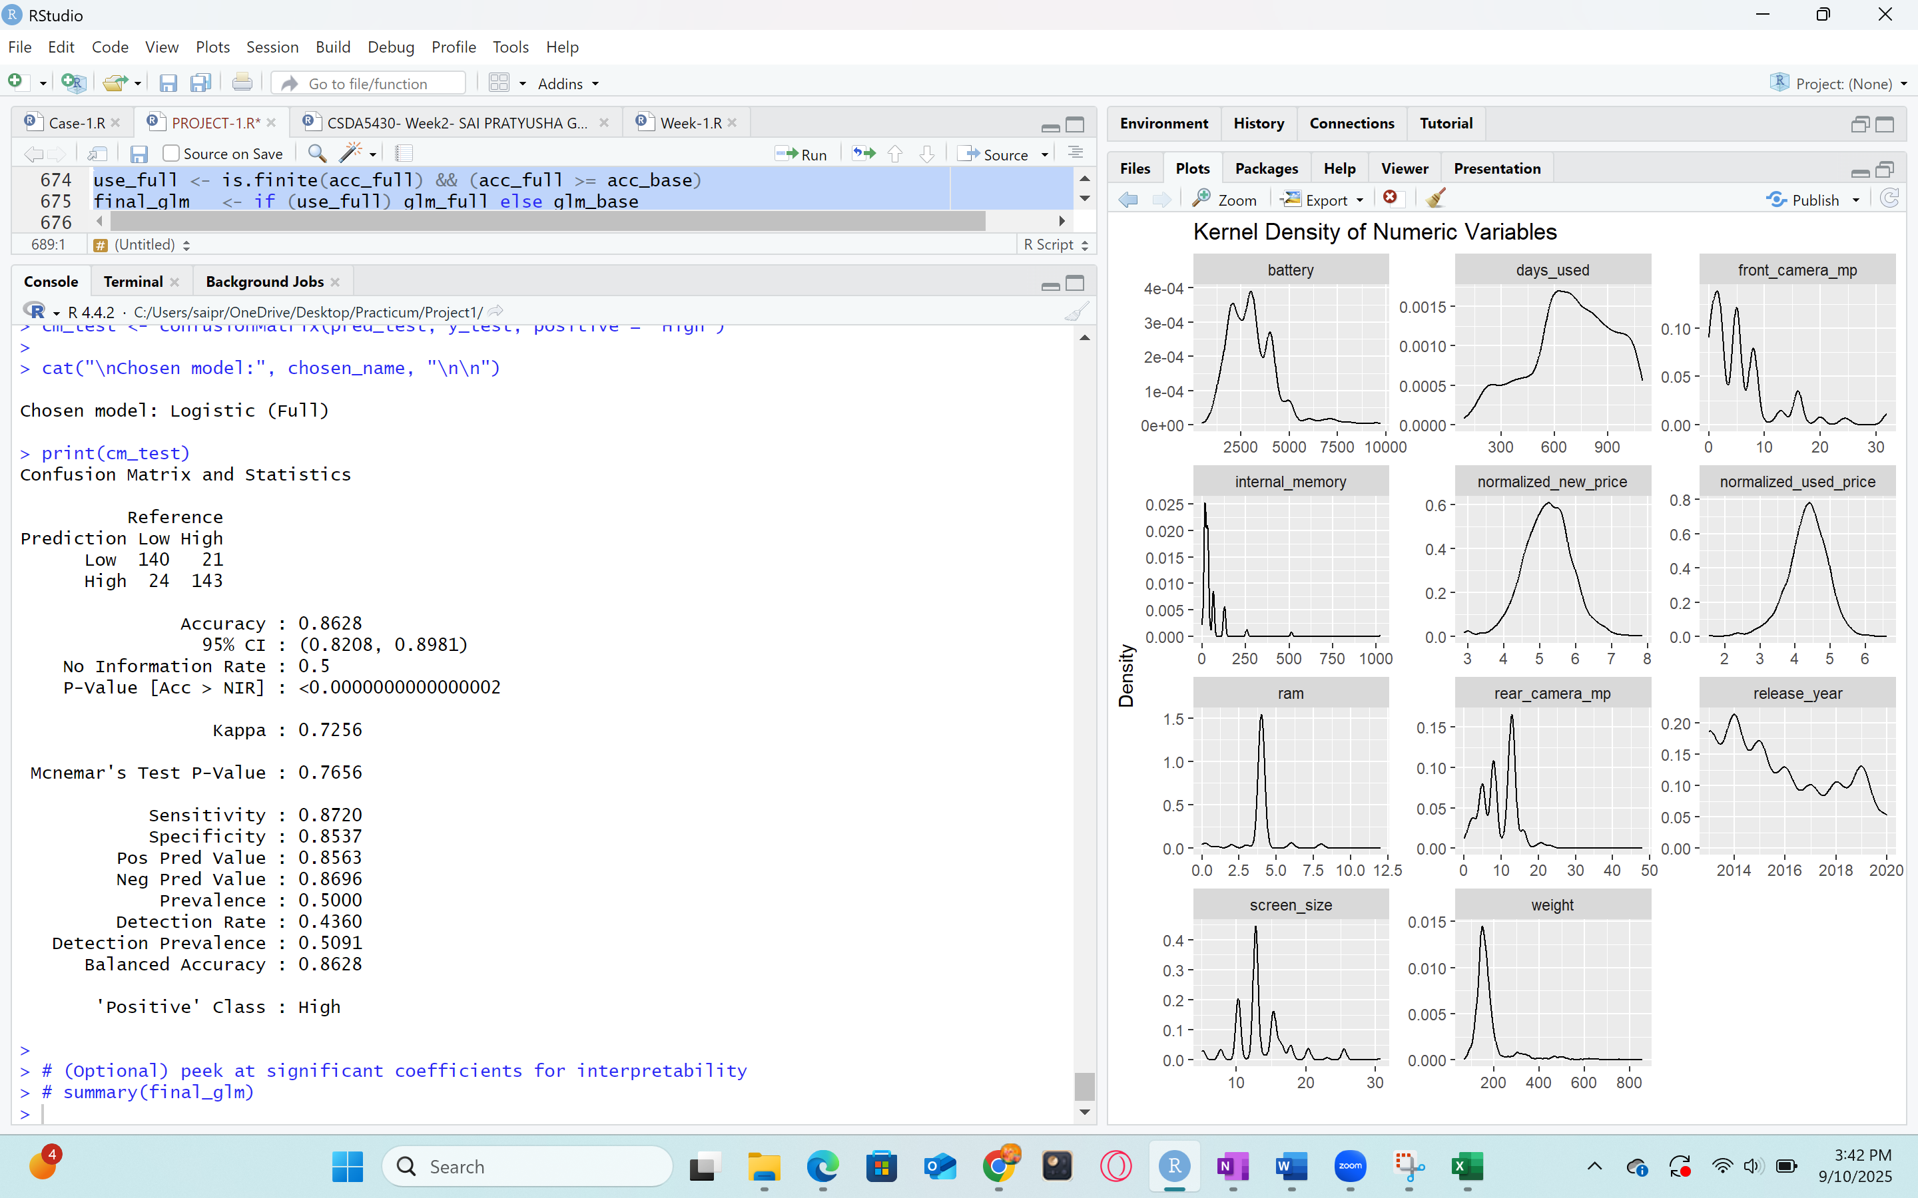

Fig52: Metrics on test data for Logistic Regression Algorithm

**Conclusion:**

Logistic regression provides a strong, interpretable classifier for used-phone price tiering that complements the continuous price models. The full specification model clearly outperforms the new-price-only baseline, showing that camera specs, screen size, internal memory, release year. With balanced sensitivity and specificity, high predictive values, and substantial Kappa on both validation and test, the model is a good fit for assigning devices to High vs. Low price bands useful for triage, pricing policy rules, and inventory decisions grounded in the same target that drives the regression analysis.

**10. Comparison of Model Performance Evaluation**

**10.1 Comparing Model Performance of Regression Algorithms**

Model performance shows how close predictions are to real used prices and how reliably a model will behave on unseen phones. Strong performance means lower typical errors (MAE/RMSE), smaller penalty on big misses (MSE), and higher explained variance (R²). Good validation results help choose the right model during development, and good test results confirm that the chosen model generalizes, which is essential for pricing decisions in the refurbished/used market.

Three regression approaches were trained and compared on the same 70/15/15 split:

* **Multiple Linear Regression (MLR)**: all numeric specifications as predictors.
* **k-Nearest Neighbors (k-NN) Regression**: numeric predictors, standardized; best k chosen on validation.
* **Random Forest Regression**: all predictors’ factors handled natively; best mtry chosen on validation.

**Validation Comparison:**

|  |  |  |  |  |
| --- | --- | --- | --- | --- |
| **MODEL** | **MAE** | **MSE** | **RMSE** | **R SQUARE** |
| **Multiple Linear Regression** | 0.1633 | 0.0406 | 0.2015 | 0.7862 |
| **K-NN (k=15)** | 0.1746 | 0.0472 | 0.2173 | 0.7515 |
| **Random Forest** | 0.1714 | 0.0452 | 0.2126 | 0.7622 |

The Multiple Linear Regression has the lowest validation errors and the highest R². Random Forest and k-NN are close but consistently behind MLR; the baseline confirms that new price alone is a strong anchor yet improved meaningfully by adding specifications.

**Test Comparison:**

|  |  |  |  |  |
| --- | --- | --- | --- | --- |
| **MODEL** | **MAE** | **MSE** | **RMSE** | **R SQUARE** |
| **MLR** | 0.1631 | 0.0403 | 0.2006 | 0.7821 |
| **K-NN** | 0.1697 | 0.0438 | 0.2093 | 0.7630 |
| **Random Forest** | 0.1691 | 0.0439 | 0.2096 | 0.7623 |

MLR remains best on the held-out test split, with the smallest RMSE and highest R². k-NN and Random Forest deliver very similar accuracy to each other and only slightly trail MLR.

**Conclusion:**

Multiple Linear Regression is the top choice for this dataset. It delivers the lowest error (RMSE ≈ 0.2006) and the highest explained variance (R² ≈ 0.7821) on test while matching or beating other methods on validation. Performance is stable across validation and test, indicating strong generalization. In addition to accuracy, MLR is transparent: coefficients clearly show how key specs (e.g., camera megapixels, screen size, release year) and normalized_new_price move used prices, which supports explainable pricing rules. Random Forest and k-NN provide competitive alternatives with similar generalization, but they do not outperform the full MLR and are less straightforward to interpret for pricing policy.

**10.2 Comparing Model Performance of Classification Algorithms**

Classification performance shows how reliably the model flags “High” vs “Low” price bands (derived from the median of normalized_used_price). Strong performance means correctly identifying high-value devices (high sensitivity), avoiding false “High” flags (high specificity), and achieving high overall accuracy on validation and on the untouched test split. Stable validation–test results indicate the model will behave the same on new, unseen phones.

Models evaluated (classification):

Two models were trained on the same 70/15/15 split using the same target label (High vs Low price band):

* C5.0 decision tree using all predictors.
* Logistic regression using all predictors with a 0.5 probability cutoff.

**Validation comparison:**

|  |  |  |  |  |  |
| --- | --- | --- | --- | --- | --- |
| **MODEL** | **ACCURACY** | **SENSITIVITY** | **SPECIFICITY** | **KAPPA** | **BALANCED ACC** |
| **C5.0** | 0.8640 | 0.8683 | 0.8598 | 0.7281 | 0.8640 |
| **Logistic Regression** | 0.8731 | 0.8683 | 0.8780 | 0.7462 | 0.8732 |

**Conclusion:**

Logistic regression edges out C5.0 on overall accuracy and balanced accuracy while matching or beating sensitivity and specificity. This suggests the linear log-odds formulation, with all specs and the new-price anchor, captures the High/Low split very well without overfitting the validation data.

**11. Model Evaluation of Selected Models**

**11.1 Model Evaluation of Selected Model from Regression**

**Selected model:** Multiple Linear Regression

**Test performance:** MAE = 0.1631, MSE = 0.0403, RMSE = 0.2006, R² = 0.7821.

Generalization and stability. Validation and test metrics are nearly identical (RMSE ≈ 0.2015 vs 0.2006; R² ≈ 0.786 vs 0.782). That tight alignment signals limited overfitting and dependable performance on new devices. Errors are small on the normalized scale, and the explained variance is high for a heterogeneous smartphone market.

**Assumptions and diagnostics**: Linear regression assumes approximately linear relationships, additive effects, and homoscedastic residuals. Earlier EDA (histograms, Q–Q) and outlier filtering reduced heavy-tail effects; the model summary showed one aliased predictor (ram) due to near-collinearity with other specs, which was safely dropped without harming fit. Residual magnitudes (RMSE ≈ 0.20) are consistent across splits, suggesting variance is reasonably stable. For formal diagnostics, residual plots and variance inflation checks can be added; the present results already indicate acceptable behavior.

**Interpretability:** Coefficients highlight how each feature moves price on the normalized scale. Larger cameras (rear and front), bigger screens, newer release year, and higher new-price anchor raise predicted used price. This supports transparent pricing rules and clear justifications for quoting higher prices to devices with stronger specifications and newer models.

**Limitation:** Some relationships may be non-linear or involve interactions. Random Forest delivered similar accuracy but with less interpretability; if future accuracy needs rise, non-linear terms or interaction dummies can be added while keeping explainability.

**Conclusion:** Multi linear regression is accurate, stable, and interpretable—well suited for day-to-day pricing guidance and easy to explain to stakeholders.

**11.2 Model Evaluation of Selected Model from Classification**

**Selected model:** Logistic Regression.

**Test performance:** Accuracy = 0.8628, Sensitivity = 0.8720, Specificity = 0.8537, Balanced Accuracy = 0.8628, Kappa = 0.7256.

**Generalization and stability:** Validation accuracy (0.8731) and test accuracy (0.8628) are close, showing consistent generalization. Sensitivity and specificity remain balanced, meaning the model identifies most truly high-value devices without over-flagging lows. Kappa above 0.70 indicates substantial agreement beyond chance.

**Threshold and operating point:** A 0.5 cutoff yields balanced behavior. If the business prefers fewer missed high-value devices, the threshold can be lowered to increase sensitivity at the cost of more false highs; if false highs are more costly, a higher threshold can be used to boost specificity. Logistic probabilities enable this policy tuning without retraining.

**Interpretability and drivers:** The model provides coefficients and odds ratios that connect specs and new-price anchor to the chance of landing in the High band. This is helpful for policy communication, risk scoring, and prioritization. Features that lift predicted probability toward High align with economic intuition (better specs and newer models tend to command higher used prices).

**Limitation:** When boundaries between High and Low are highly non-linear, a tree-based model can capture them. In this dataset logistic regression matches or exceeds the tree’s accuracy, so the simpler, more interpretable model is preferred. If class balance shifts in future data, recalibration and threshold review should be performed.

**Conclusion:** The full logistic model achieves strong, stable classification of price bands with clear probability outputs and balanced errors, making it a practical choice for screening and decision support.

**Conclusion:**

The aim was to replace guesswork with consistent, explainable pricing for used smartphones. The analysis used thousands of historical devices with rich technical details and usage history. Zeros that represent real cases such as no front camera were kept; only true missing entries and duplicates were removed. Outliers were screened to reduce noise, and the data was split into training, validation, and test to ensure honest, real-world evaluation.

Price estimation models of regression learn the relationship between a phone’s specs/age and its used price. Results are judged by how small the errors are (MAE/RMSE) and how much variation is explained (R²). Tiering classification models assign each phone to a High or Low-price band using a threshold based on the training data. Results are judged by accuracy, and by how well High devices are found (sensitivity) and Low devices are not over-flagged as High (specificity). Multiple Linear Regression gave the most accurate continuous prices and remained easy to explain, showing clearly how each feature moves value. Random Forest and k-NN were close runners-up and confirmed the same price drivers.

Logistic Regression provided the strongest and most balanced High/Low classification accuracy, slightly outperforming the decision tree while keeping probability outputs that support policy tuning.

The new price is the main reason for the resale value, and modern, high-spec devices retain more value. More days of use brings prices down. Validation and test scores are nearly identical across methods, indicating robust performance on new inventory. These models support fair, competitive pricing, faster triage, and clear justifications to customers and partners. Embed the regression model for quoting prices and the logistic model for quick tiering in store systems. Review key metrics periodically, refresh models with new batches of data, and consider adding condition grades or local market indicators as they become available. This will keep pricing accurate, consistent, and aligned with market movement.